Moduldokumentation

Modul Applikationssicherheit (apsi)

Simon Wächter

2019

Inhalt

1 Einleitung 9

1.1 Einleitung 9

1.2 Lernziele 9

1.3 Prüfungen 9

2 Woche 1 10

2.1 Agenda 10

2.2 Administrative Issues 10

2.3 Who is Your Lecturer (Wagner) 10

2.4 whoami (Schläpfer) 11

2.5 Why is Application Security Important? 11

2.6 Lecture Overview (1) 12

2.7 Lecture Overview (2) 12

2.8 Lecture Overview (3) 13

2.9 Example: Buffer Overflow 13

2.10 How does a Buffer Overflow Work? 13

2.11 Buffer Overflow Demo 14

2.12 Not Really a Fix for Buffer Overflow: Stack Protection 14

2.13 Fix for Buffer Overflow: Checked Buffers 14

2.14 Example: Taint Checking in Perl (1) 15

2.15 Example: Taint Checking (2) 15

2.16 Example: Taint Checking (3) 16

2.17 Example: Taint Checking (4) 16

2.18 Example: Data Leakage by Behavior (1) 16

2.19 Example: Data Leakage by Behavior (2) 17

2.20 Example: Data Leakage by Error Output 17

2.21 Human Factors 18

2.22 Exercises and Preparation for Next Week 18

2.23 Reserve 18

3 Woche 2 19

3.1 Agenda 19

3.2 Recap: What do Attackers Want? 19

3.3 Buffer Overflow II 19

3.4 Buffer Overflow II 20

3.5 Buffer Overflow II 20

3.6 Buffer Overflow II 21

3.7 Buffer Overflow II 21

3.8 Attack Technique: Fuzzing 22

3.9 Error Handling 22

3.10 Case study – Handling too long input 23

3.11 Case-study: Compression Bomb 23

3.12 Error Handling 24

3.13 Algorithmic Complexity Attacks 25

3.14 Algorithmic Complexity: Sorting 25

3.15 Algorithmic Complexity: Hashing 26

3.16 Algorithmic Complexity: Regular Expressions 26

4 Woche 3 27

4.1 Agenda 27

4.2 Secure Coding Principle: Test-before-use 27

4.3 Input Validation 27

4.4 Input Normalization 28

4.5 Unix Permission Model (simplified) 28

4.6 Chroot 29

4.7 Mandatory Access Control (MAC) 29

4.8 MAC Example: SELinux 30

4.9 MAC Example: AppArmor 30

4.10 Secure Coding Principle: Defense in Depth 31

4.11 Privilege Separation 31

4.12 Overall Idea 32

4.13 Form of the Modules 32

4.14 Example: OpenSSH 33

4.15 OpenSSH: Privilege Separation Approach 33

4.16 Example: Postfix MTA (Email Server) 33

4.17 Postfix System View 34

4.18 Postfix: Example Data-Flow 34

5 Woche 4 35

5.1 Agenda 35

5.2 Security Testing (for Software) 35

5.3 Pen-Test 35

5.4 How does a Pen-Test fail? 36

5.5 Code Inspection and Review 36

5.6 Code Scanners 37

5.7 Execution Emulators 37

5.8 Patching 38

5.9 How to Patch 38

5.10 Problems with Patching 39

5.11 Problems with not Patching 39

5.12 Problems with Unavailability of Patches 39

5.13 Economic Aspects of Security 40

5.14 Case Study: DDoS on Brian Krebs (20.9.2016) 40

5.15 What can Perform Such an Attack? 40

5.16 IoT: Internet of insecure Things 41

5.17 Why are These IoT Devices so Insecure? 41

5.18 Possible Solutions 42

5.19 Does it Pay to make Software Secure? 42

5.20 So, what to do? 43

6 Woche 5 44

6.1 Agenda 44

6.2 Generating Cryptographic Keys 44

6.3 Information-Theoretical Entropy 45

6.4 Estimating Entropy is Tricky 45

6.5 Seeding a CPRNG 46

6.6 Bad Seeding Examples 46

6.7 Storing Cryptographic Keys Securely 46

6.8 Storing Passwords 47

6.9 Rainbow Table 47

6.10 Storing Passwords 48

6.11 So What is Wrong with PBKDF2? 48

6.12 Hardware RNGs 49

6.13 Example 1: Via C3 Hardware CPRNG Schematic 49

6.14 Example 2: Intel RDRAND Schematic 50

6.15 Compromise on Design-Level 50

6.16 Storing Private Data (as a Service Provider) 51

6.17 Disk/Storage Encryption 51

6.18 Disk Encryption Protects Against What? 51

6.19 Decryption Only With User Logged In 52

6.20 Encryption in the Cloud 52

6.21 JavaScript Client-Side Encryption in Web-Apps 53

7 Woche 6 54

7.1 Agenda 54

7.2 Virtualization vs. Security 54

7.3 DoS on Application Layer 55

7.4 DoS on Application Layer 55

7.5 Code Analysis for Security 56

7.6 Backdoors in Code 56

7.7 Backdoor Hiding Techniques 57

7.8 Finding Backdoors 57

7.9 Backdoors in Cryptography 58

7.10 Example 1: ECC 58

7.11 Example 2: Specially selected Primes for Discreet Logarithms 59

7.12 Fuzz-Testing: The Idea 59

7.13 Possibilities and Limitations 60

7.14 Structured Fuzzing vs. Random Fuzzing 60

7.15 Fuzzing for Regular Tests 61

7.16 Useful Fuzzing Tools 61

8 Woche 7 62

8.1 Agenda 62

8.2 Example Request in the TCP/IP Model 62

8.3 HTTP 62

8.4 HTTP Request Example: GET 63

8.5 HTTP Request Example: POST 63

8.6 HTTP Response Example 64

8.7 Exotic Requests: PUT, DELETE, ... 64

8.8 HTTP Authentication 65

8.9 HTTP Authentication 65

8.10 Cookies 66

8.11 Cookie Options 66

8.12 Cookies: Access via JavaScript 67

8.13 Session Management 67

8.14 Security Problems with Session Management 68

8.15 Keeping State Securely on Client-Side 68

8.16 Remark: Cookies and Application Paths vs. Proxies 69

8.17 SSL/TLS 69

8.18 SSL/TLS 70

8.19 CGI: General Idea 70

8.20 CGI Scripts in Different Languages 71

8.21 CGI in BASH 72

8.22 CGI in BASH: Output 72

8.23 CGI in Perl 73

8.24 CGI in Perl: Output 73

8.25 CGI in C 74

8.26 CGI in C: Output 74

8.27 CGI in Java 75

8.28 CGI Security 75

9 Woche 8 76

9.1 Dates 76

9.2 11.11.19: Guest Speaker about WAF 76

9.3 Agenda 76

9.4 OWASP – Open Web Application Security Project 77

9.5 OWASP Top Ten 77

9.6 OWASP Top Ten 78

9.7 Cross-Site Scripting (XSS): Cookie Theft 78

9.8 Stored XSS Countermeasures 79

9.9 Reflected XSS 79

9.10 Defense Against Reflected XSS 80

9.11 Cross Site Request Forgery (CRSF) 80

9.12 CRSF Example 2 80

9.13 CRSF Countermeasures 81

9.14 Same-Origin Policy 81

9.15 Cookies and Same Origin 82

9.16 Same Origin Policy (SOP) and its Limits 82

9.17 CORS Overview 83

9.18 CORS Preflight Requests 83

9.19 CORS Example (slightly abbreviated) 84

9.20 CORS for Multiple Domains 84

9.21 Content Security Policy (CSP) Headers 85

9.22 Overview of Common CSP Options 85

9.23 Exercise: U08 86

10 Woche 9 87

10.1 Agenda 87

10.2 Coding Style Guides / Coding Standards 87

10.3 Linux Kernel Coding Style: Introduction 87

10.4 Linux Kernel Coding Style: Examples (1) 88

10.5 Linux Kernel Coding Style: Examples (2) 88

10.6 Linux Kernel Coding Style: Examples (3) 89

10.7 Linux Kernel Coding Style: Examples (4) 89

10.8 CERT/SEI Rules and Recommendations 89

10.9 What do Coding Style Guides Accomplish in Reality? 90

10.10 Problems with Restrictive Coding Environments 90

10.11 What About Interfaces and Naming in Them? 91

10.12 So use a Style Guide or not? 91

11 Woche 10 92

11.1 Agenda 92

11.2 Authentication 92

11.3 Authorization 92

11.4 Access to a Resource 93

11.5 Recap: Public Key Cryptography 93

11.6 JSON Object Signing and Encryption (JOSE) 94

11.7 JSON Web Signatures (JWS) 94

11.8 JSON Web Encryption (JWE) 95

11.9 JSON Web Token (JWT) 95

11.10 Nested JWT 96

11.11 JOSE Implementation Details 96

11.12 OAuth 2.0 97

11.13 OAuth Access Flow 97

11.14 Identity Federation 98

11.15 OpenID Connect 98

11.16 OAuth vs. OpenID 99

11.17 OpenID Connect 99

11.18 Recent OAuth 2.0 Flaws 99

11.19 SAML 2.0 100

11.20 SAML 2.0 100

12 Woche 11 101

13 Woche 12 102

13.1 Agenda 102

13.2 Why use a Security Framework? 102

13.3 Bad Reasons to use a (Security-) Framework 102

13.4 Problems of Using a Security Framework 103

13.5 What if the Framework will not let you go? 103

13.6 The Spring Security Framework 104

13.7 Project Integration: Maven 104

13.8 Project Integration: Gradle 104

13.9 Characteristics of the External Dependency 105

13.10 Attacks Via External Dependency 105

13.11 Attacks Via External Dependency 106

13.12 Security Track-Record of Spring Security 106

13.13 Security Architecture of a Web Application 107

13.14 Security Architecture of a Web Application 107

13.15 User States 108

13.16 State Transitions 108

13.17 Content-Based Attacks 109

13.18 How to Protect Against User-Generated Content? 109

14 Woche 13 110

14.1 Agenda 110

14.2 Example Enterprise Access Control Architecture (simplified) 110

14.3 Decentralized Access Gateways 110

14.4 Federated Authentication and Authorization 111

14.5 Central Authentication and Authorization 111

14.6 Externalized Authorization Management 112

14.7 XACML Architecture and Sample Authorization Flow 112

14.8 Unified Hybrid Multi-Cloud Application Deployment 113

14.9 Access Gateway based on the Sidecar Pattern 113

14.10 Central Access Control Summary 114

14.11 OWASP WebGoat 114

14.12 Setup WebGoat the Simple Way 114

14.13 Setup OWASP Zed Attack Proxy (ZAP) 115

14.14 Using OWASP WebGoat 115

14.15 Homework 115

15 Woche 14 116

16 Woche 15 117

16.1 Agenda 117

16.2 Some Definitions (mostly from Wikipedia...) 117

16.3 Reasons for Privacy 118

16.4 "Authorities" have a long history of fighting privacy 119

16.5 The Role of Fear 119

16.6 Democracy and Freedoms need to be fought for 120

16.7 Why is this relevant to APSI? 120

16.8 What Can be Done with Data? 121

16.9 How Critical Can (Seemingly Harmless) Data Be? 121

16.10 Privacy-Relevant Data 121

16.11 Principles of IT Data Privacy 122

16.12 Privacy by Design (from Systems Engineering) 122

16.13 Role of Encryption 123

16.14 Data Anonymization 123

16.15 What about the Cloud? 124

16.16 Homework 124

17 Woche 16 125

# Einleitung

## Einleitung

Dieses Dokument stellt die Moduldokumentation für das Modul apsi dar. Allfällige Unterlagen sind im Modulordner zu finden.

## Lernziele

Das Modul beinhaltet folgende Lernziele:

* Kennen typische Bedrohungen von Applikationen sowie ihren Daten und können abschätzen, wieweit diese für durch sie zu entwickelnde Software ein Sicherheitsrisiko darstellen
* Kennen typische Sicherheitsprobleme und können sie vermeiden
* Sind in der Lage, einschlägige Quellen zu konsultieren, um neu veröffentlichte Sicherheitsprobleme zu erfassen und zu verstehen, wie diese zu vermeiden sind
* Verfügen über Konzeptwissen, nicht nur Produktwissen, um das Gelernte auch in anderen Umfeldern und mit anderen Programmiersprachen anwenden zu können

## Prüfungen

Die Modulnote setzt sich zu 100% aus einer Semesterprüfung und einer Modulschlussprüfung zu je 50% zusammen.

# Woche 1

## Agenda

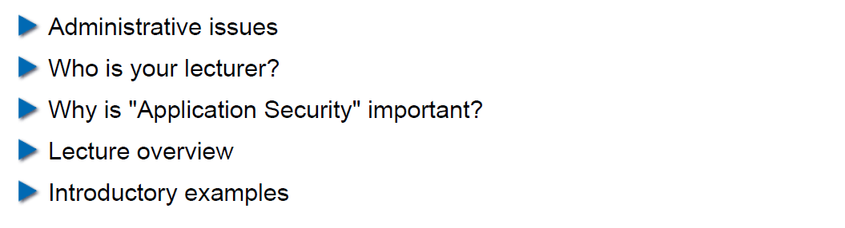

## Administrative Issues

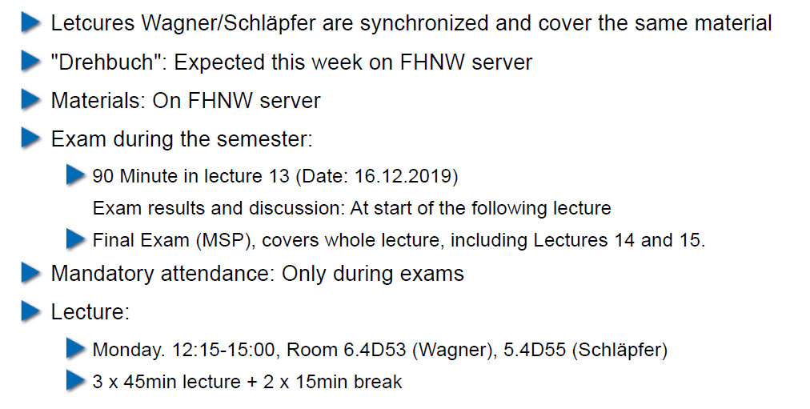

## Who is Your Lecturer (Wagner)

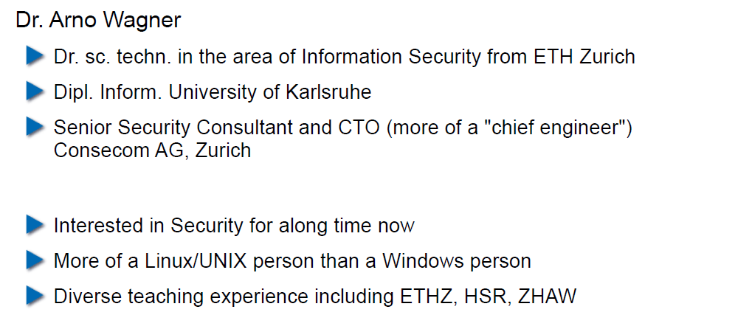

## whoami (Schläpfer)

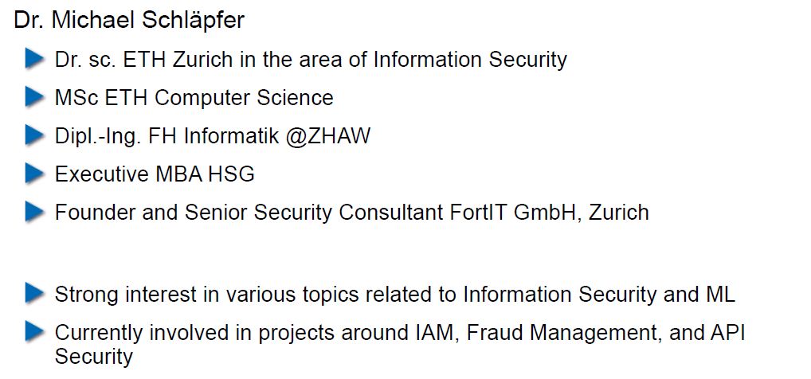

## Why is Application Security Important?

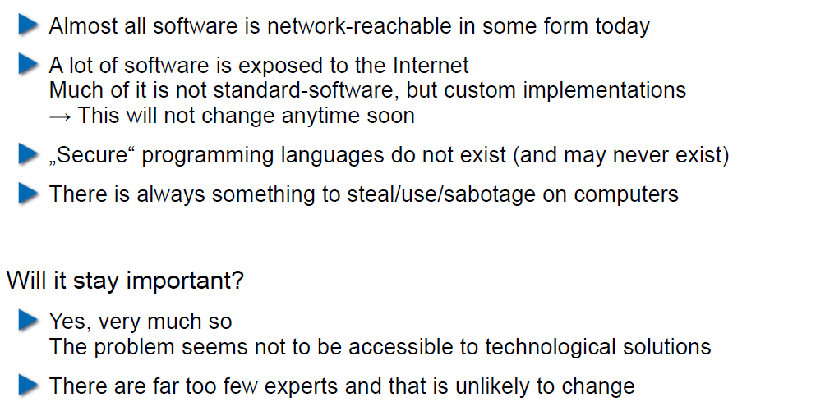

## Lecture Overview (1)

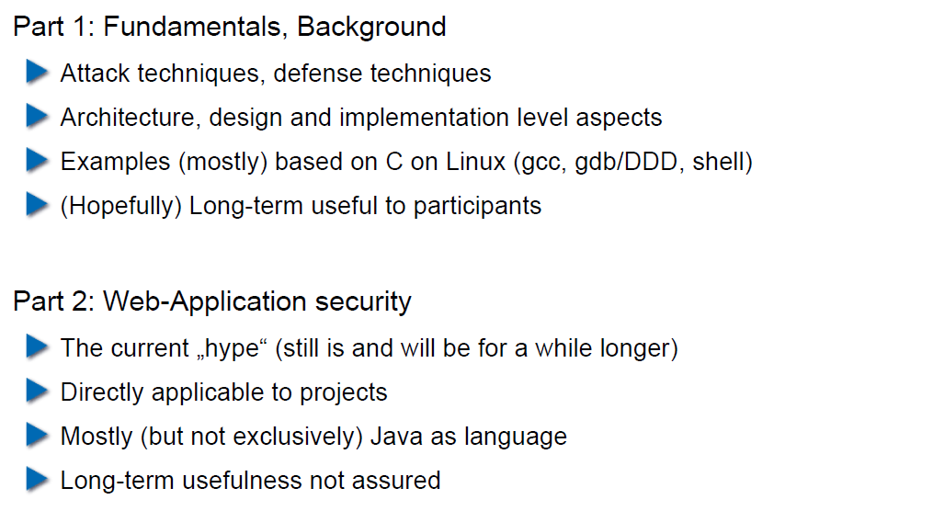

## Lecture Overview (2)

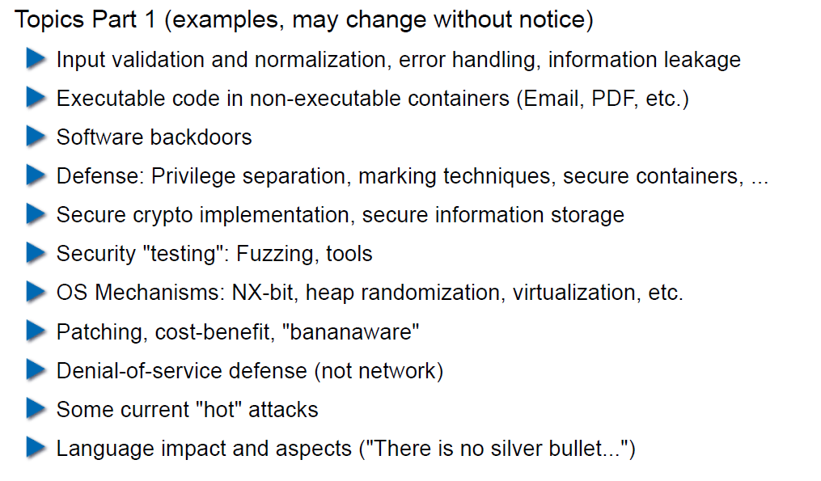

## Lecture Overview (3)

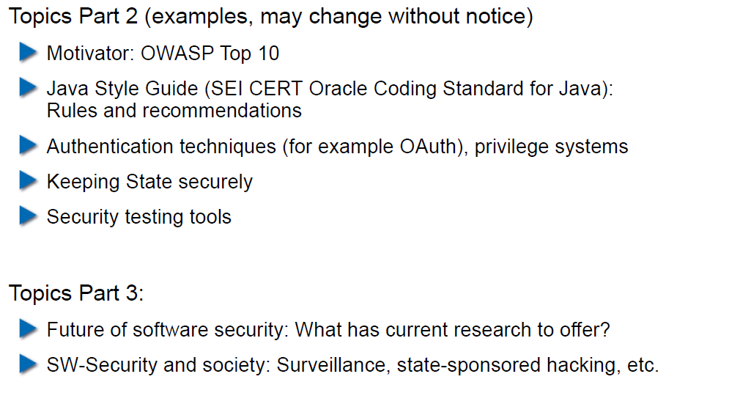

## Example: Buffer Overflow

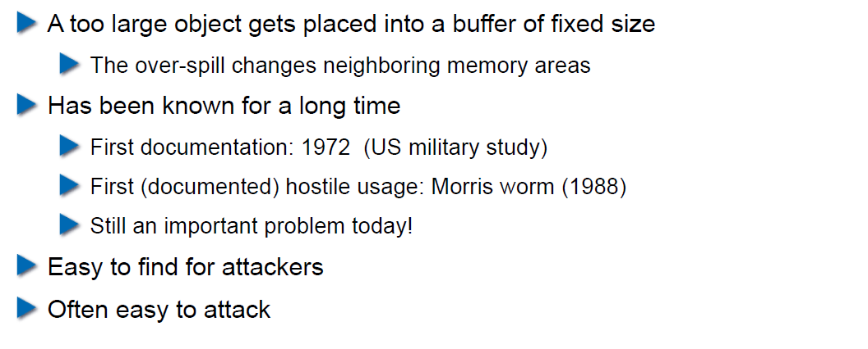

## How does a Buffer Overflow Work?

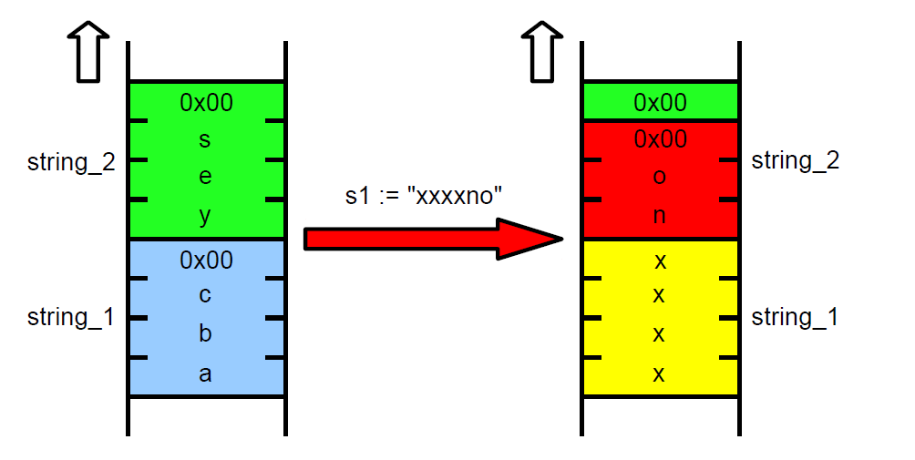

## Buffer Overflow Demo

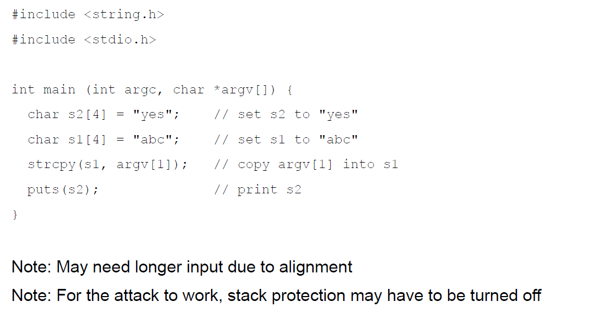

## Not Really a Fix for Buffer Overflow: Stack Protection

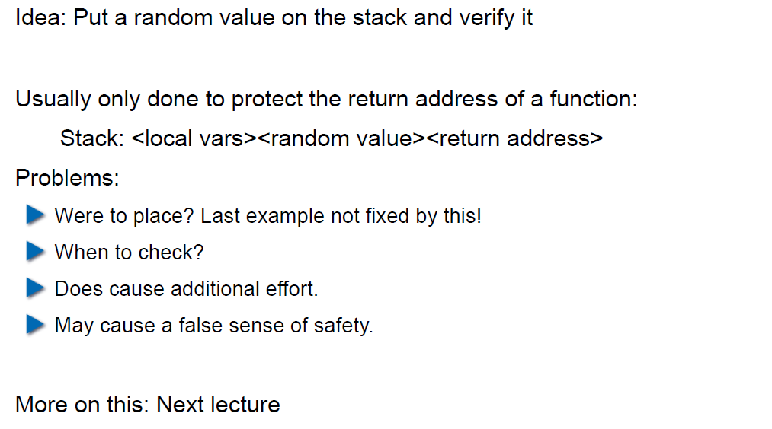

## Fix for Buffer Overflow: Checked Buffers

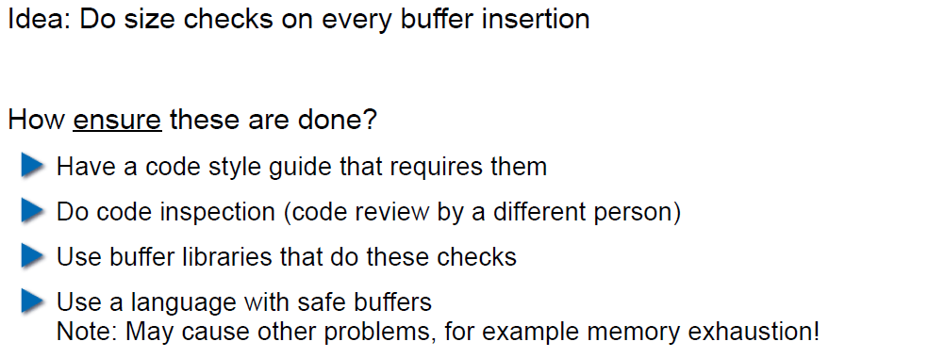

## Example: Taint Checking in Perl (1)

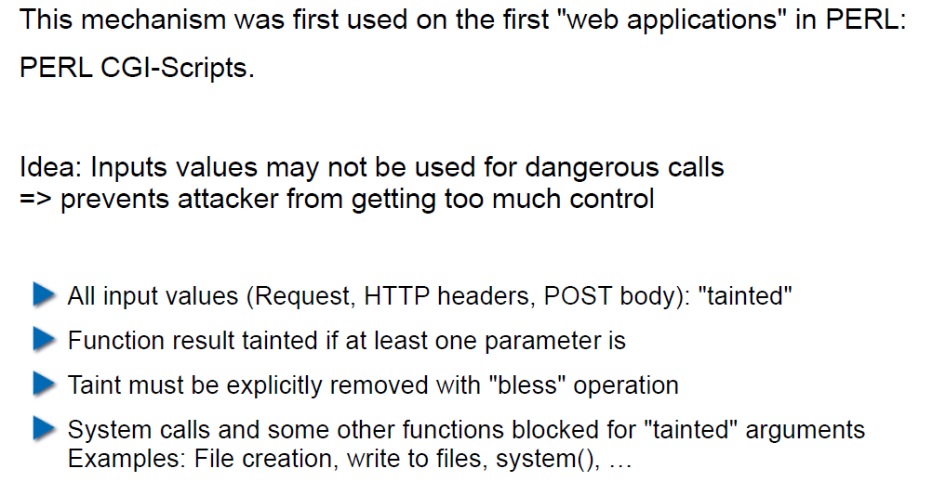

## Example: Taint Checking (2)

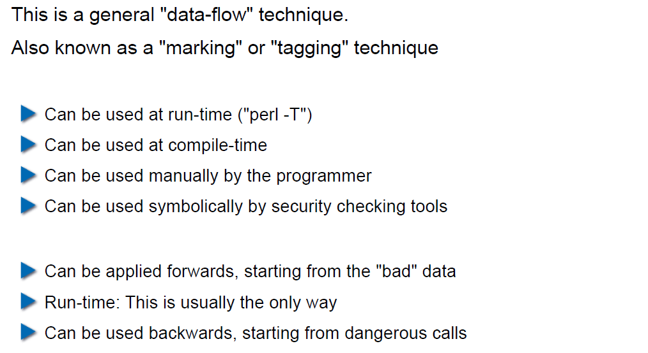

## Example: Taint Checking (3)

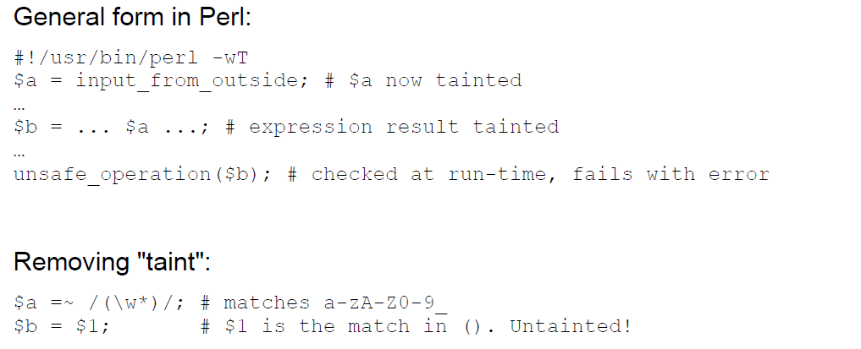

## Example: Taint Checking (4)

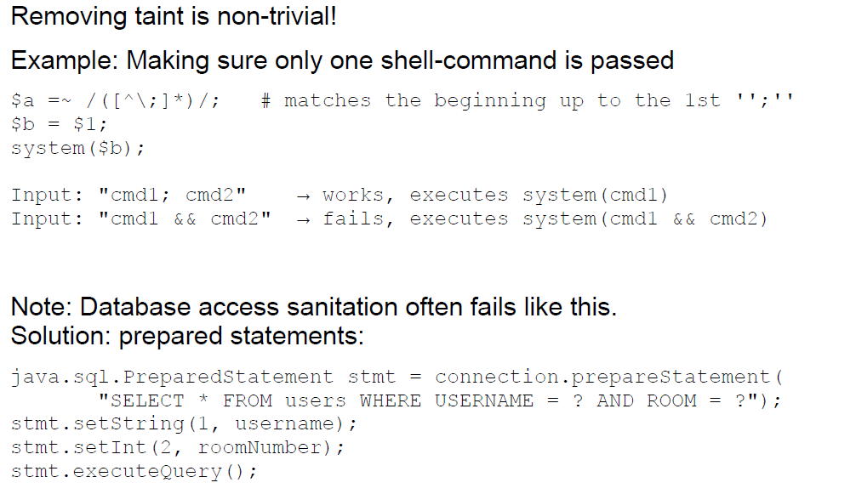

## Example: Data Leakage by Behavior (1)

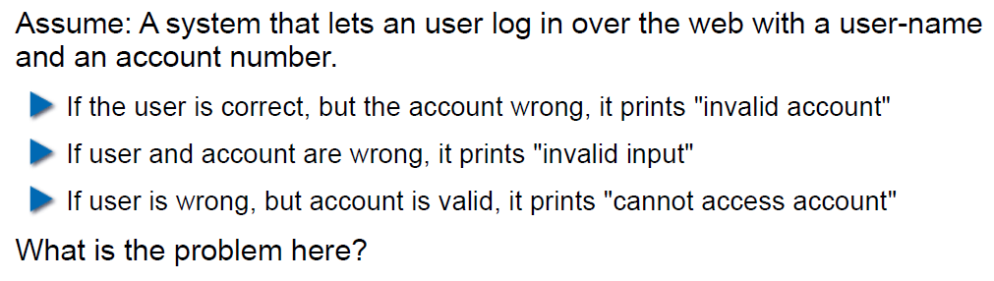

## Example: Data Leakage by Behavior (2)

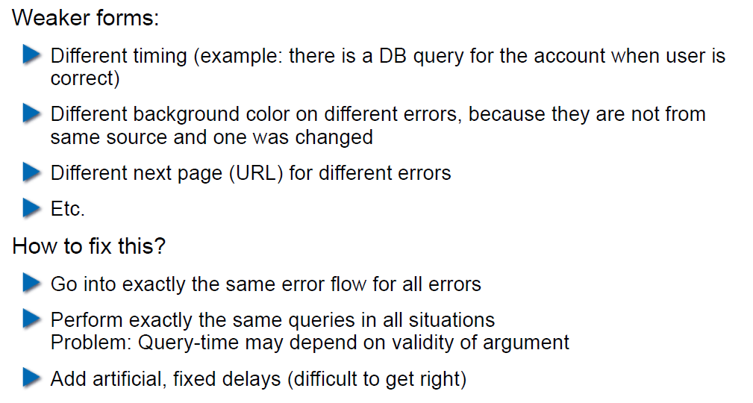

## Example: Data Leakage by Error Output

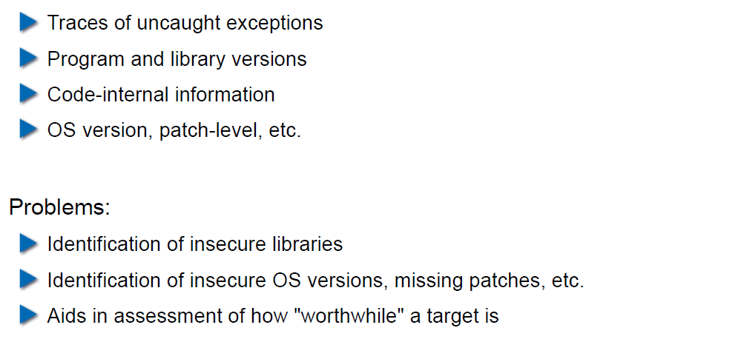

## Human Factors

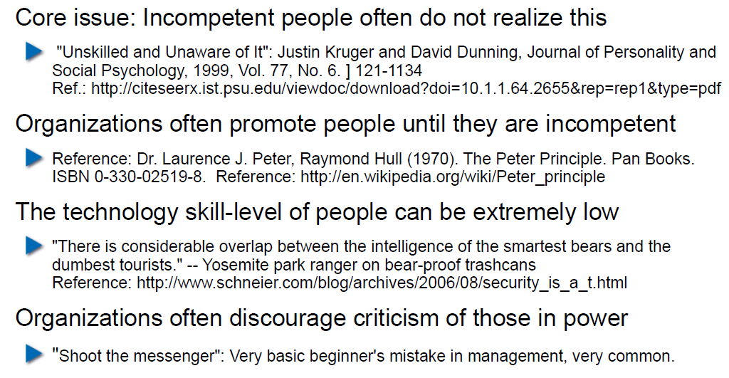

## Exercises and Preparation for Next Week

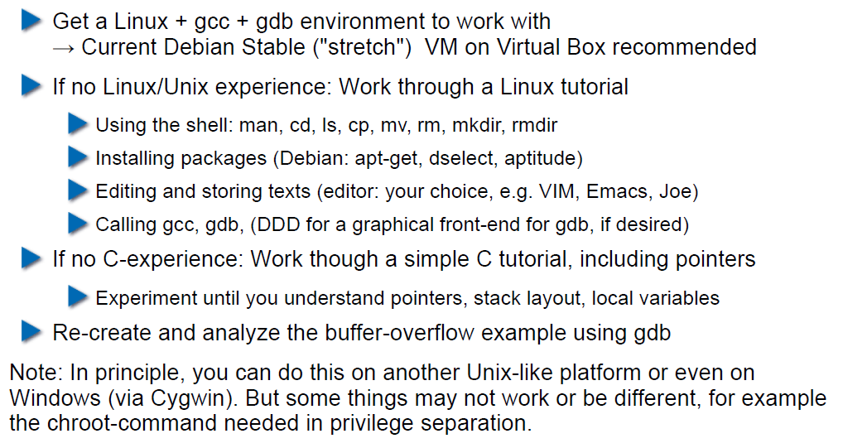

## Reserve

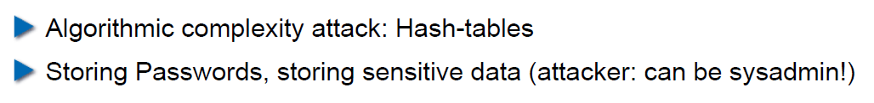

# Woche 2

## Agenda

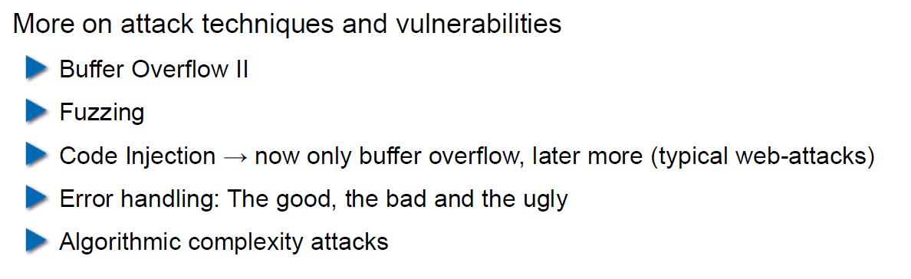

## Recap: What do Attackers Want?

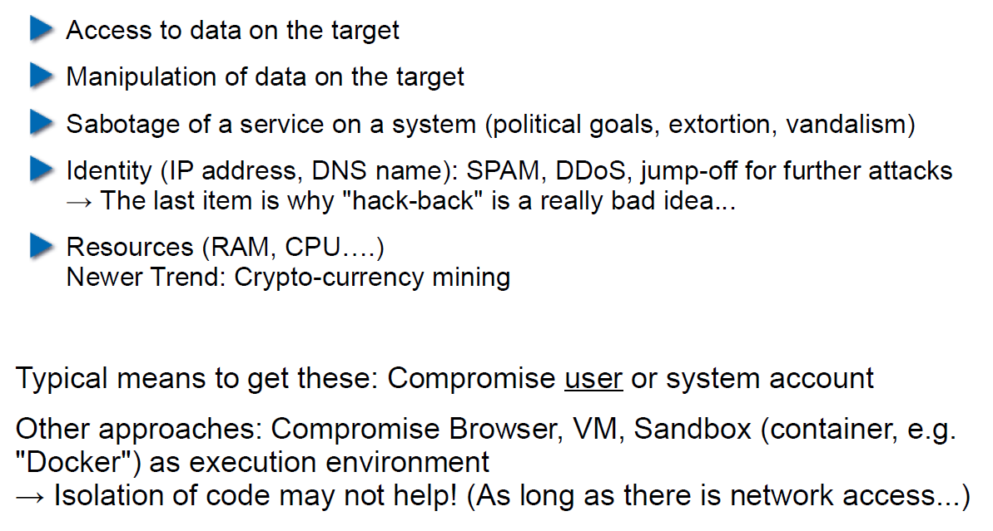

## Buffer Overflow II

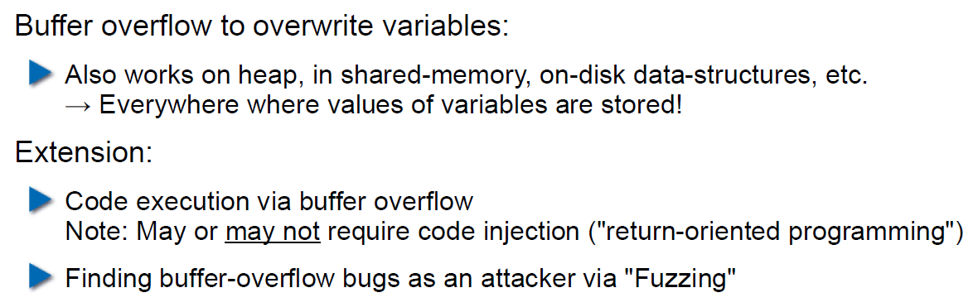

## Buffer Overflow II

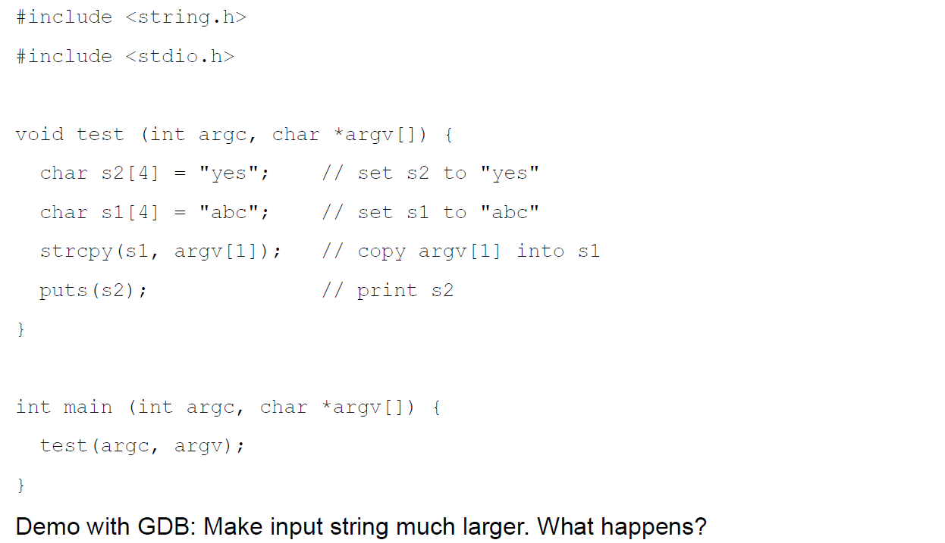

## Buffer Overflow II

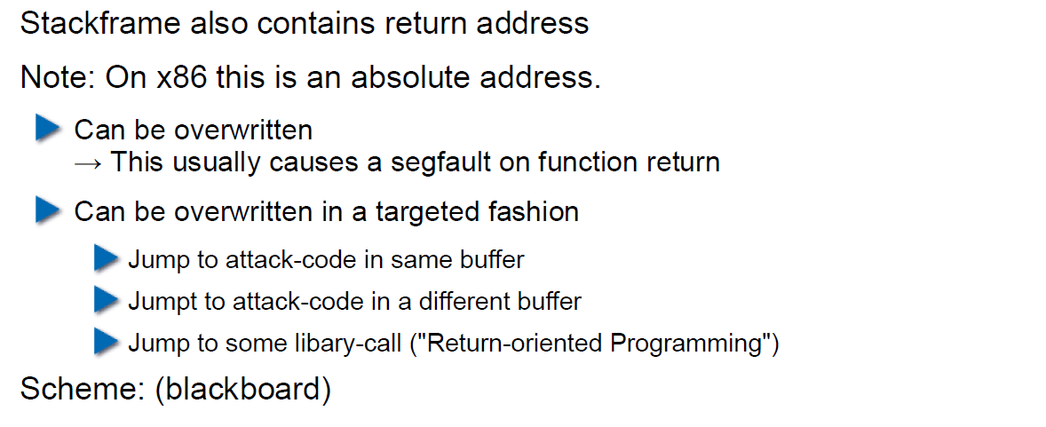

## Buffer Overflow II

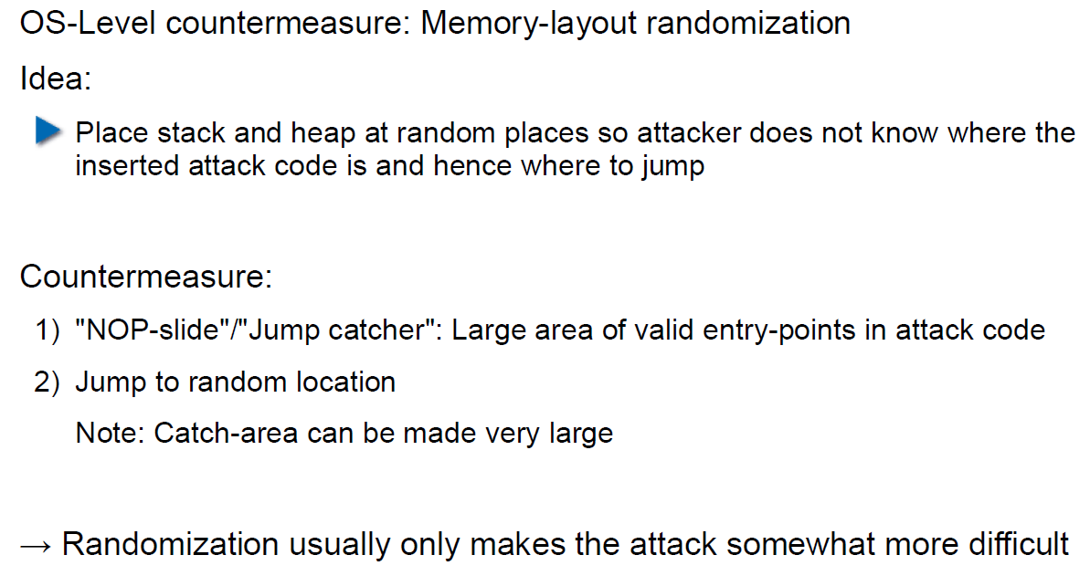

## Buffer Overflow II

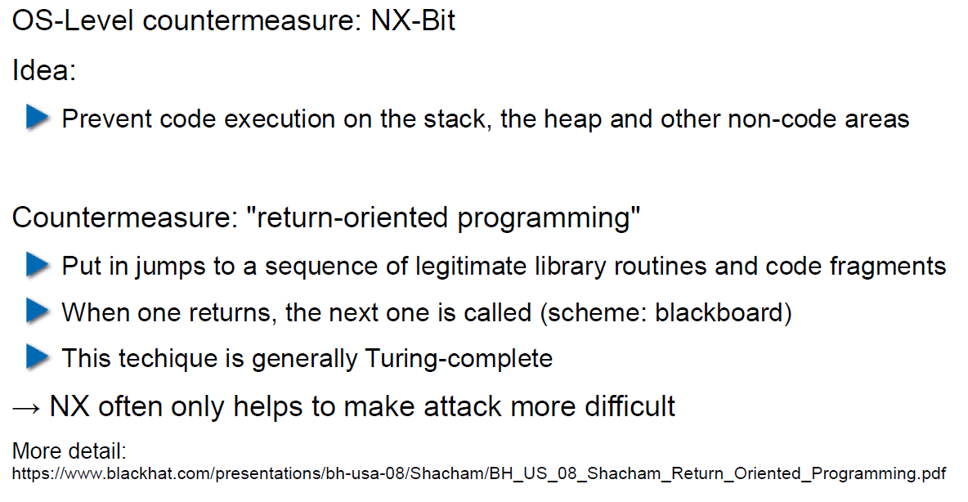

## Attack Technique: Fuzzing

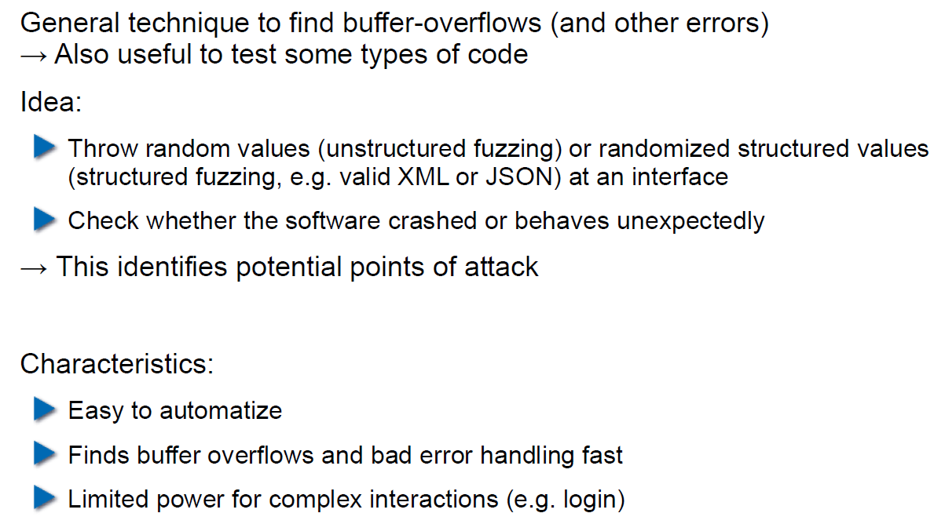

## Error Handling

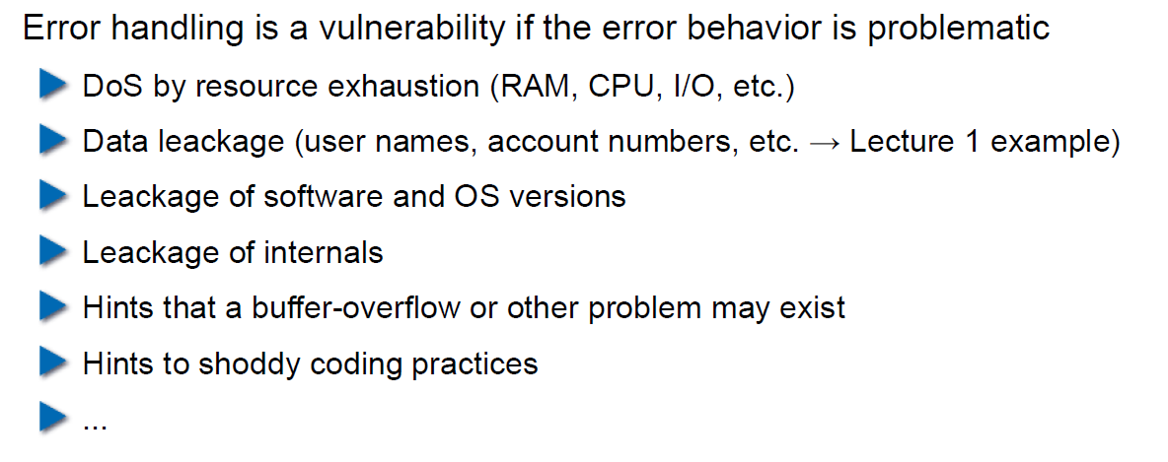

## Case study – Handling too long input

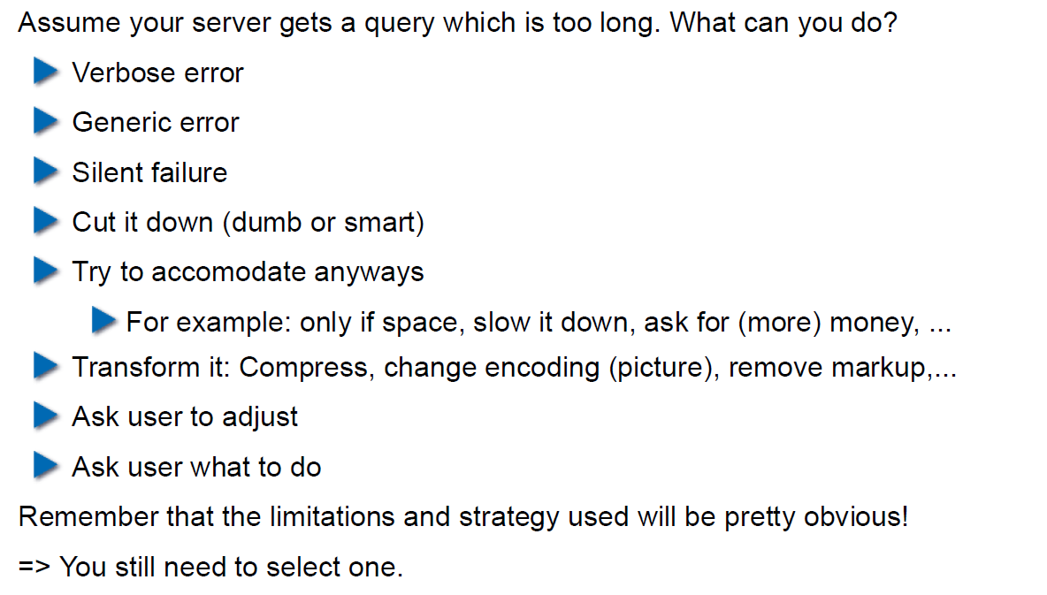

## Case-study: Compression Bomb

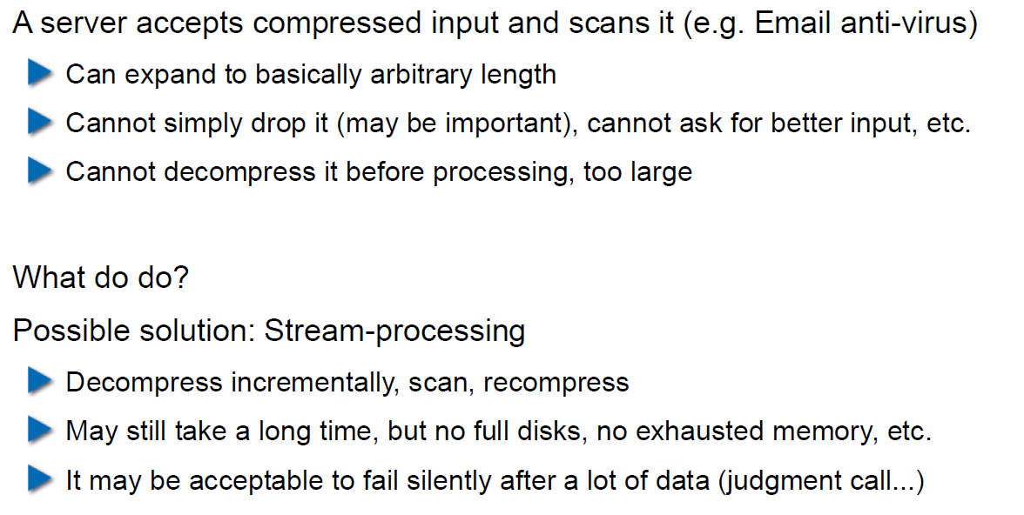

## Error Handling

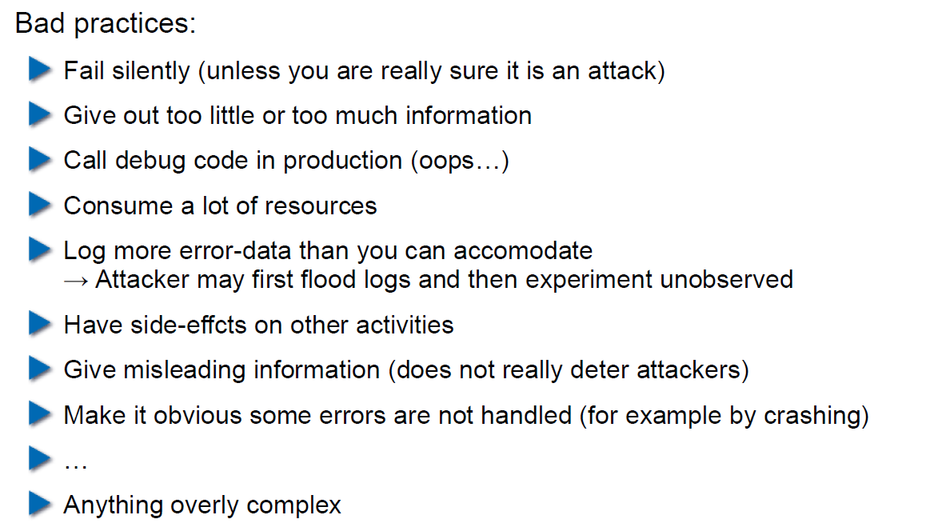

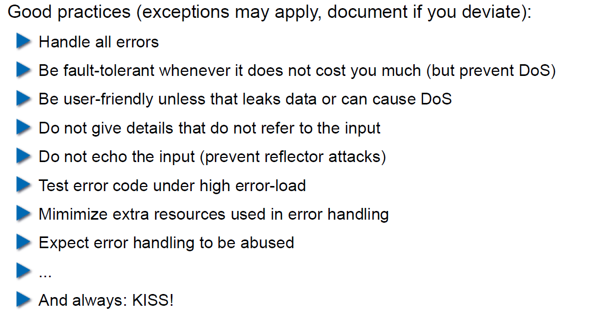

## Algorithmic Complexity Attacks

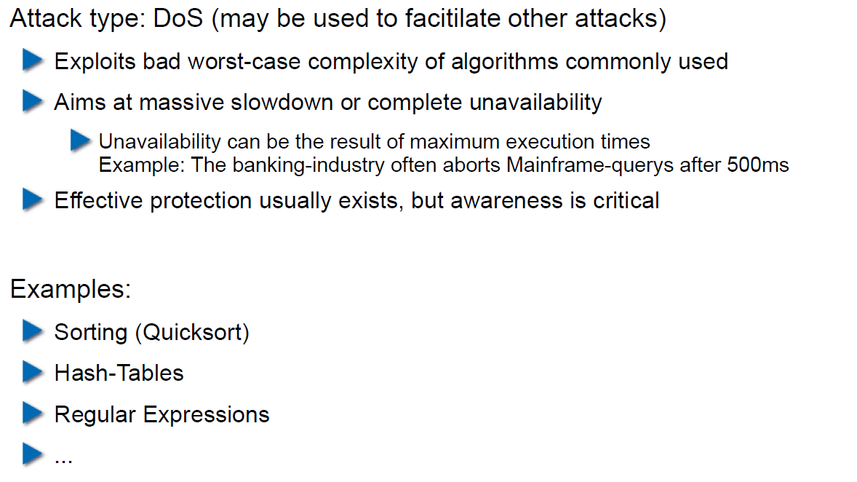

## Algorithmic Complexity: Sorting

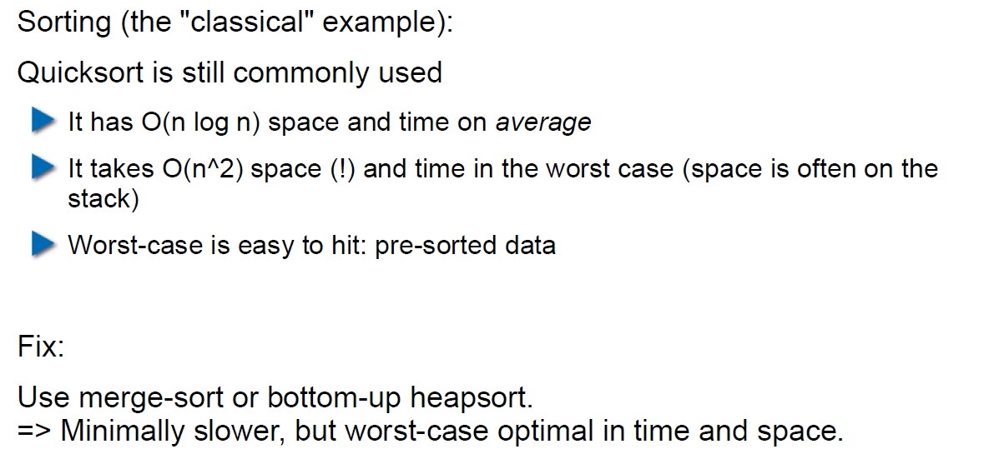

## Algorithmic Complexity: Hashing

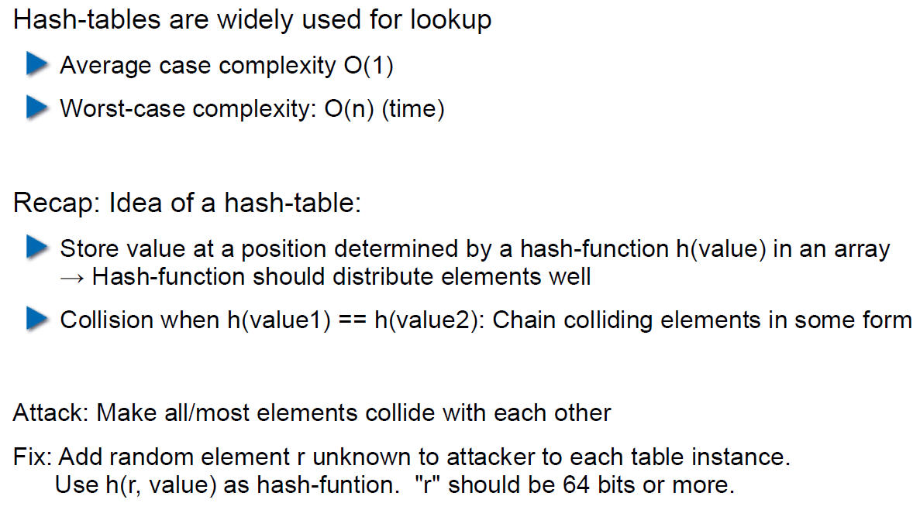

## Algorithmic Complexity: Regular Expressions

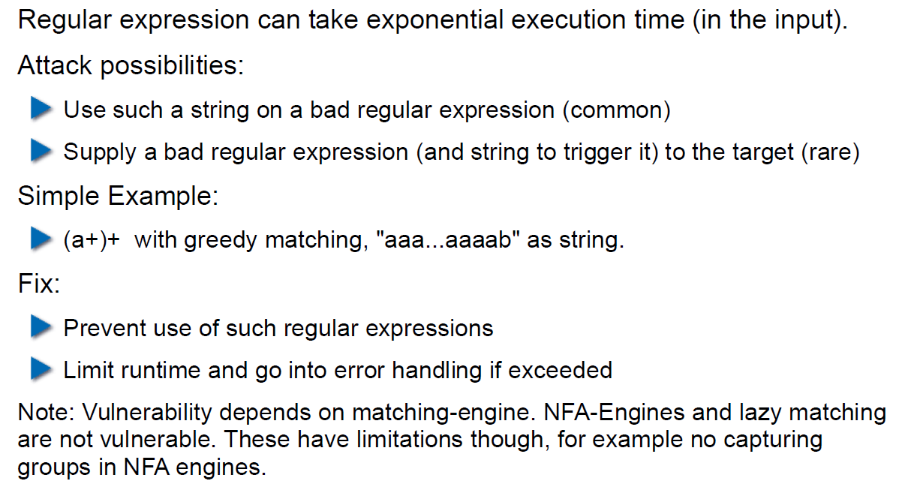

# Woche 3

## Agenda

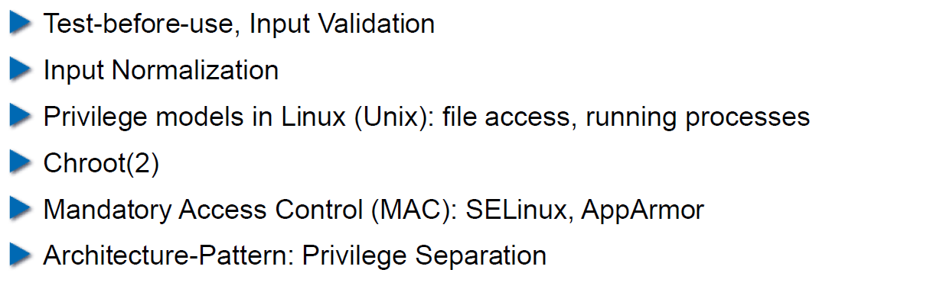

## Secure Coding Principle: Test-before-use

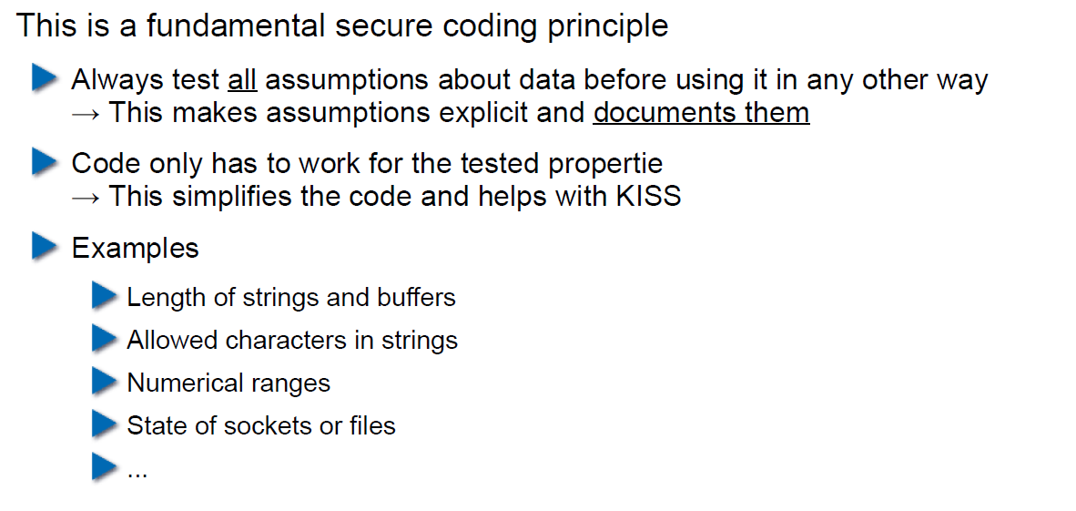

## Input Validation

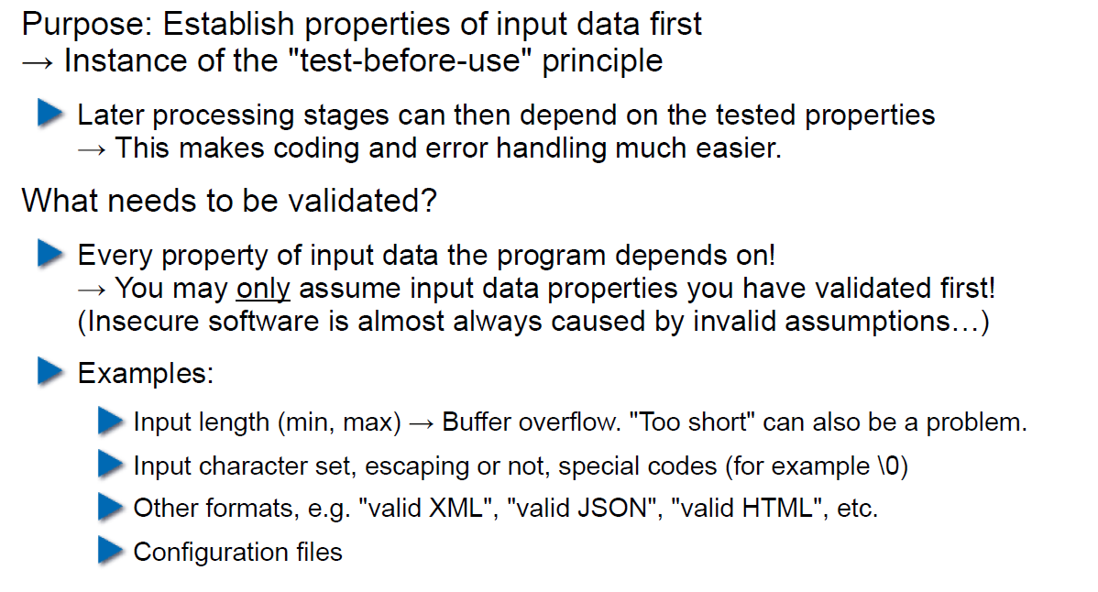

## Input Normalization

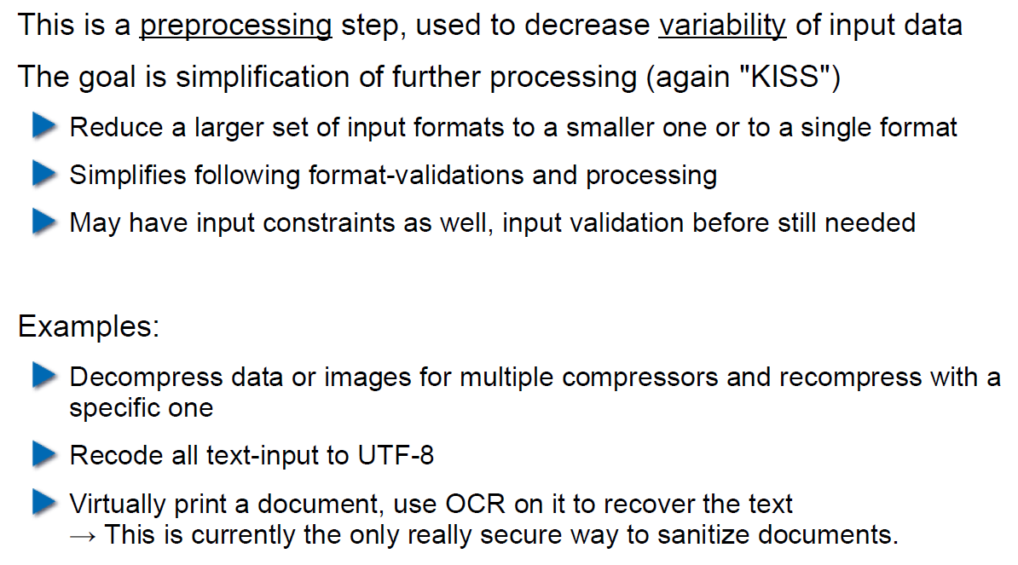

## Unix Permission Model (simplified)

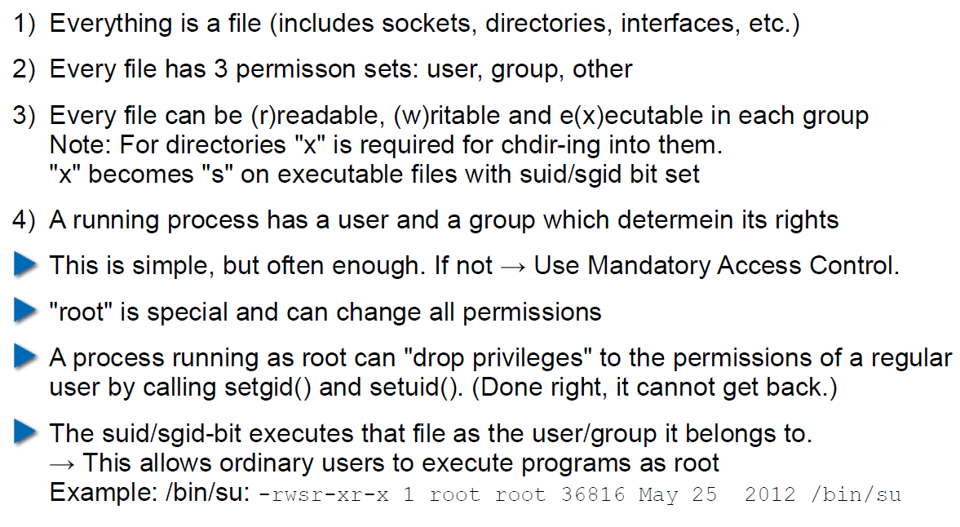

## Chroot

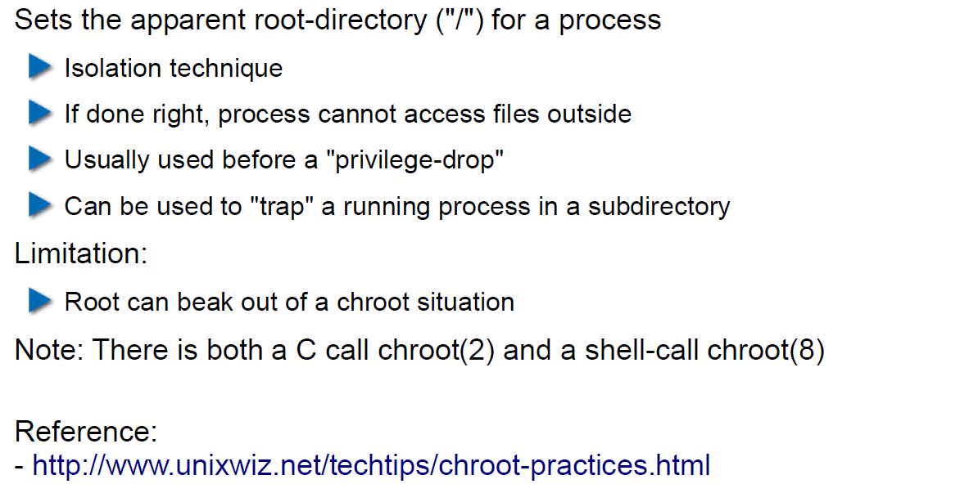

## Mandatory Access Control (MAC)

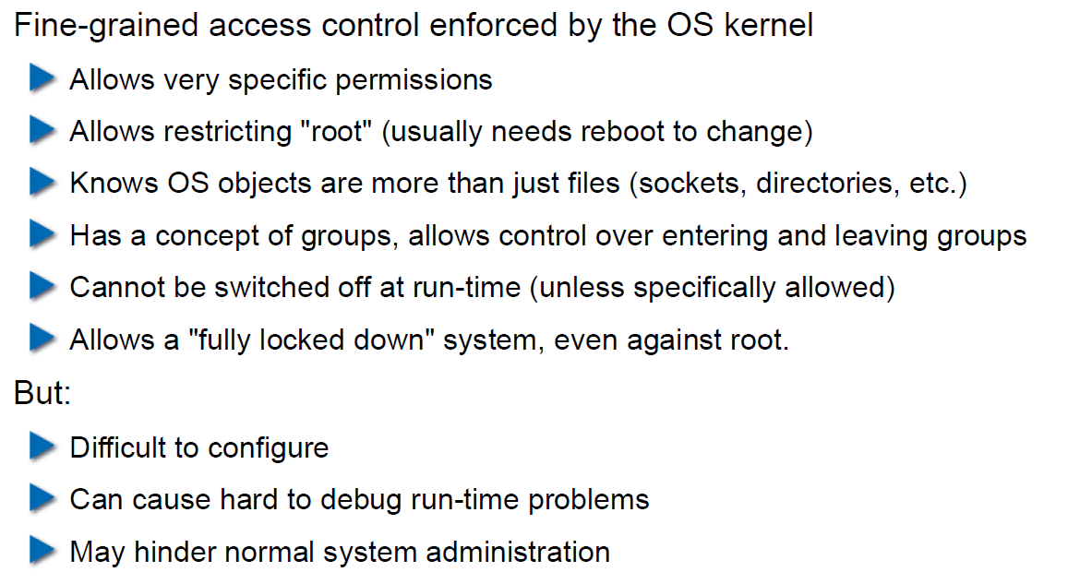

## MAC Example: SELinux

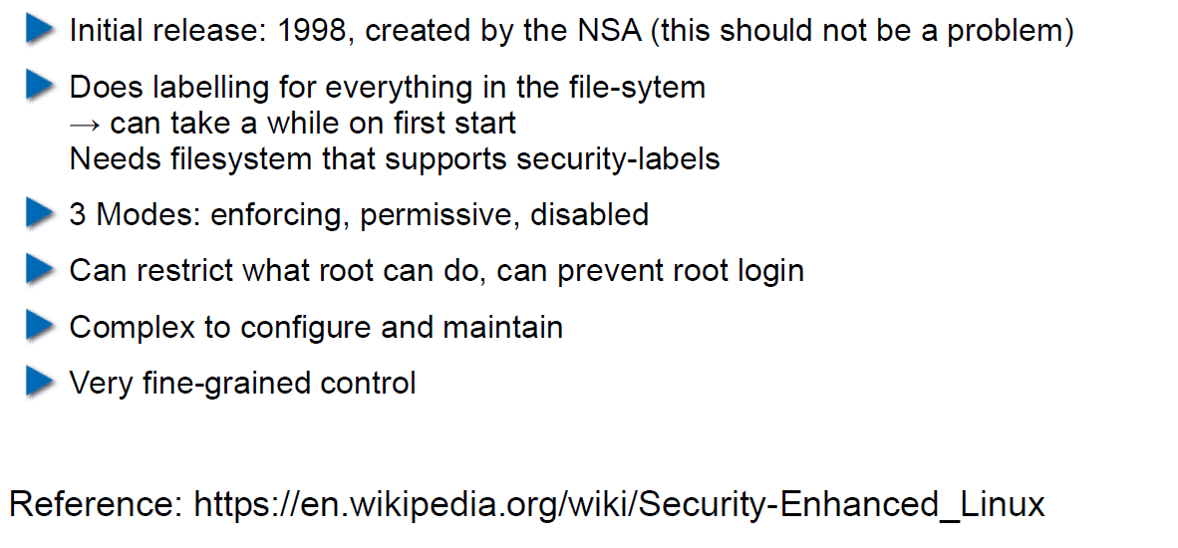

## MAC Example: AppArmor

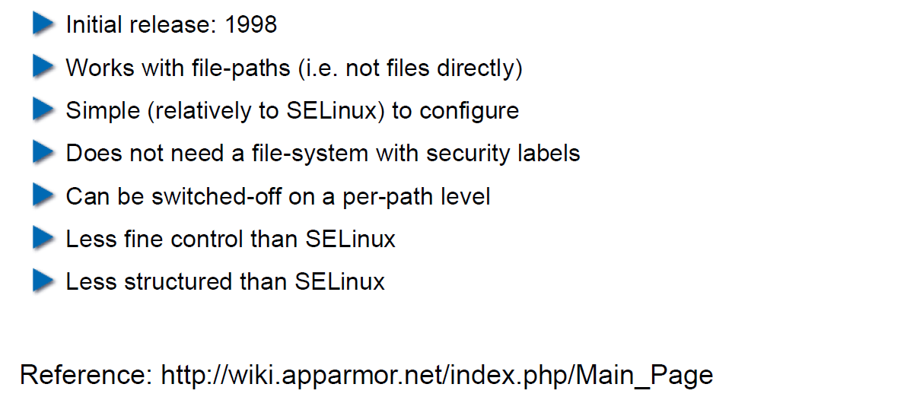

## Secure Coding Principle: Defense in Depth

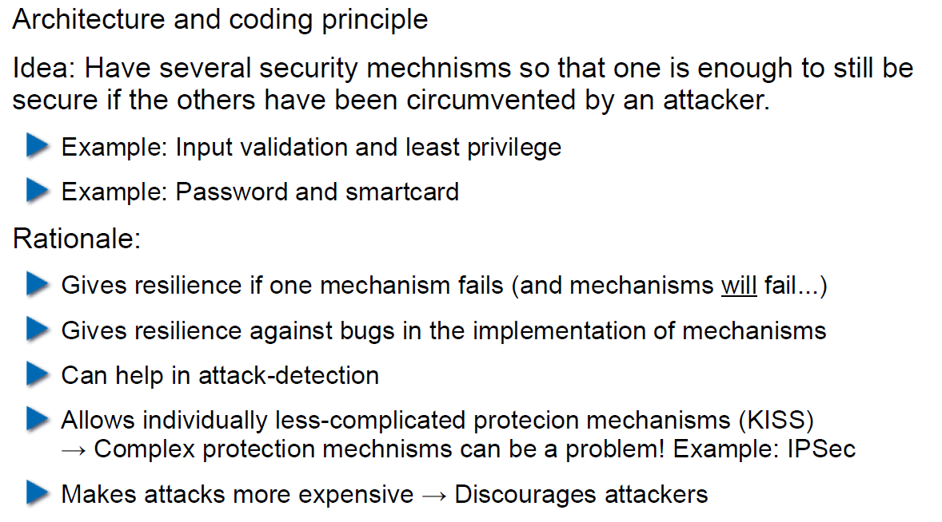

## Privilege Separation

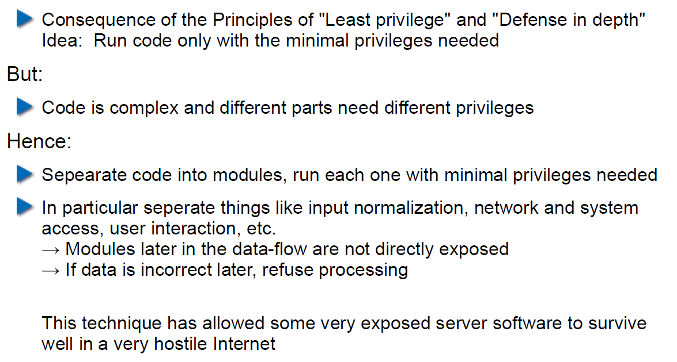

## Overall Idea

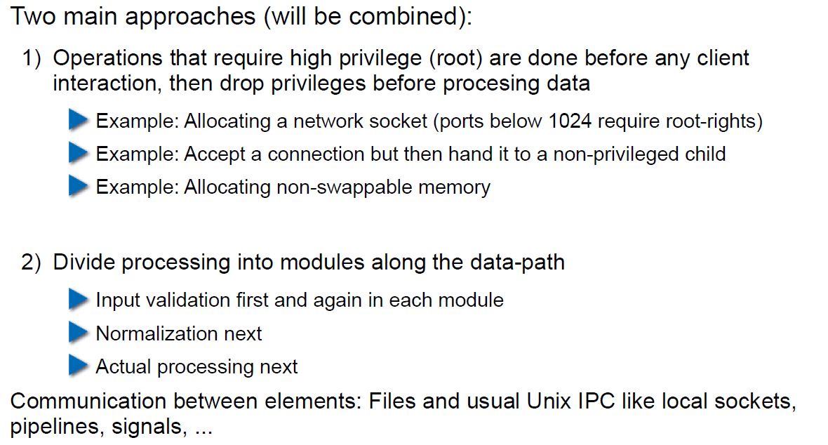

## Form of the Modules

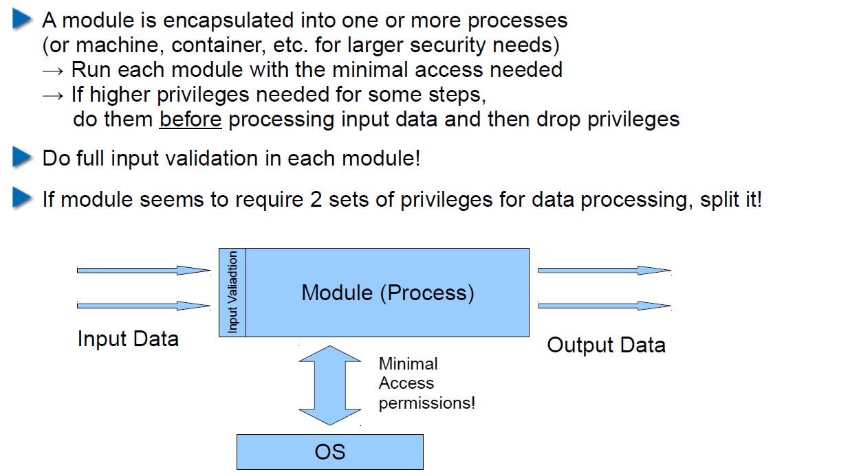

## Example: OpenSSH

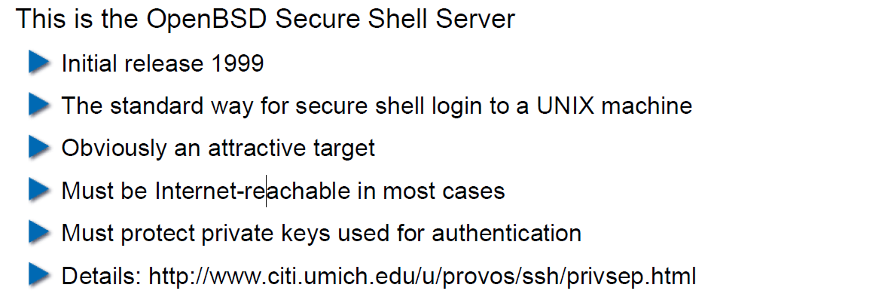

## OpenSSH: Privilege Separation Approach

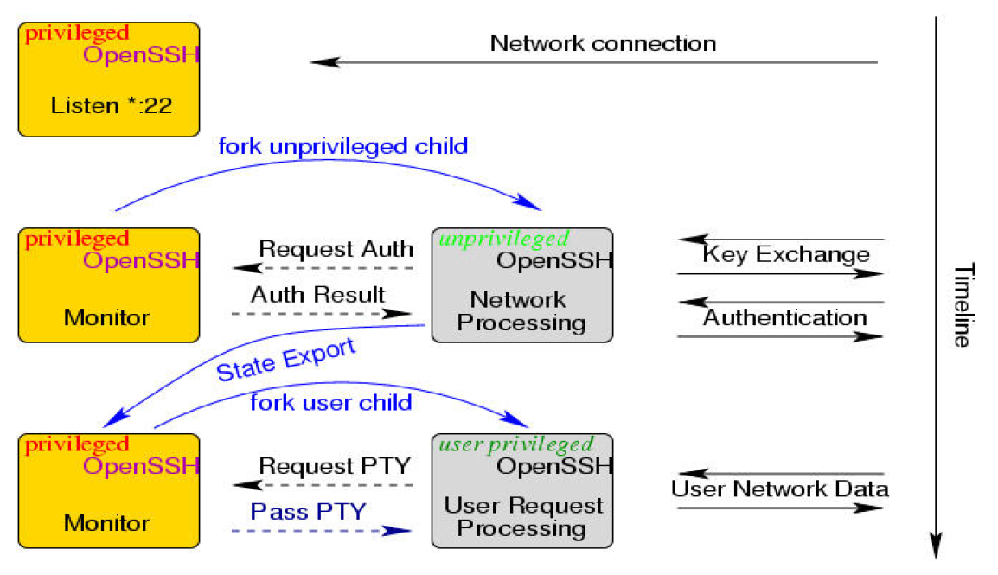

## Example: Postfix MTA (Email Server)

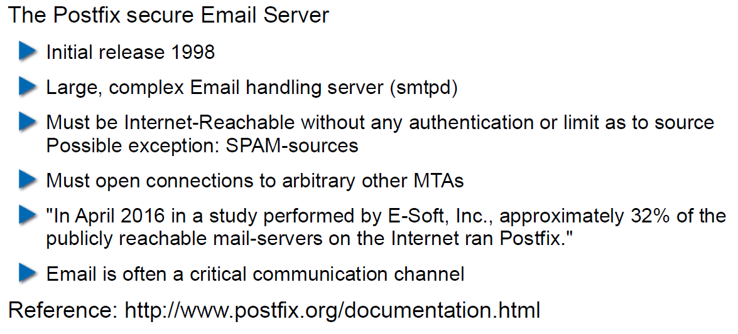

## Postfix System View

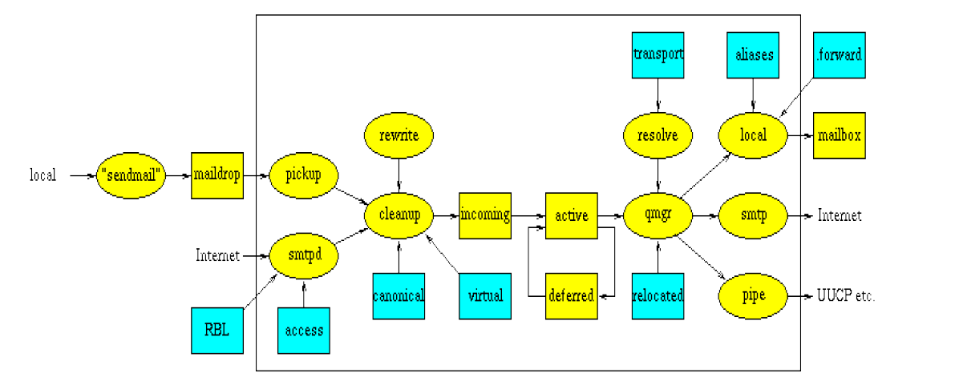

## Postfix: Example Data-Flow

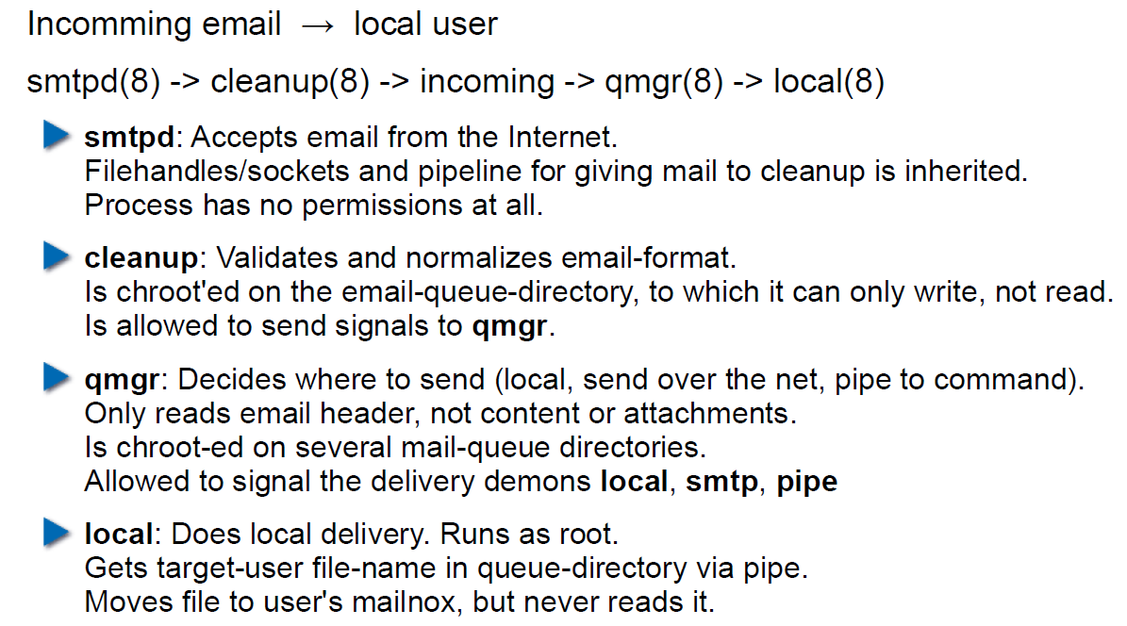

# Woche 4

## Agenda

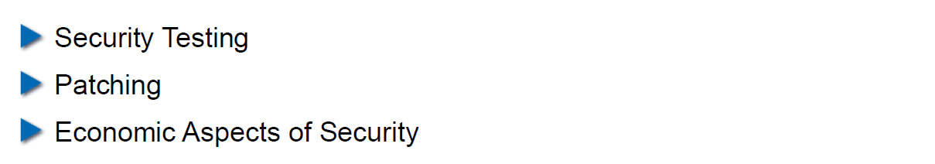

## Security Testing (for Software)

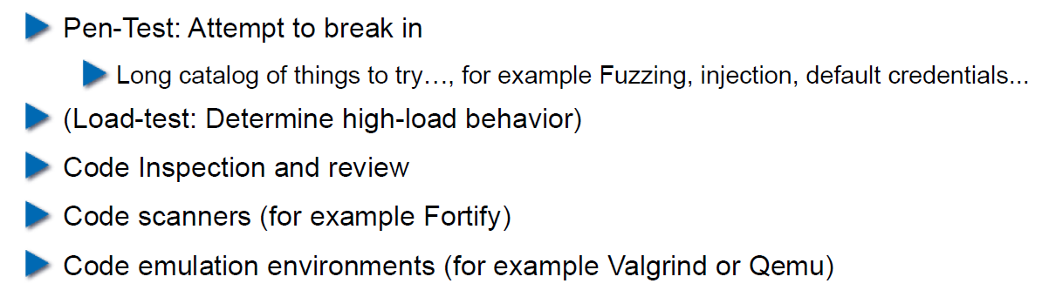

## Pen-Test

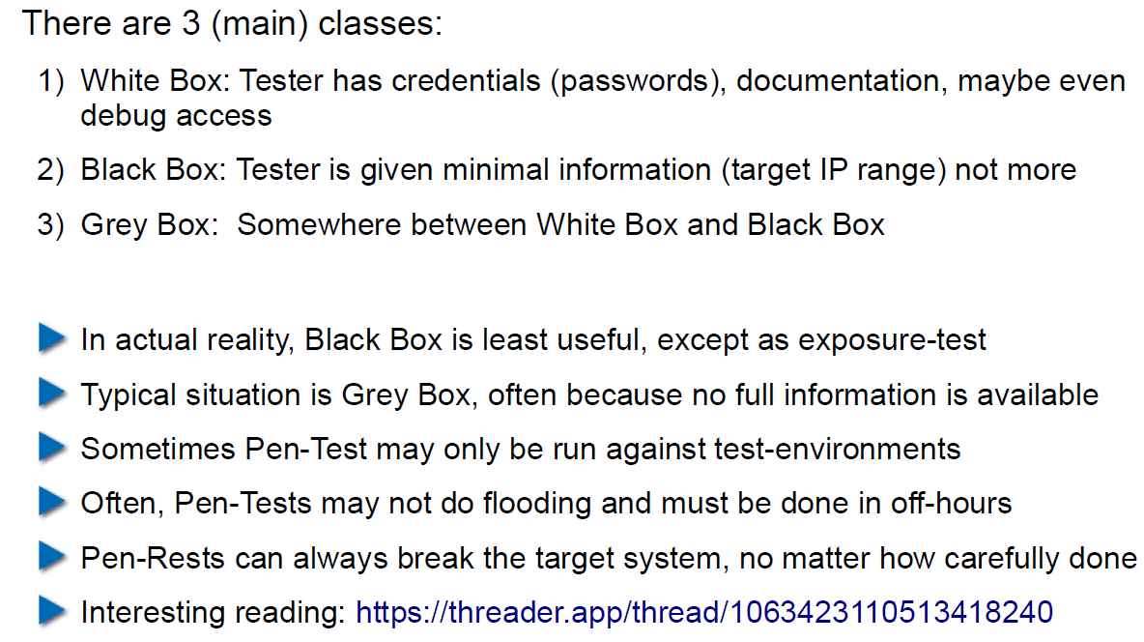

## How does a Pen-Test fail?

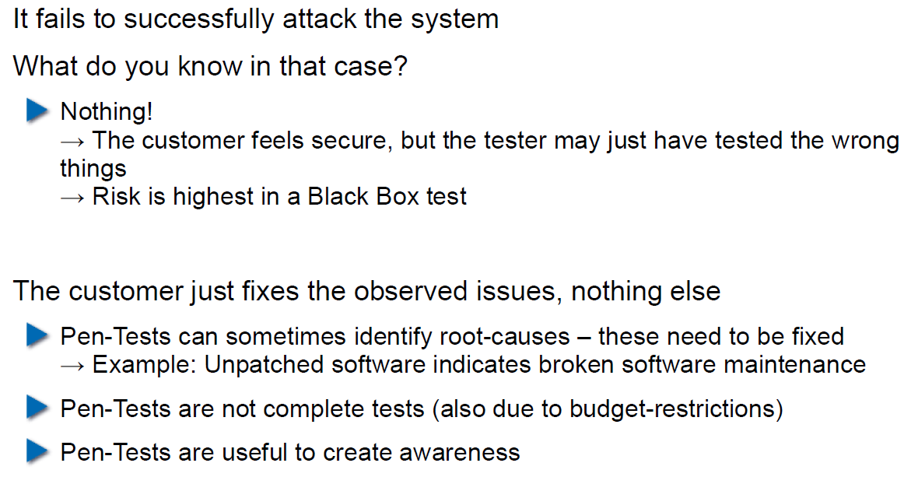

## Code Inspection and Review

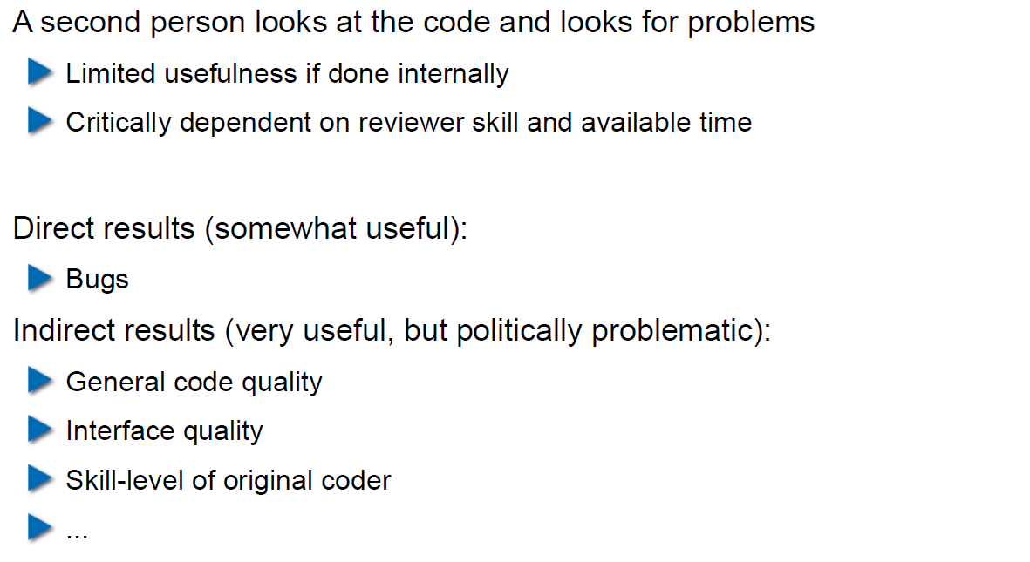

## Code Scanners

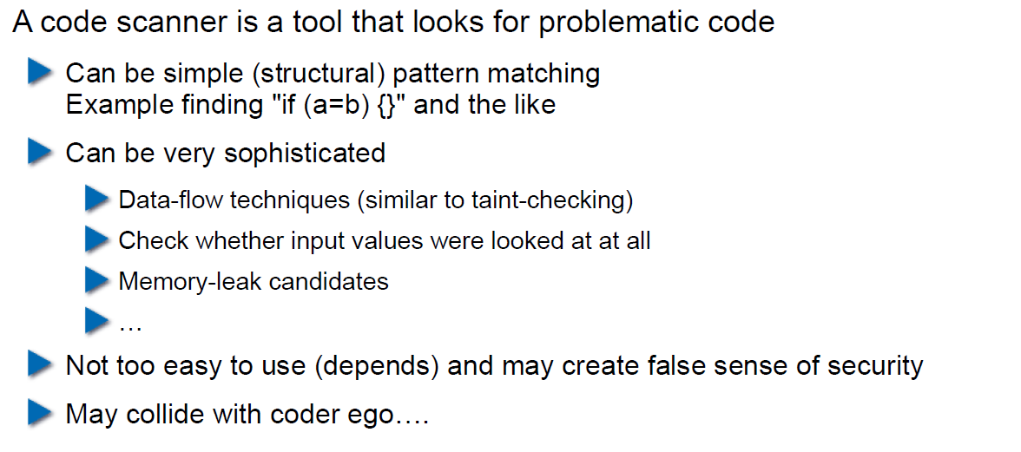

## Execution Emulators

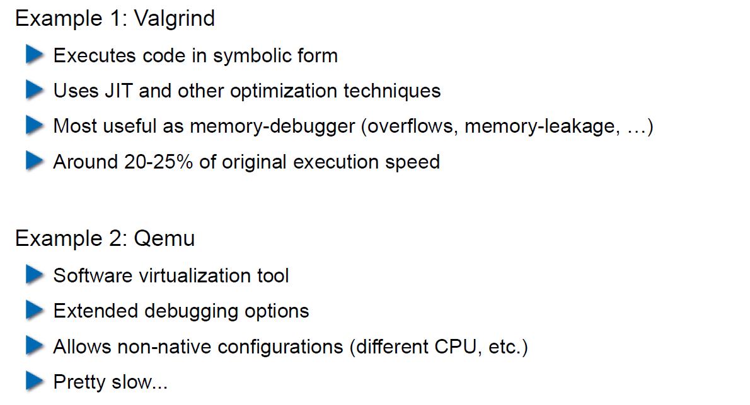

## Patching

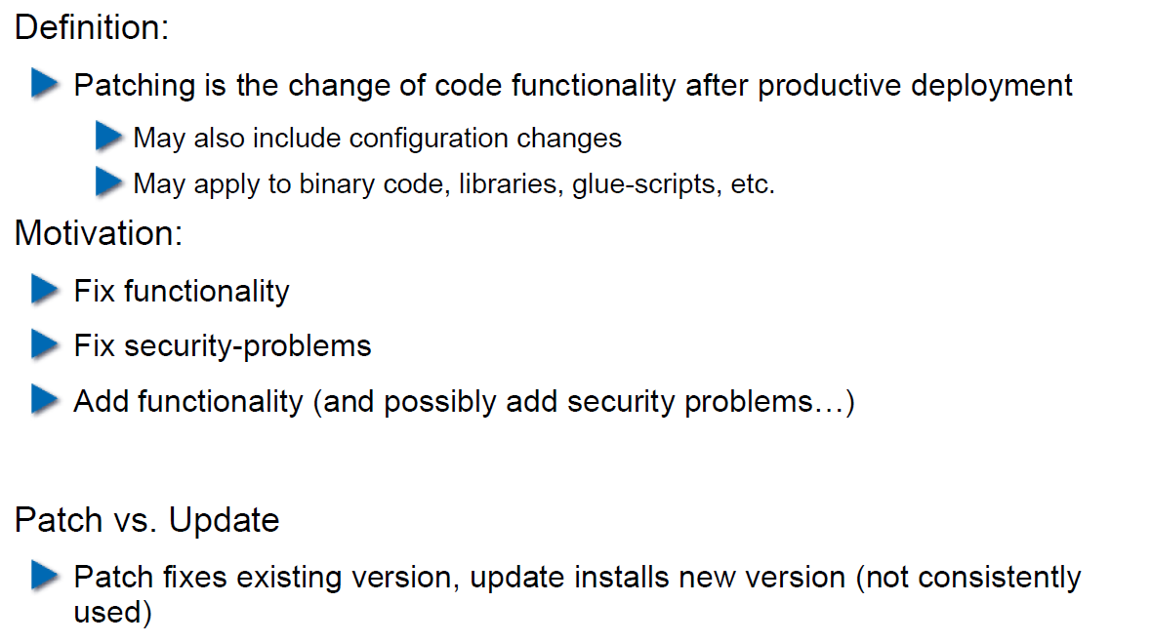

## How to Patch

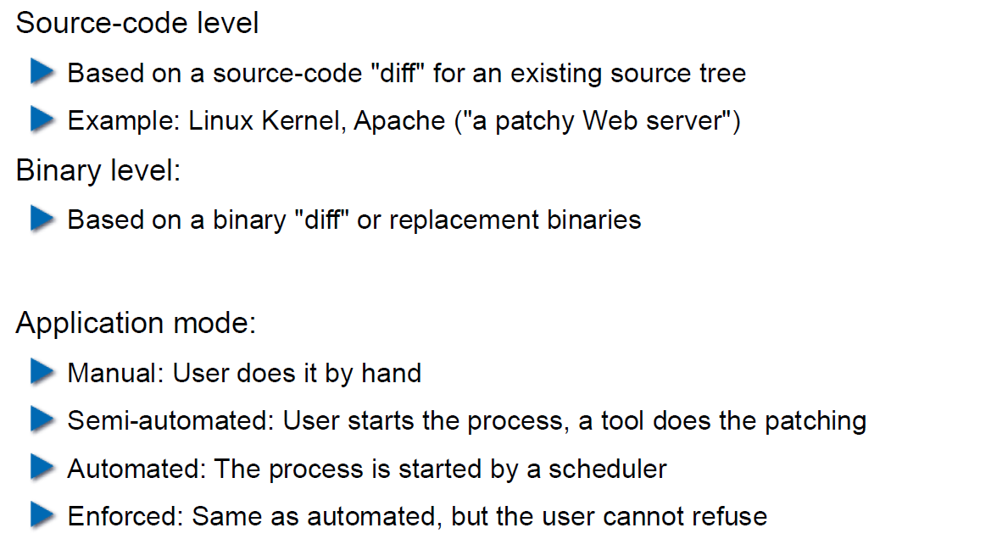

## Problems with Patching

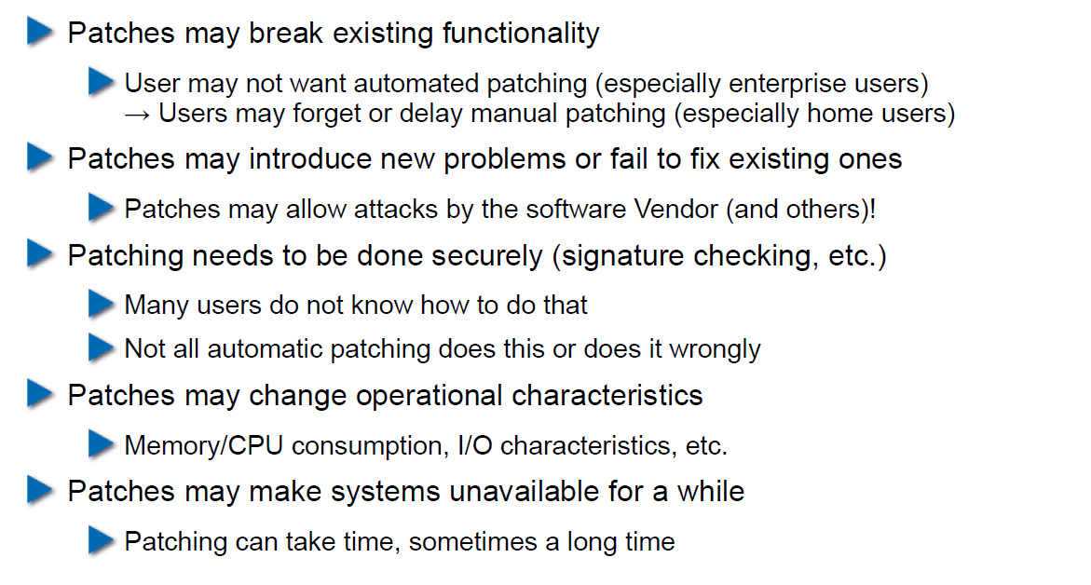

## Problems with not Patching

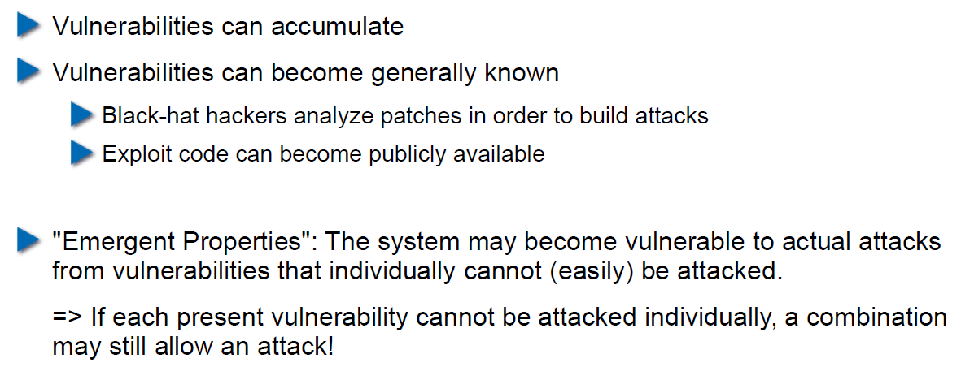

## Problems with Unavailability of Patches

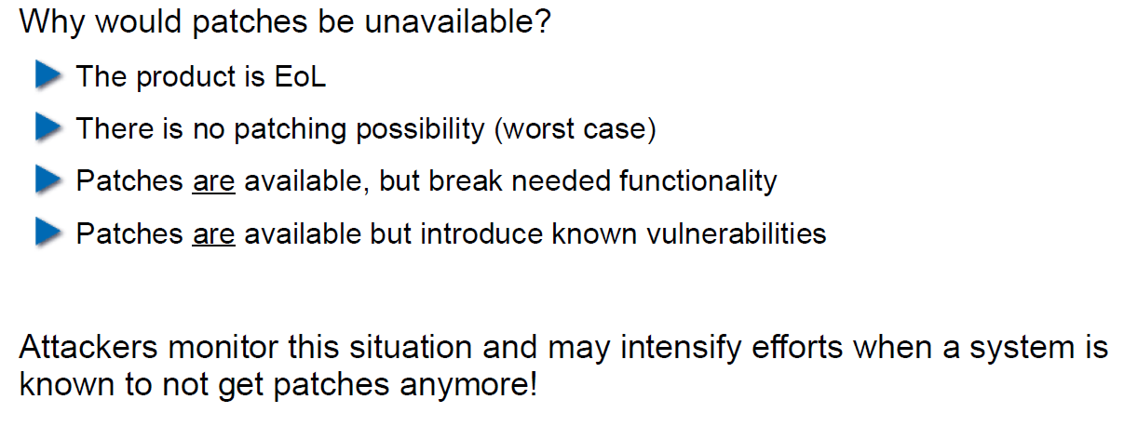

## Economic Aspects of Security

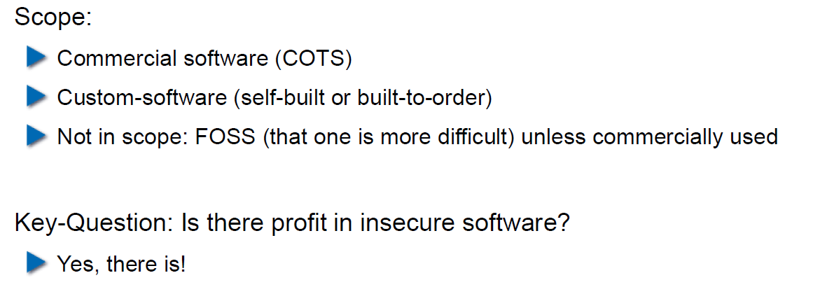

## Case Study: DDoS on Brian Krebs (20.9.2016)

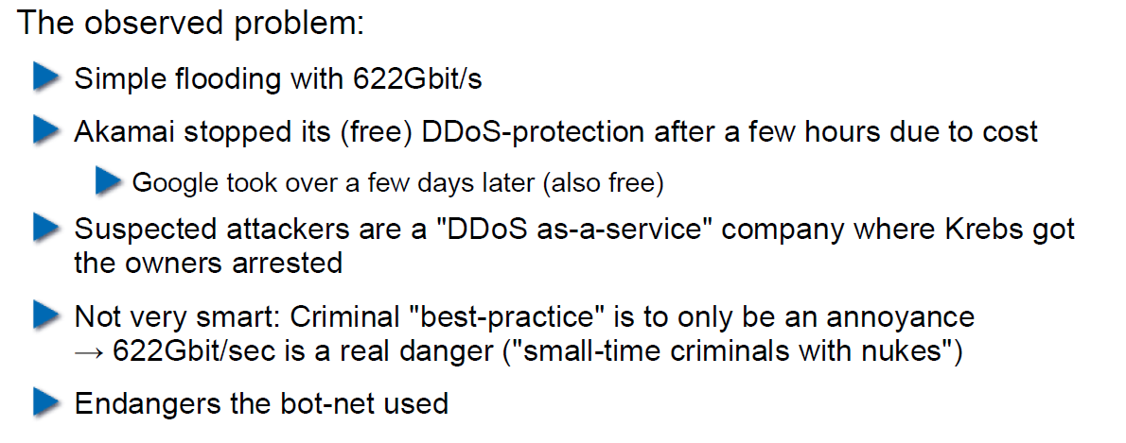

## What can Perform Such an Attack?

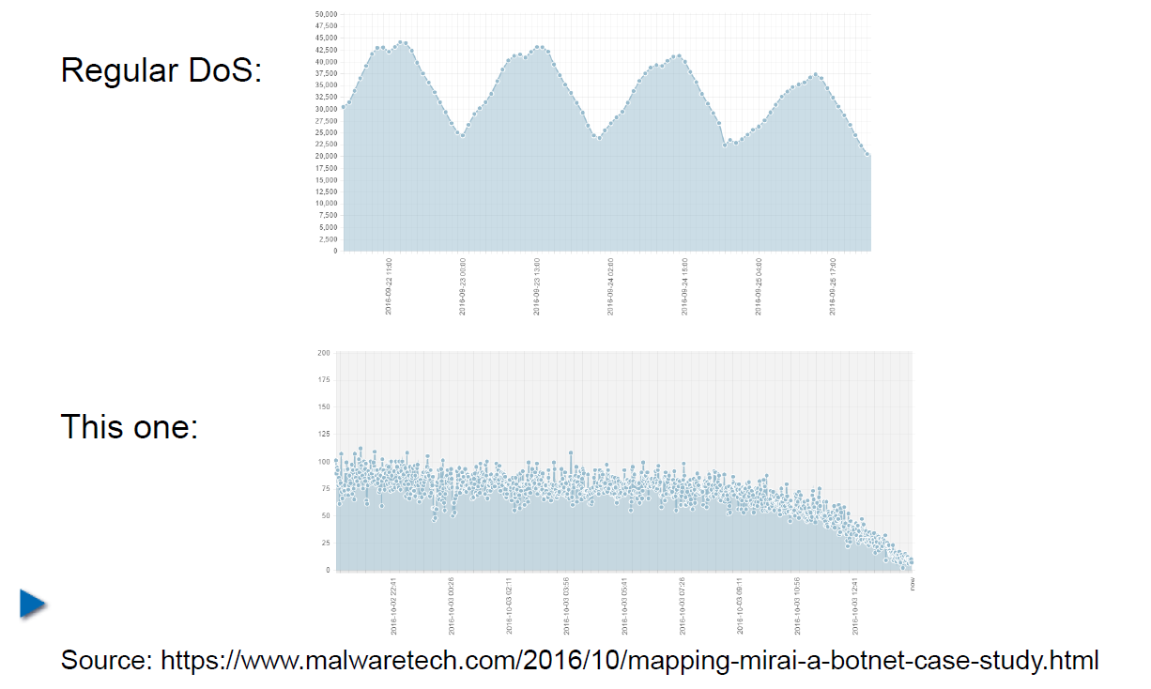

## IoT: Internet of insecure Things

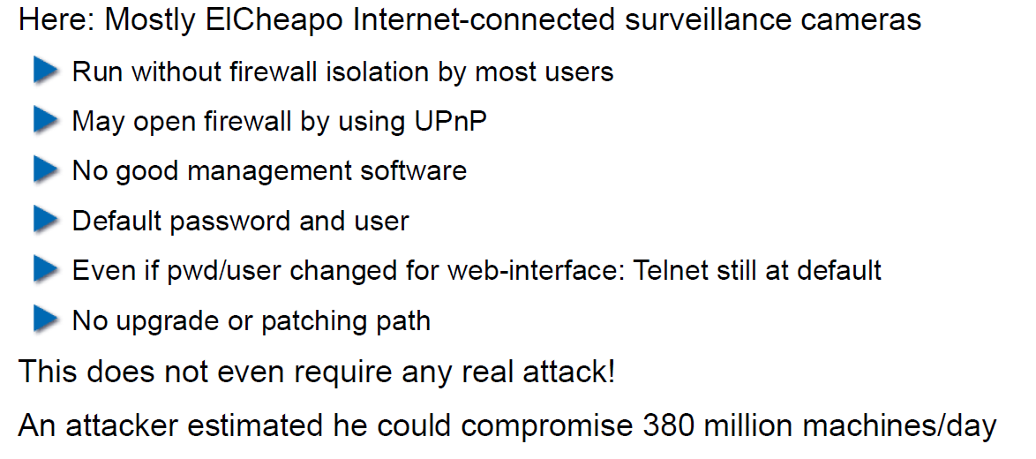

## Why are These IoT Devices so Insecure?

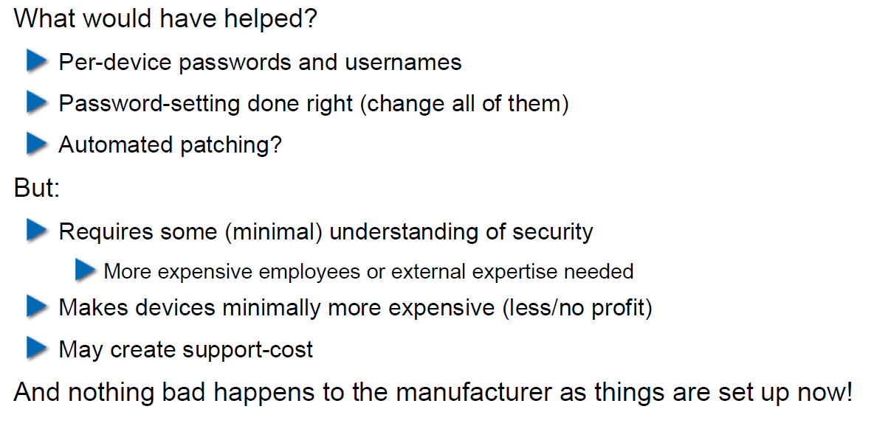

## Possible Solutions

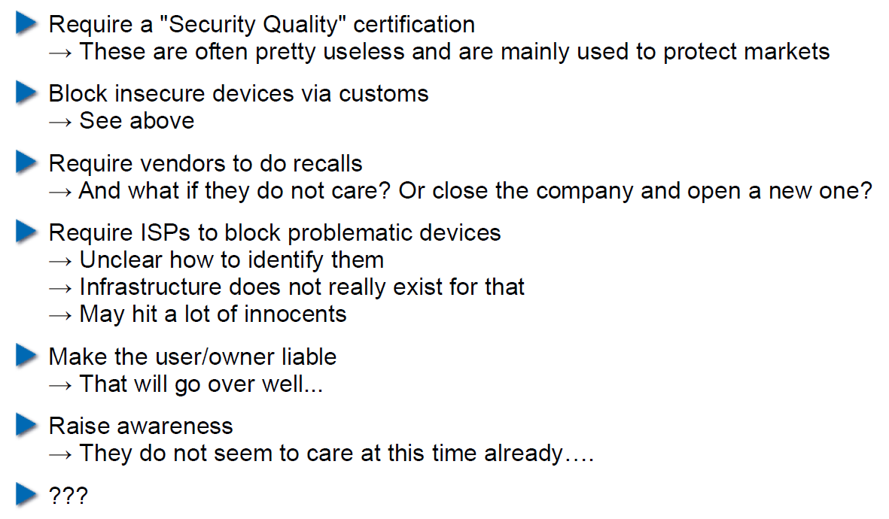

## Does it Pay to make Software Secure?

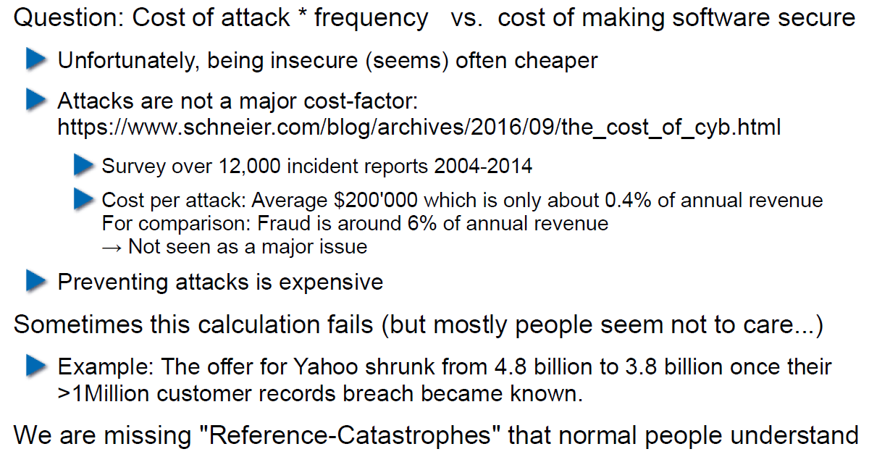

## So, what to do?

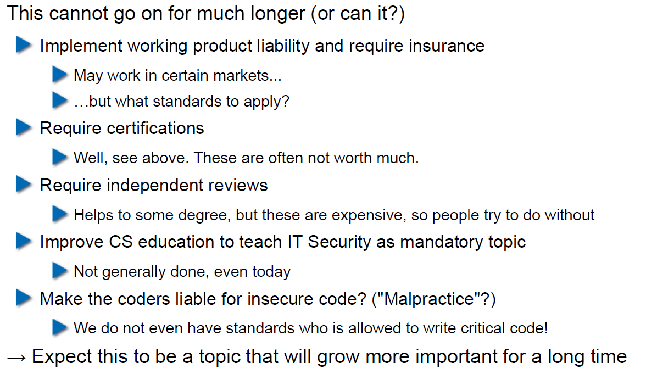

# Woche 5

## Agenda

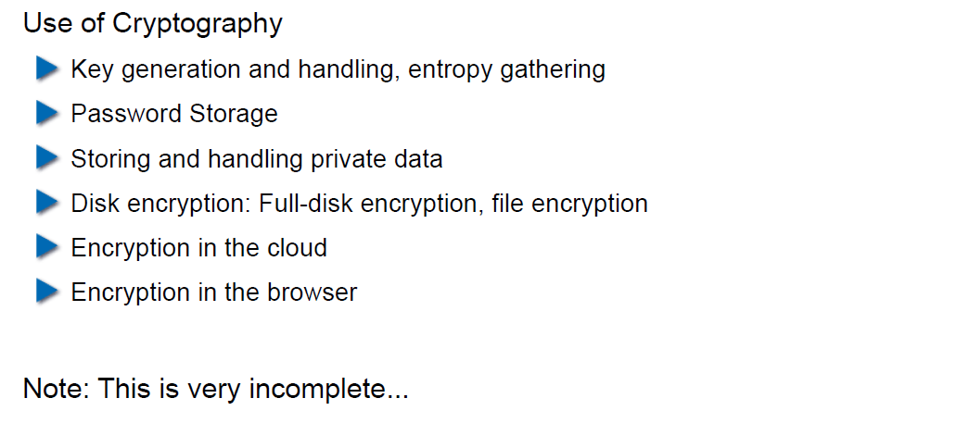

## Generating Cryptographic Keys

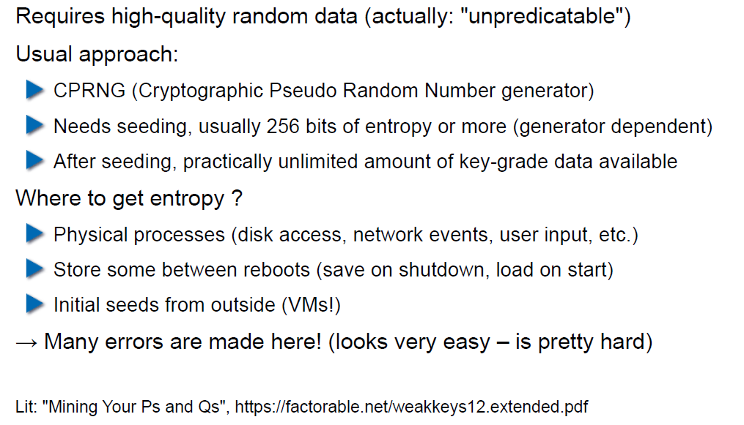

## Information-Theoretical Entropy

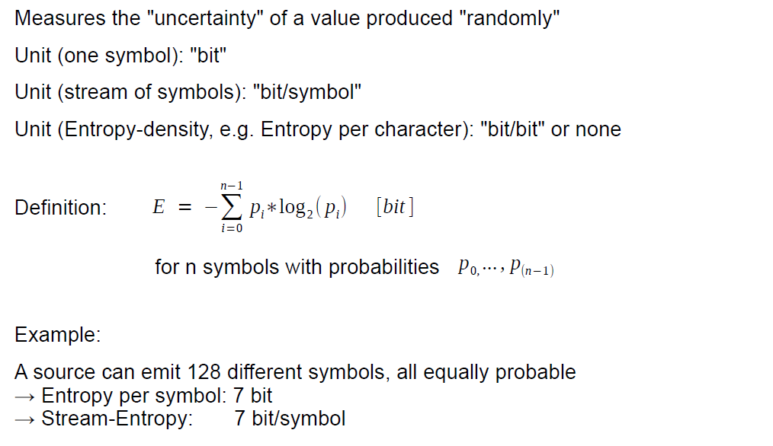

## Estimating Entropy is Tricky

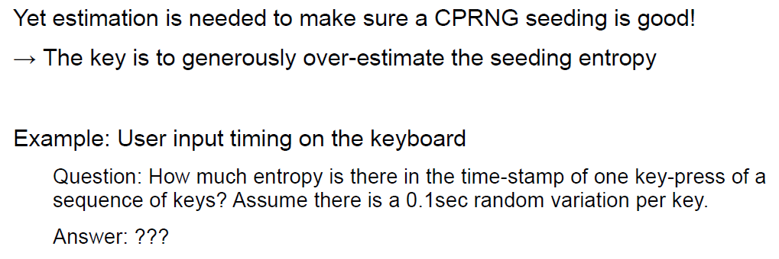

## Seeding a CPRNG

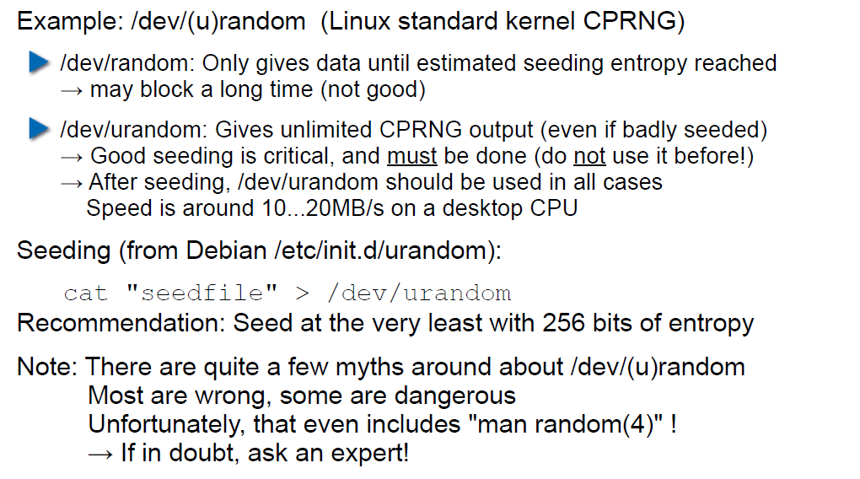

## Bad Seeding Examples

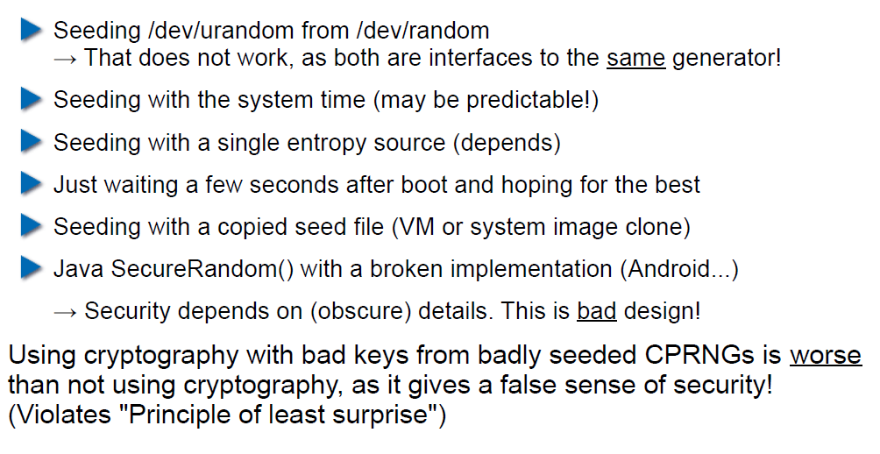

## Storing Cryptographic Keys Securely

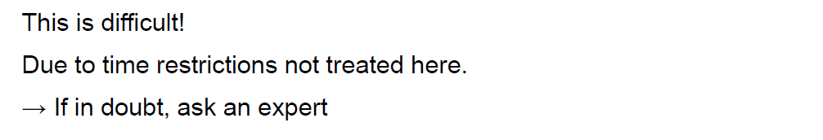

## Storing Passwords

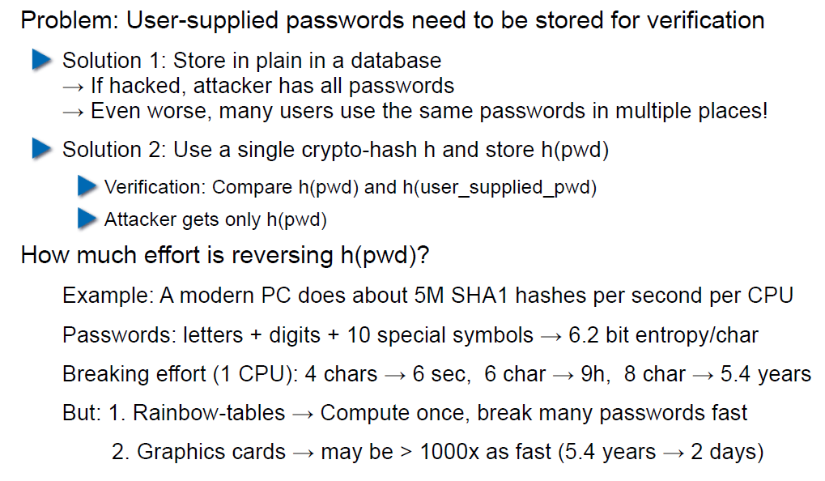

## Rainbow Table

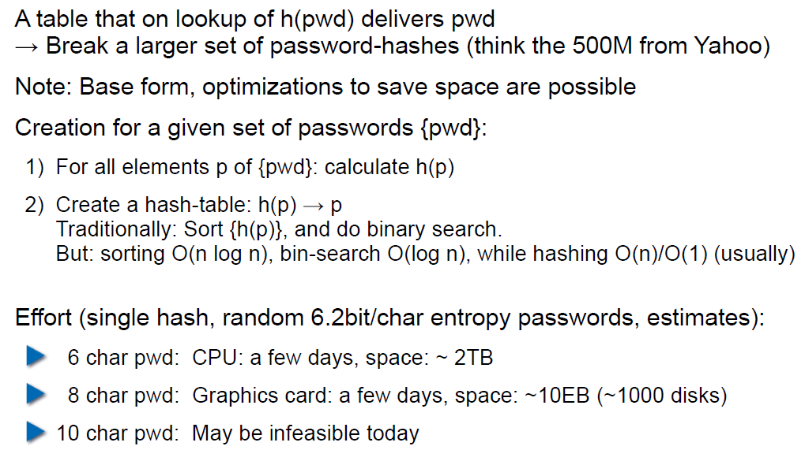

## Storing Passwords

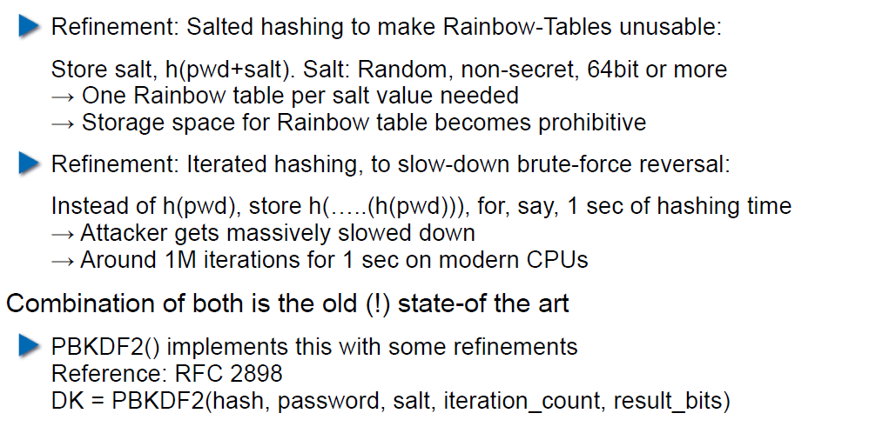

## So What is Wrong with PBKDF2?

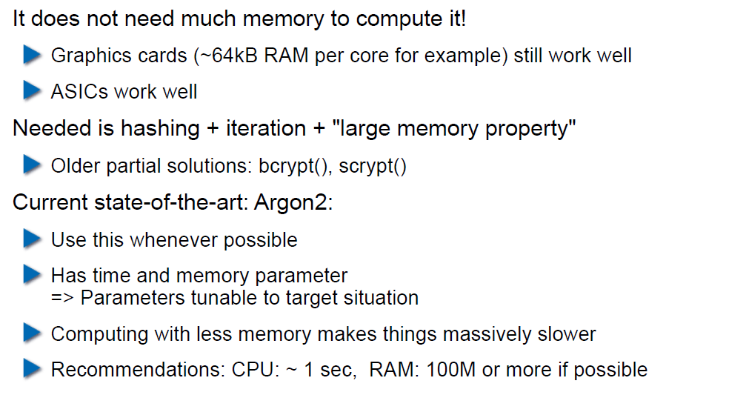

## Hardware RNGs

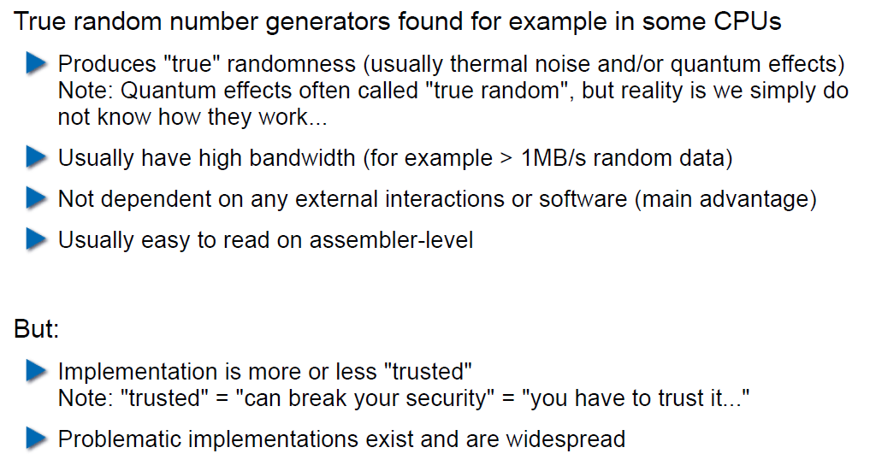

## Example 1: Via C3 Hardware CPRNG Schematic

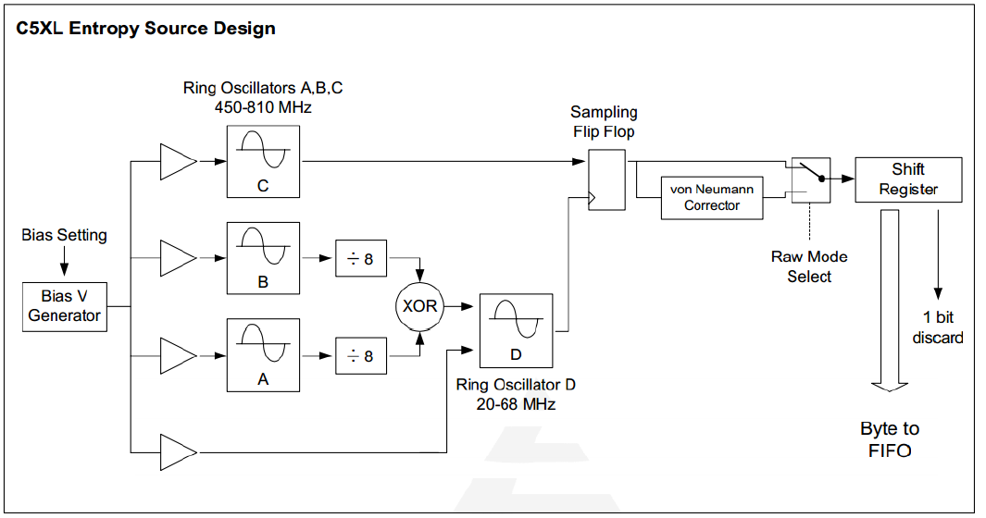

## Example 2: Intel RDRAND Schematic

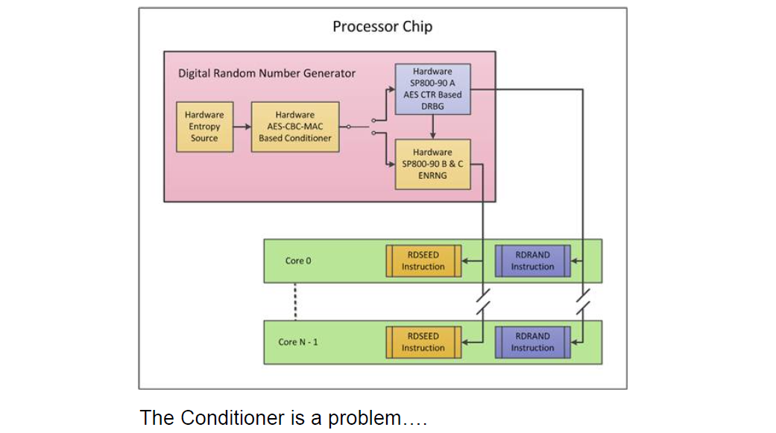

## Compromise on Design-Level

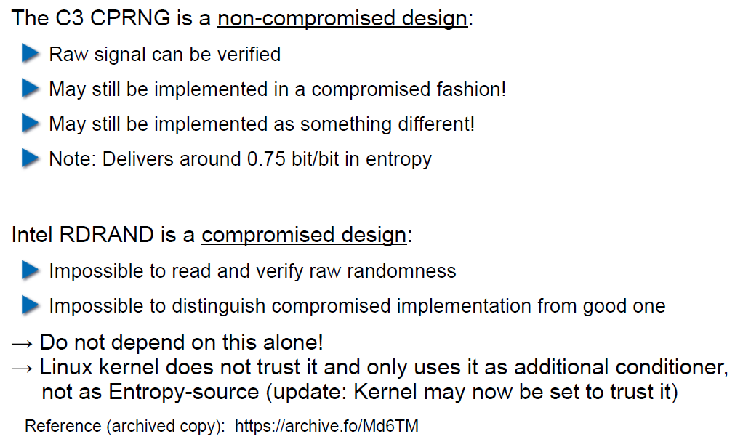

## Storing Private Data (as a Service Provider)

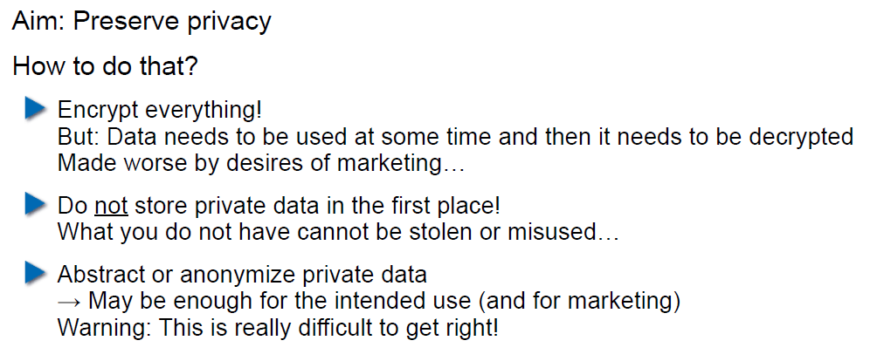

## Disk/Storage Encryption

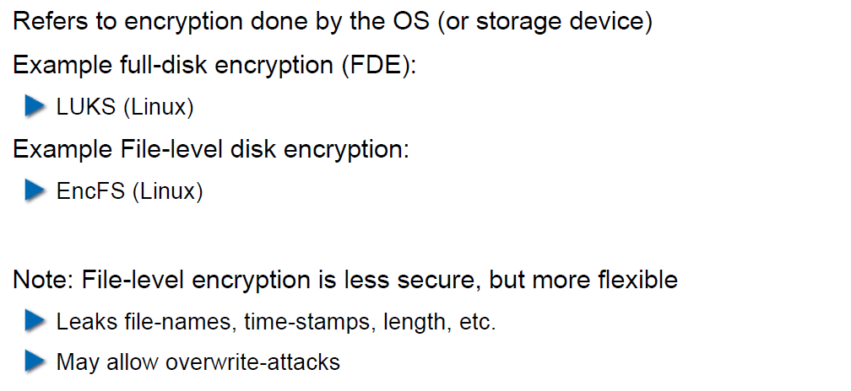

## Disk Encryption Protects Against What?

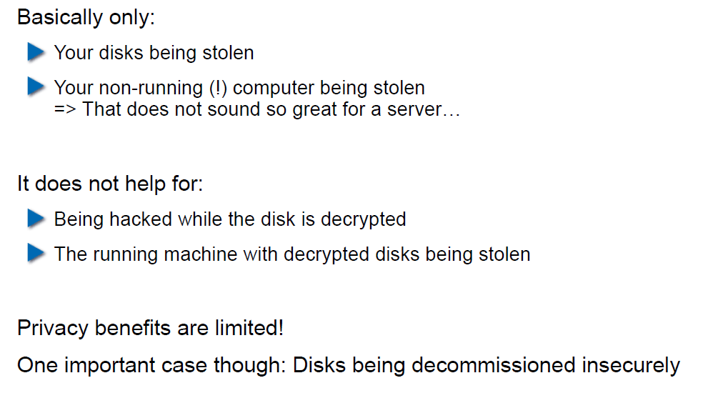

## Decryption Only With User Logged In

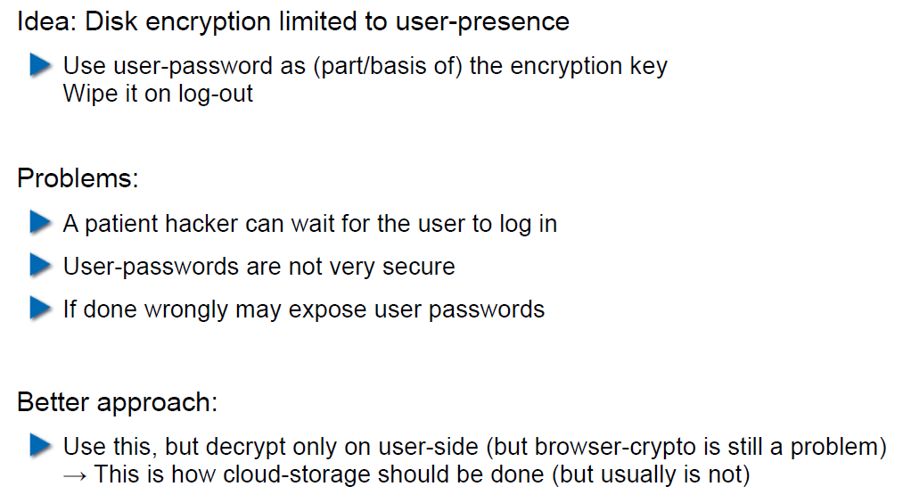

## Encryption in the Cloud

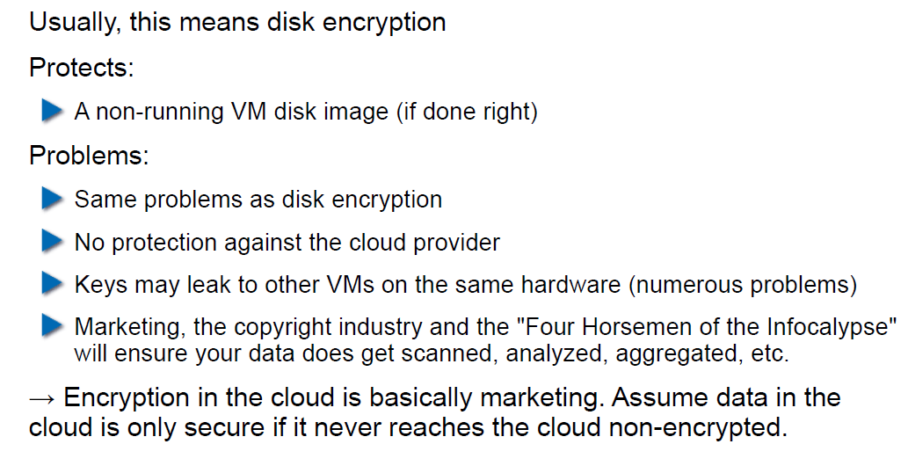

## JavaScript Client-Side Encryption in Web-Apps

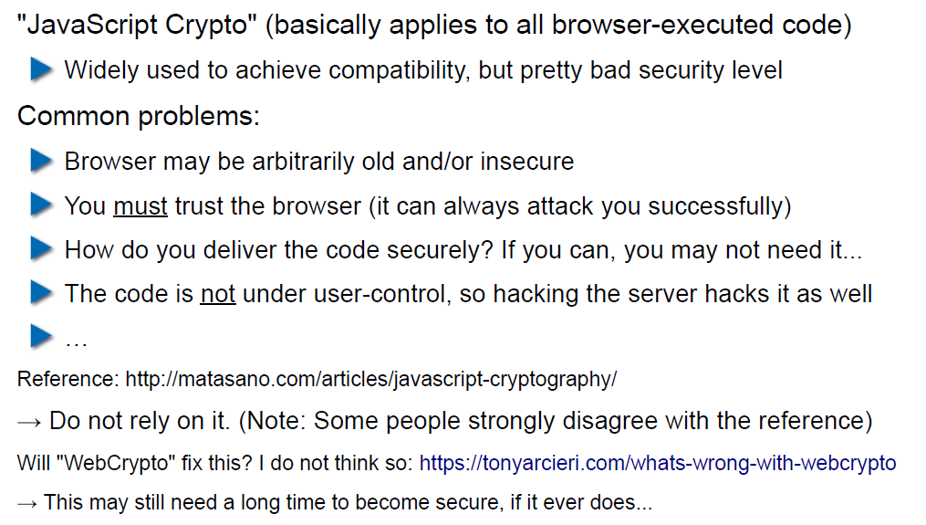

# Woche 6

## Agenda

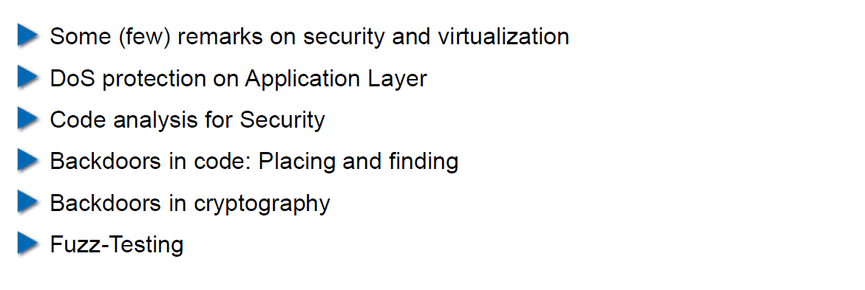

## Virtualization vs. Security

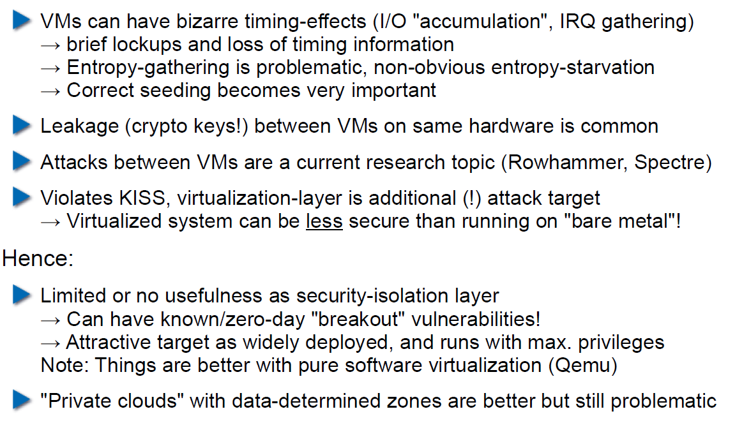

## DoS on Application Layer

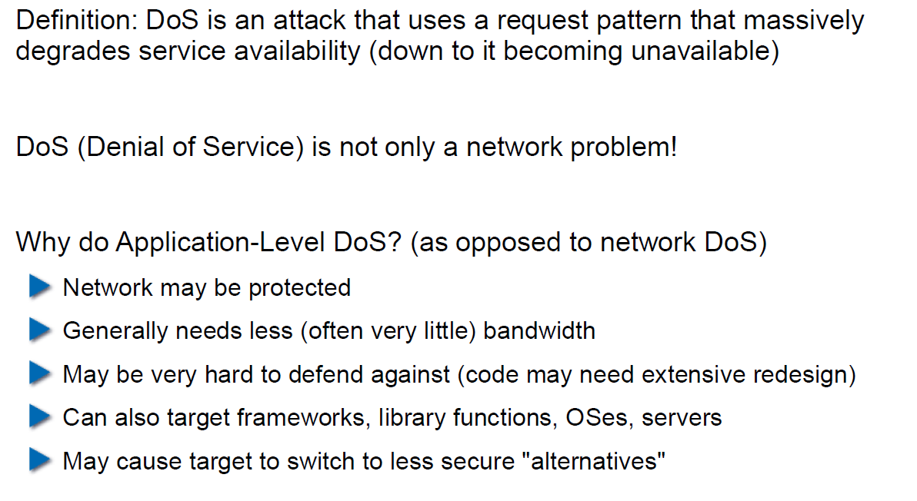

## DoS on Application Layer

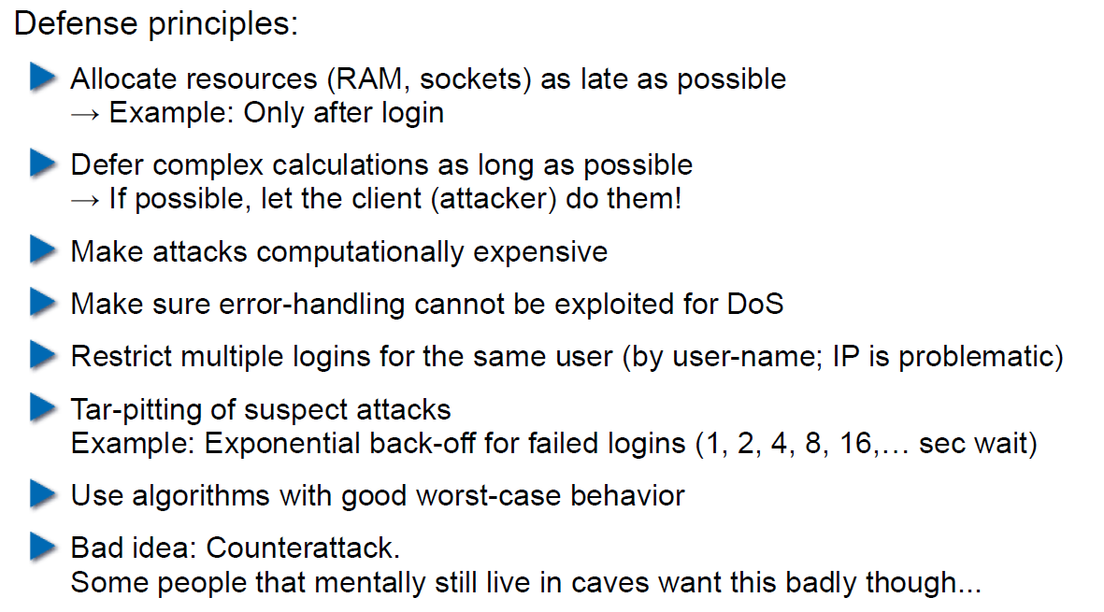

## Code Analysis for Security

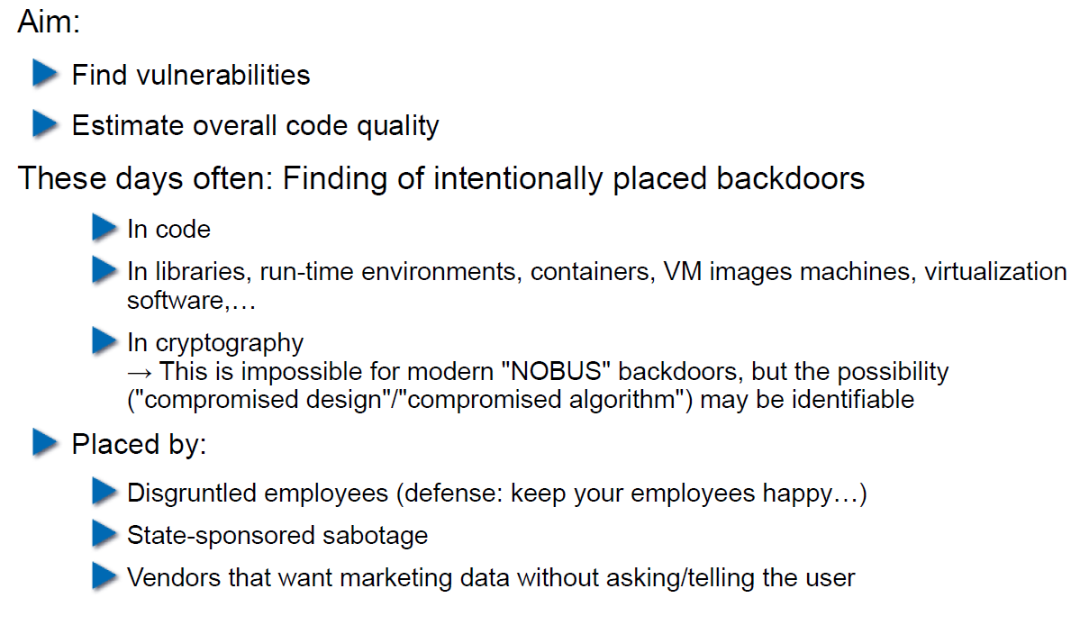

## Backdoors in Code

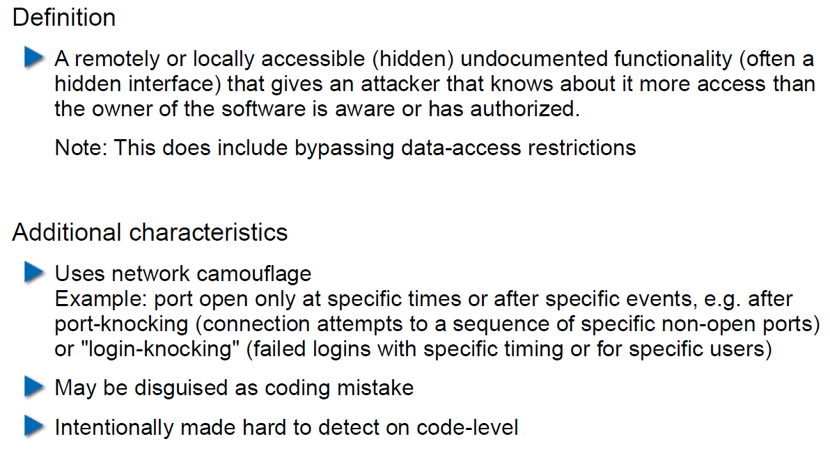

## Backdoor Hiding Techniques

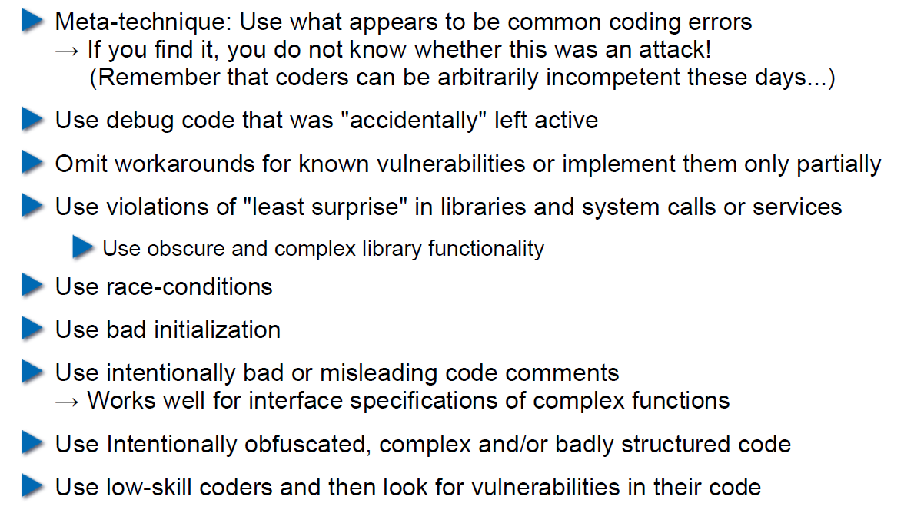

## Finding Backdoors

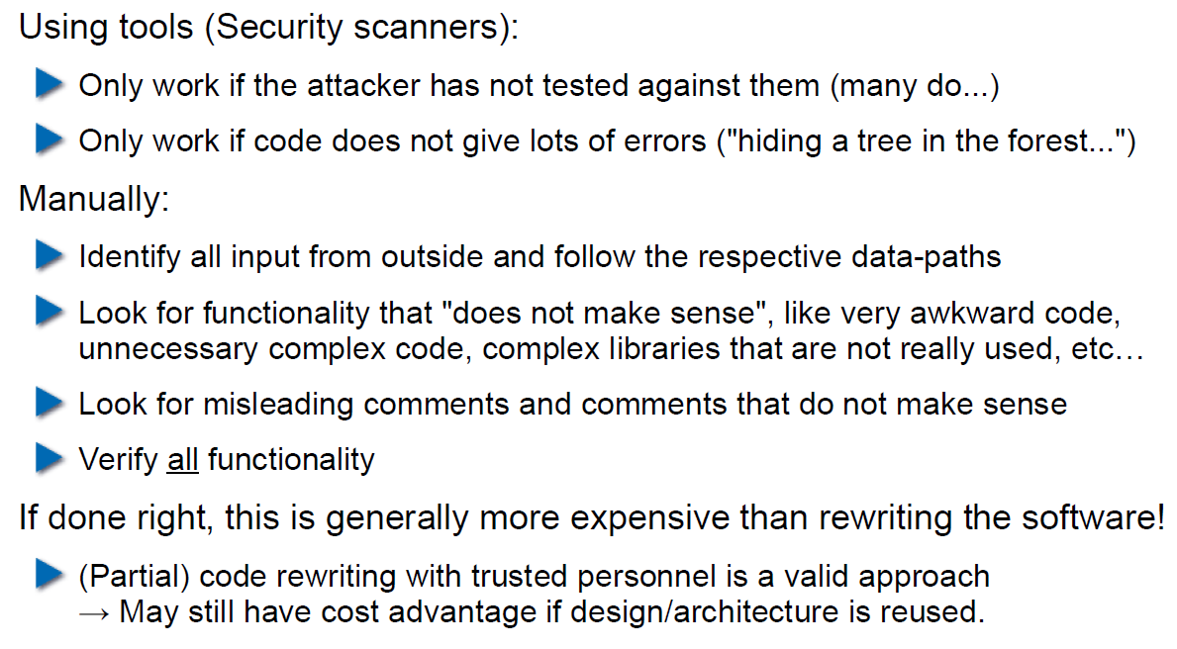

## Backdoors in Cryptography

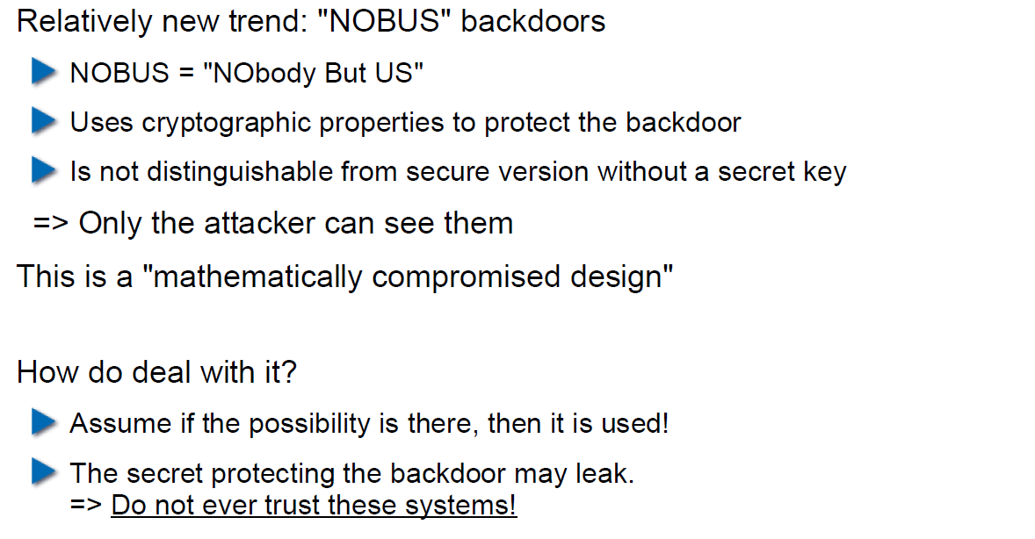

## Example 1: ECC

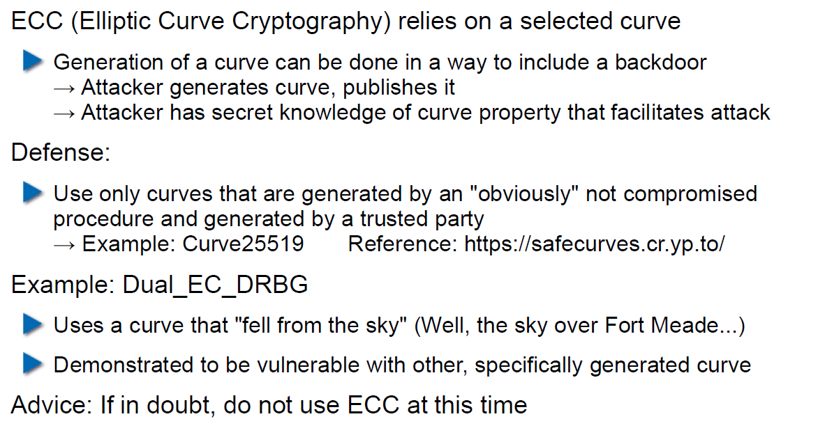

## Example 2: Specially selected Primes for Discreet Logarithms

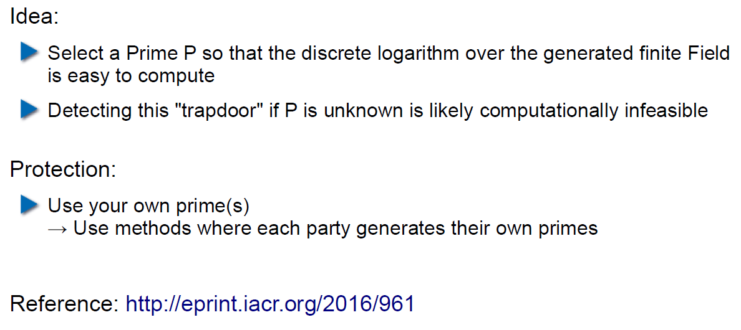

## Fuzz-Testing: The Idea

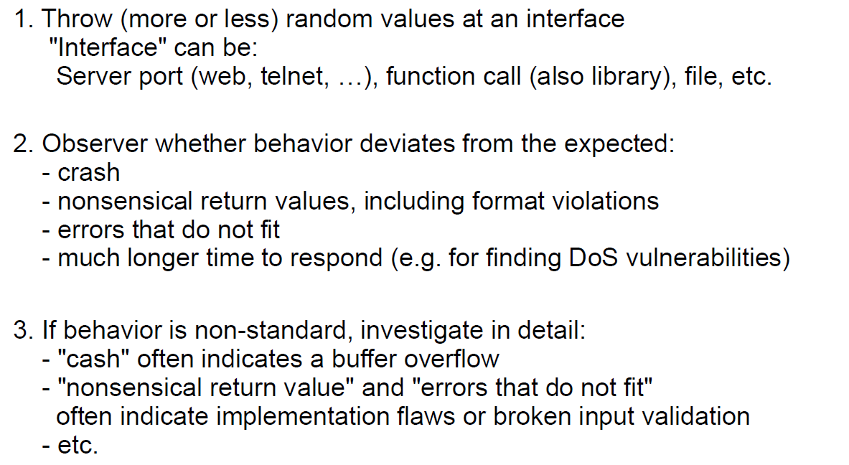

## Possibilities and Limitations

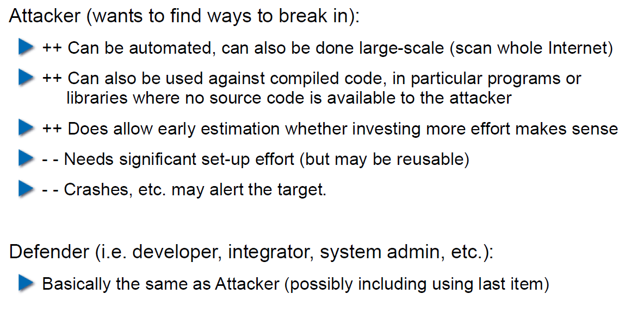

## Structured Fuzzing vs. Random Fuzzing

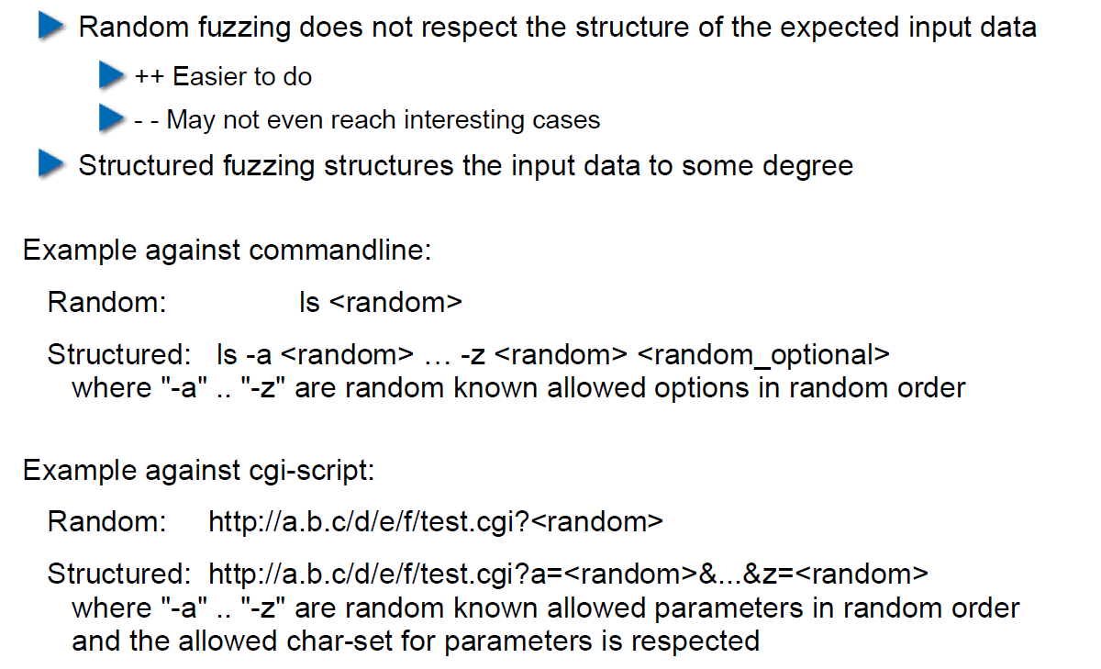

## Fuzzing for Regular Tests

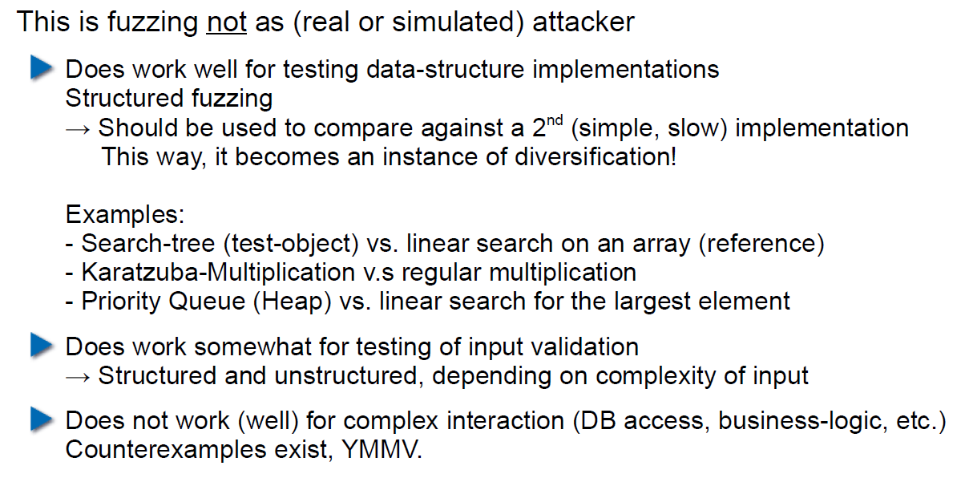

## Useful Fuzzing Tools

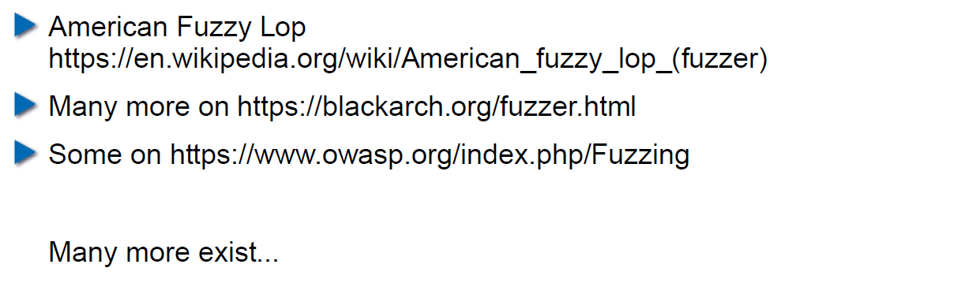

# Woche 7

## Agenda

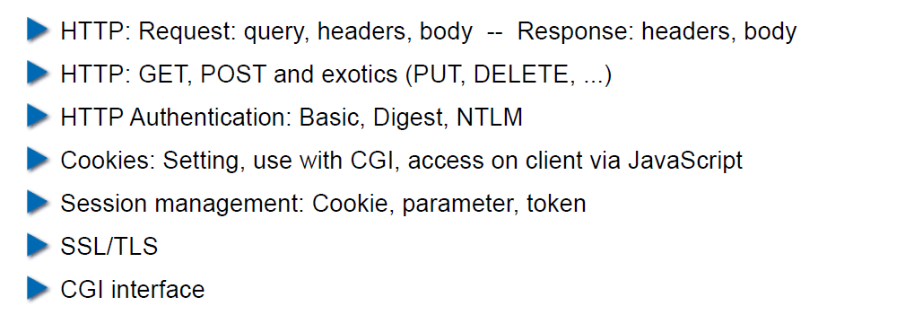

## Example Request in the TCP/IP Model

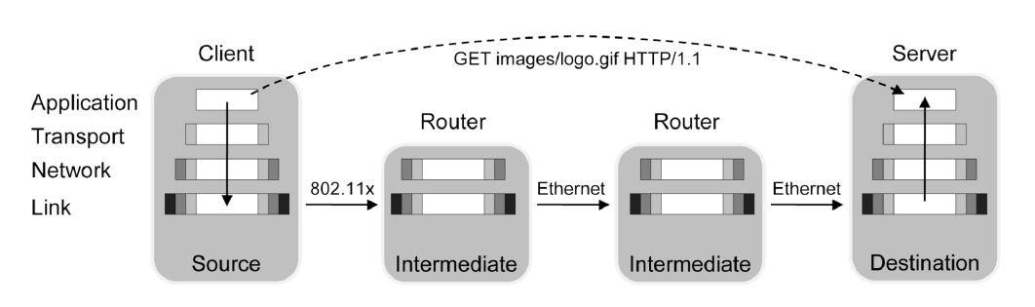

## HTTP

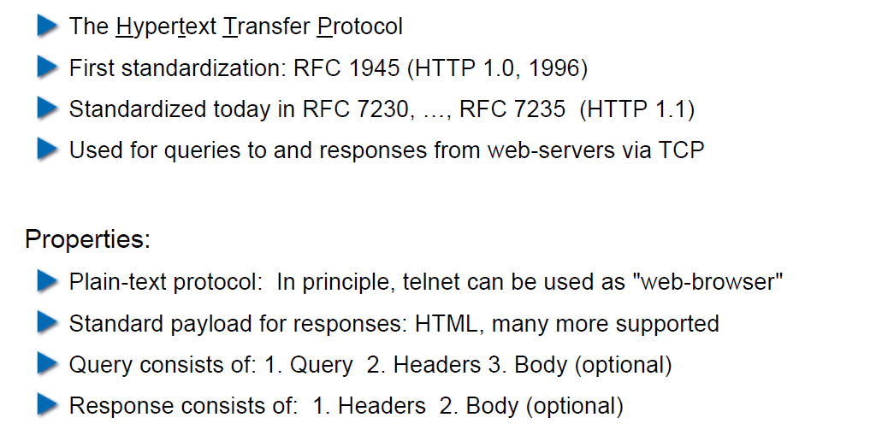

## HTTP Request Example: GET

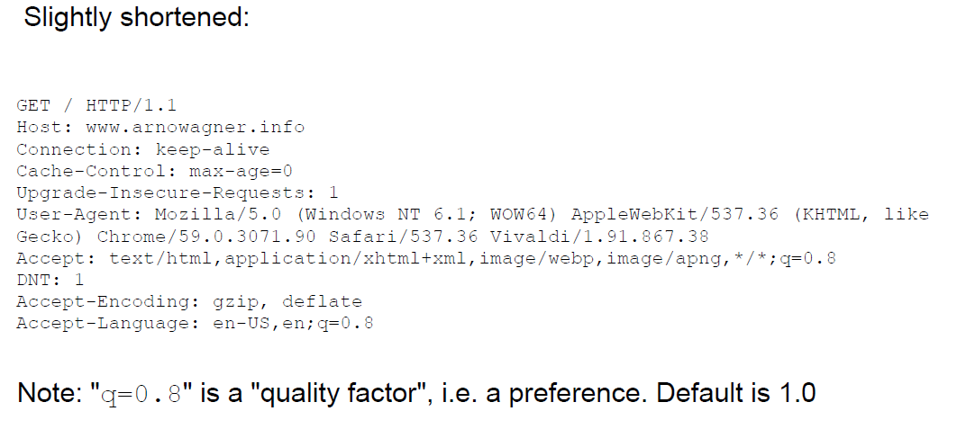

## HTTP Request Example: POST

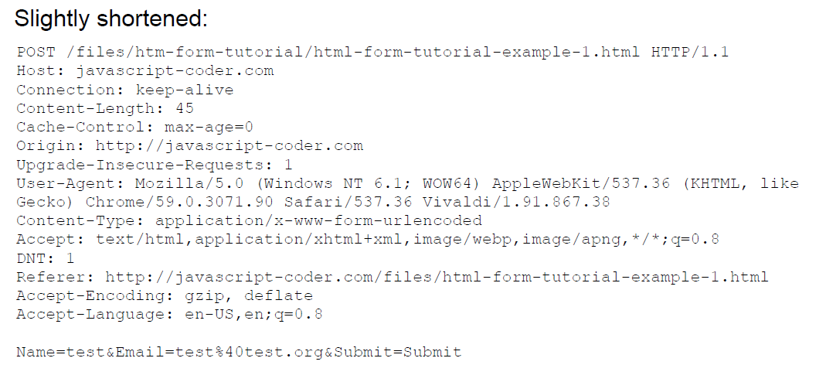

## HTTP Response Example

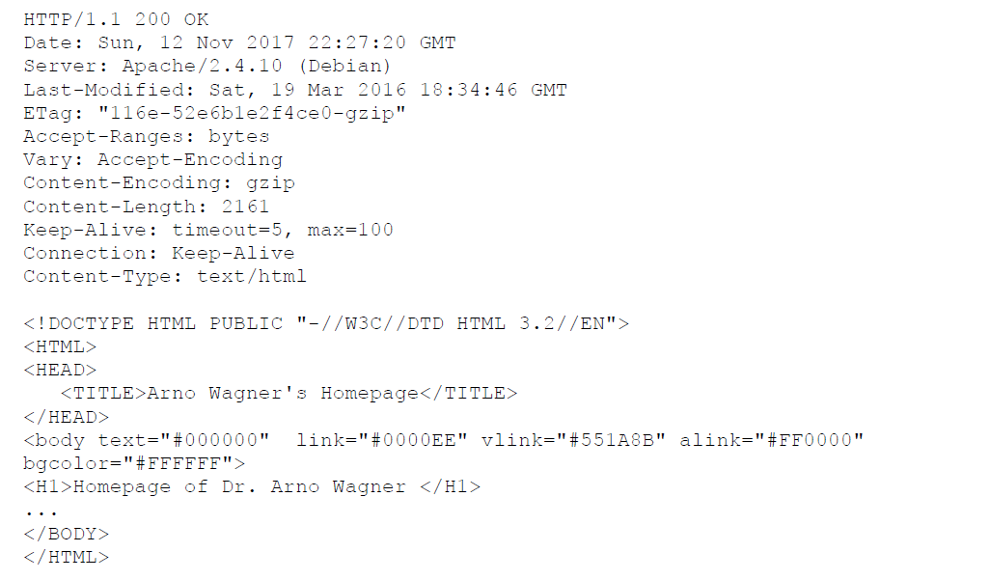

## Exotic Requests: PUT, DELETE, ...

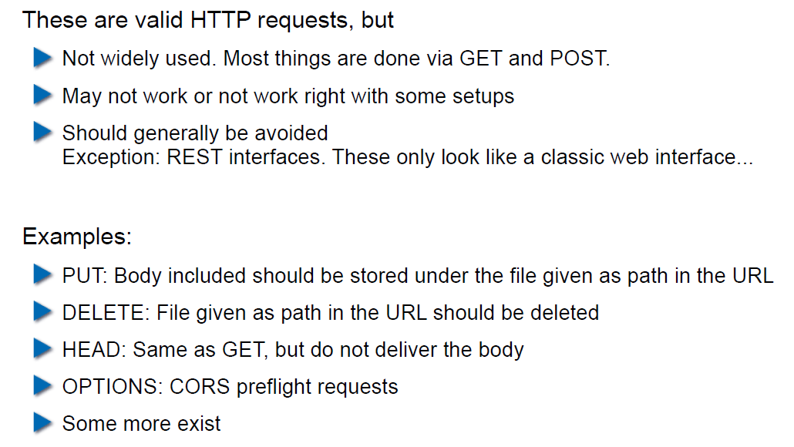

## HTTP Authentication

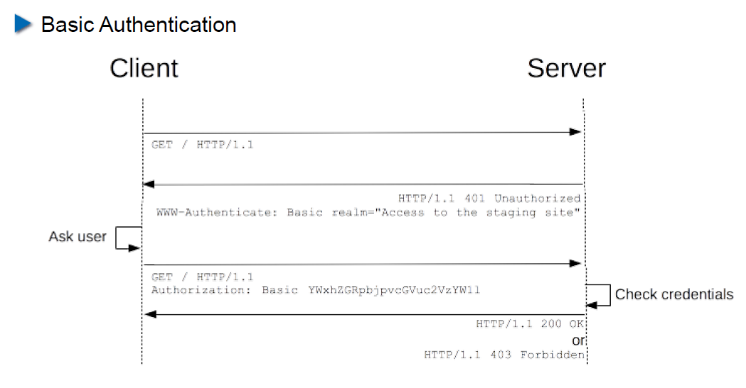

## HTTP Authentication

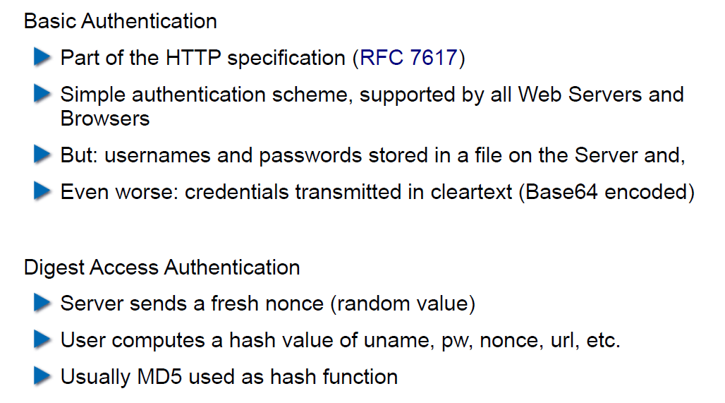

## Cookies

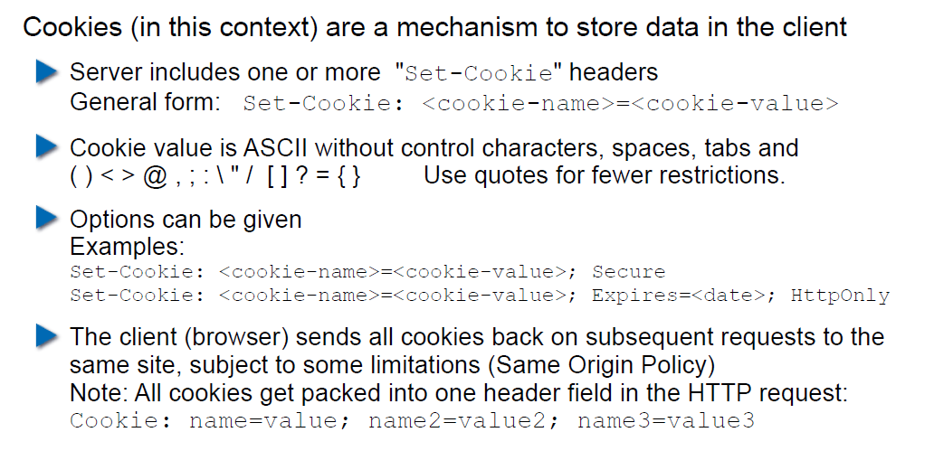

## Cookie Options

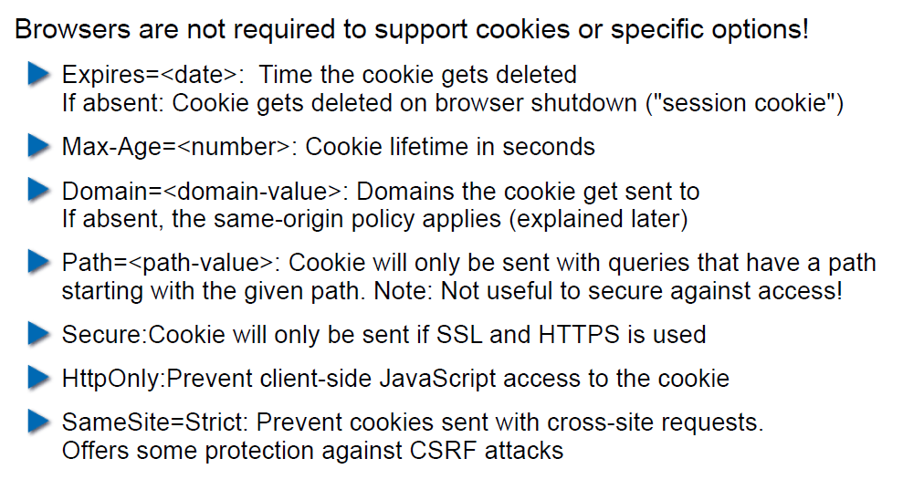

## Cookies: Access via JavaScript

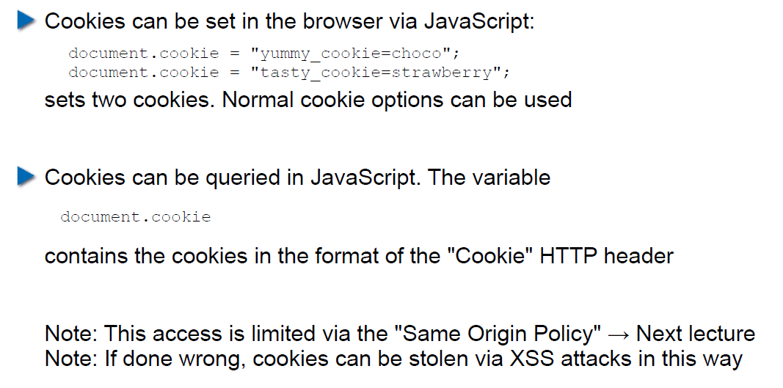

## Session Management

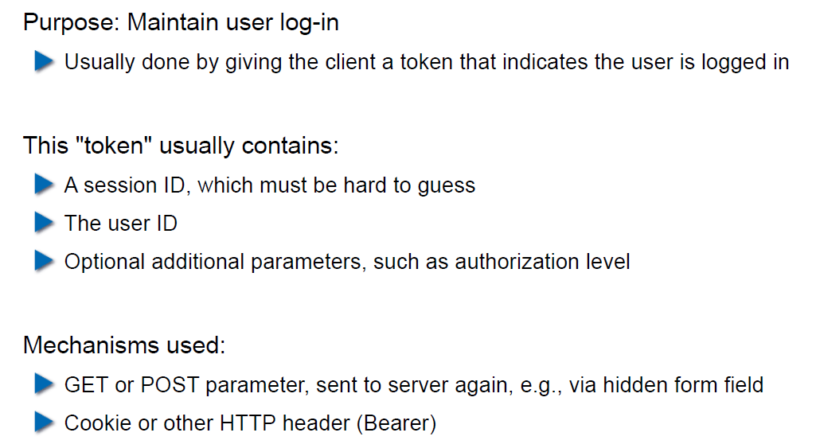

## Security Problems with Session Management

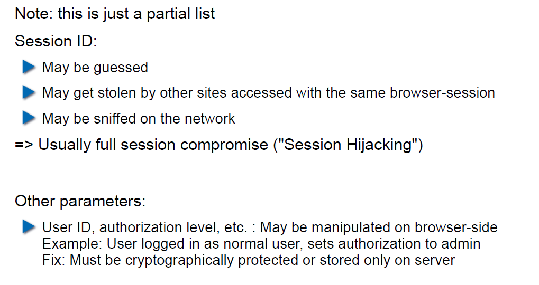

## Keeping State Securely on Client-Side

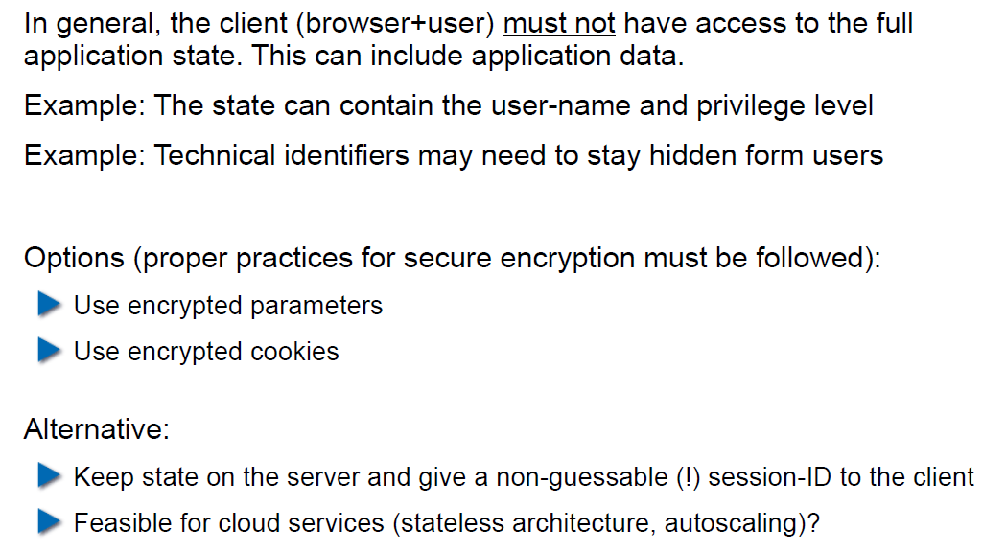

## Remark: Cookies and Application Paths vs. Proxies

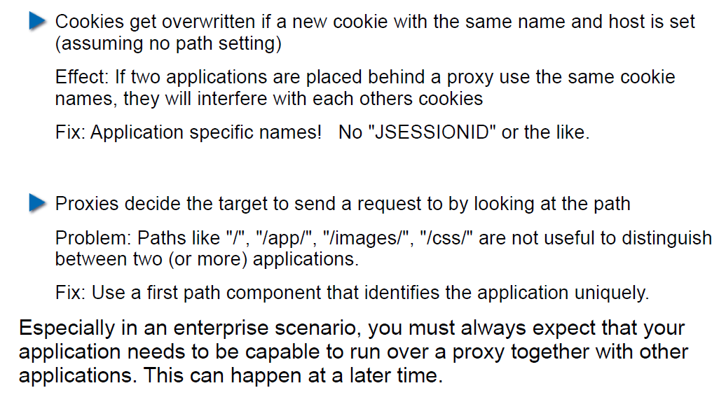

## SSL/TLS

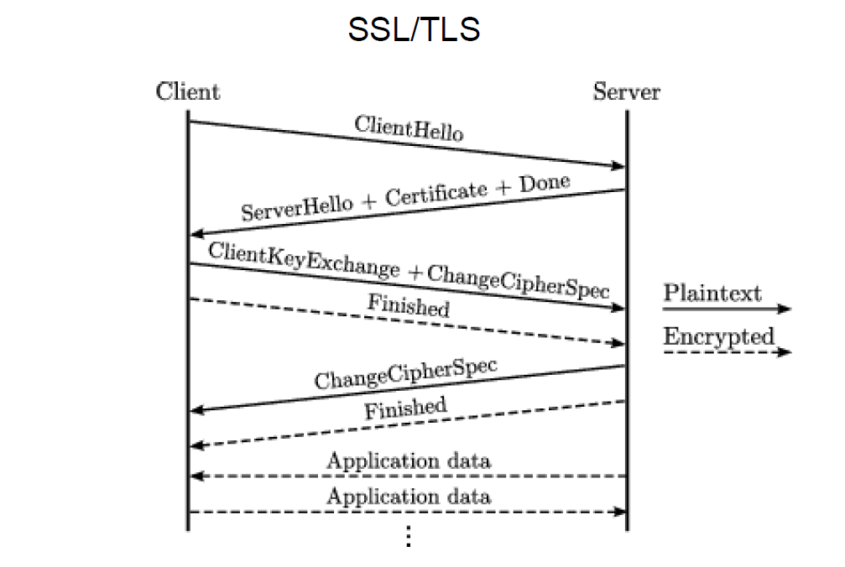

## SSL/TLS

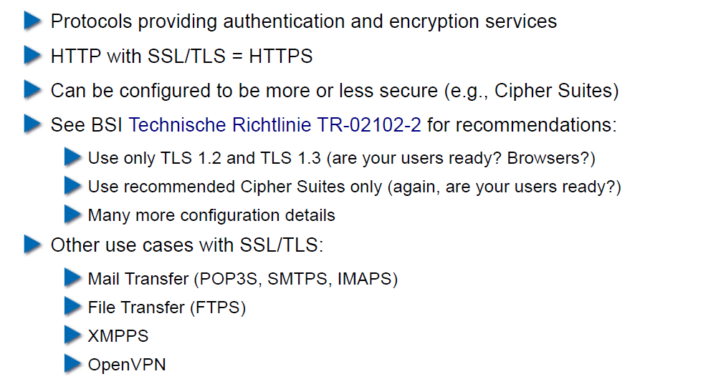

## CGI: General Idea

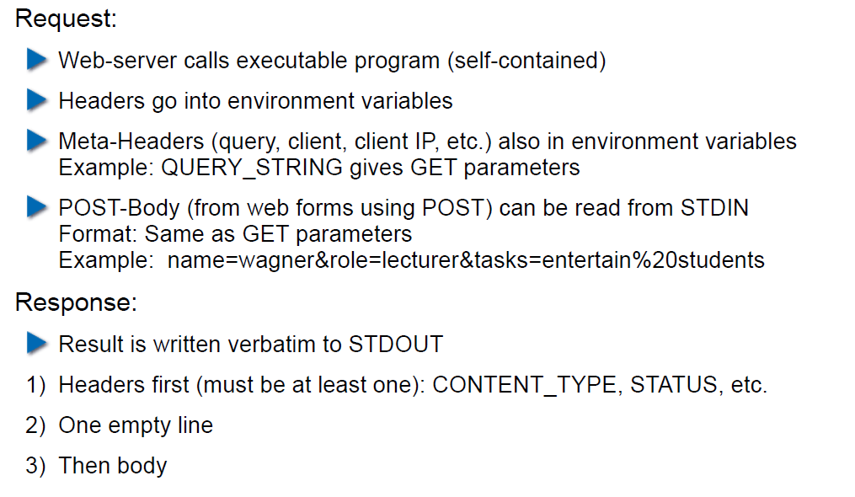

## CGI Scripts in Different Languages

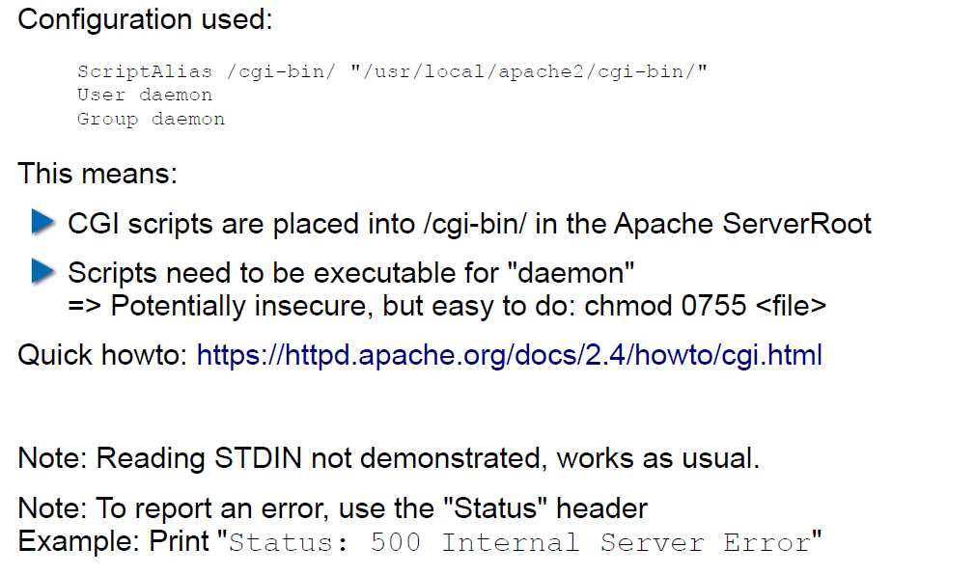

## CGI in BASH

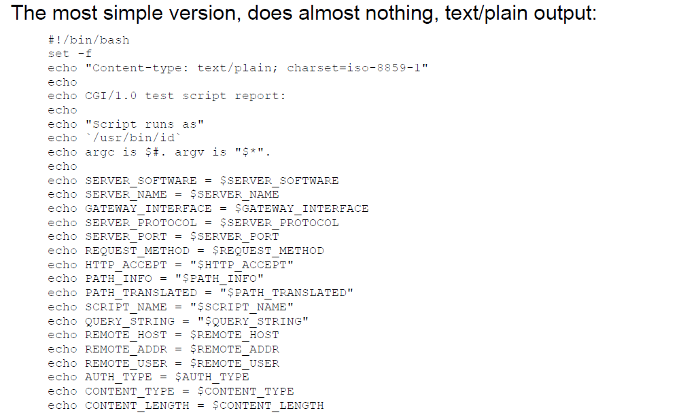

## CGI in BASH: Output

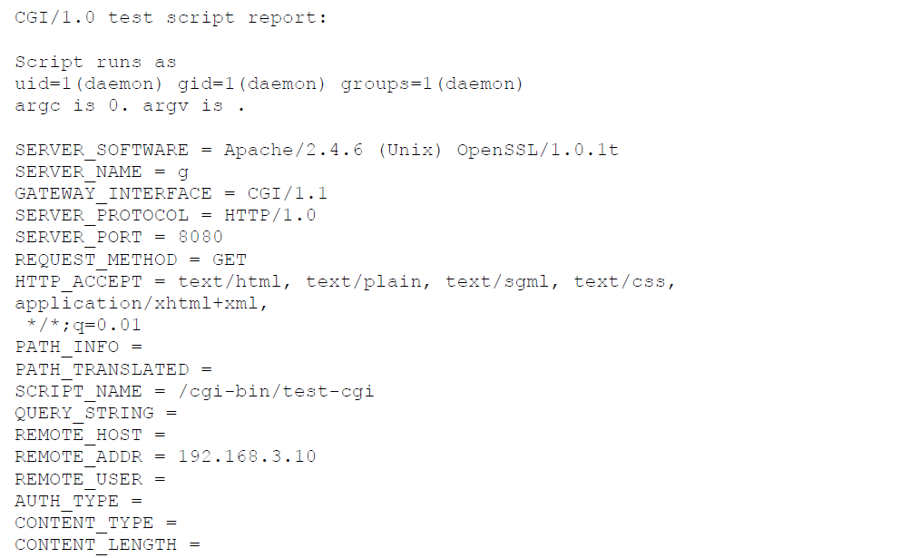

## CGI in Perl

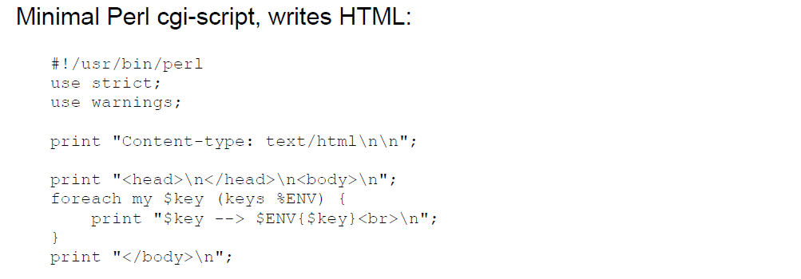

## CGI in Perl: Output

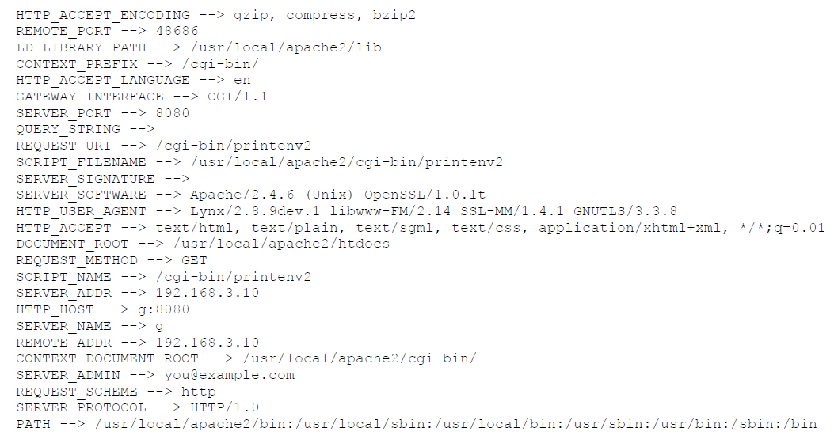

## CGI in C

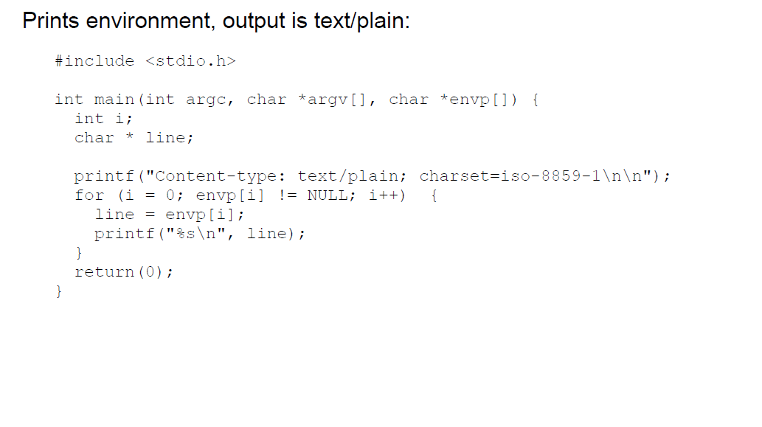

## CGI in C: Output

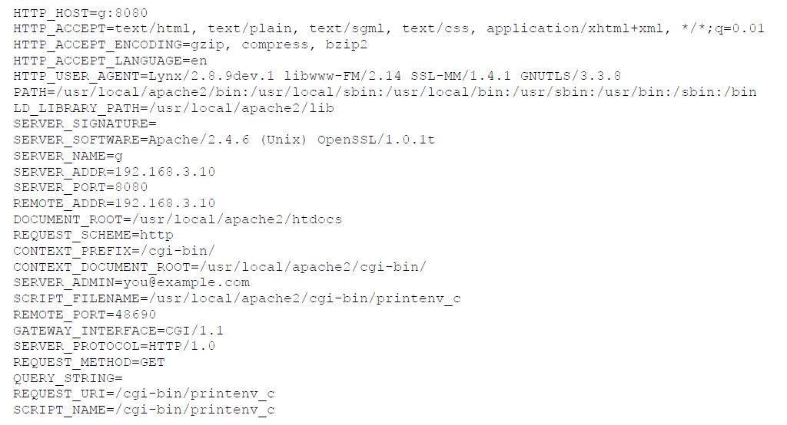

## CGI in Java

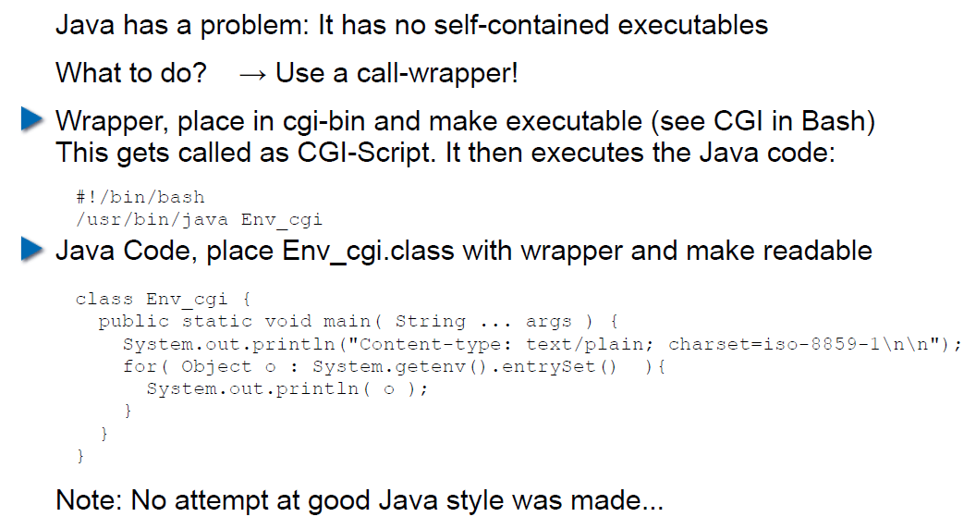

## CGI Security

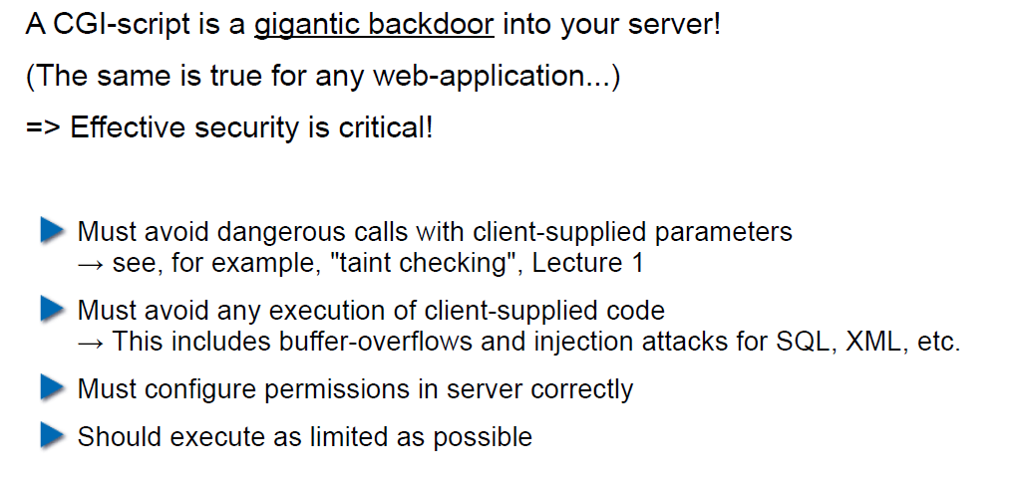

# Woche 8

## Dates

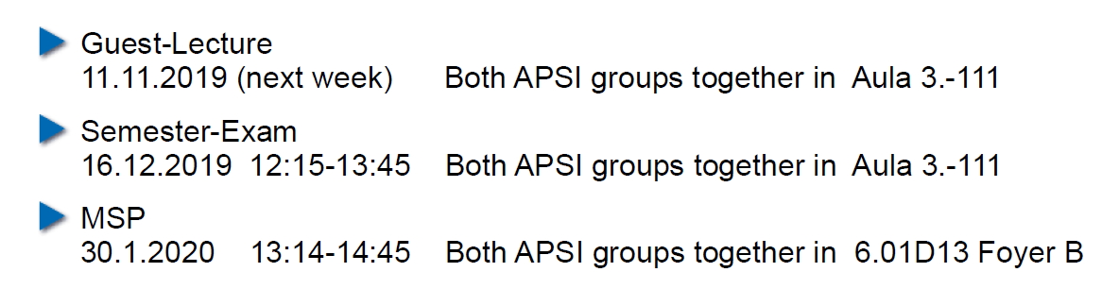

## 11.11.19: Guest Speaker about WAF

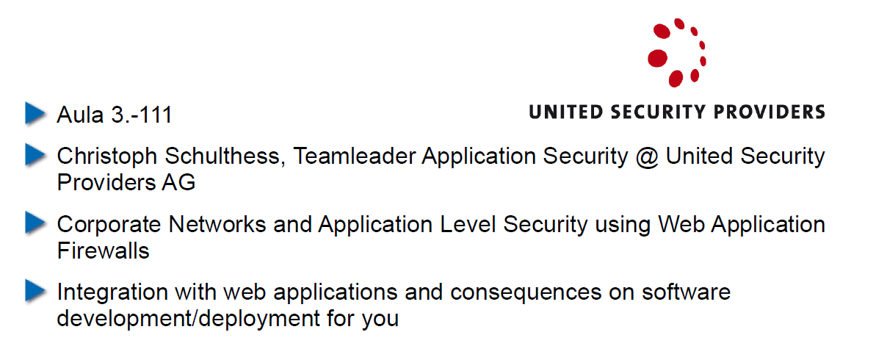

## Agenda

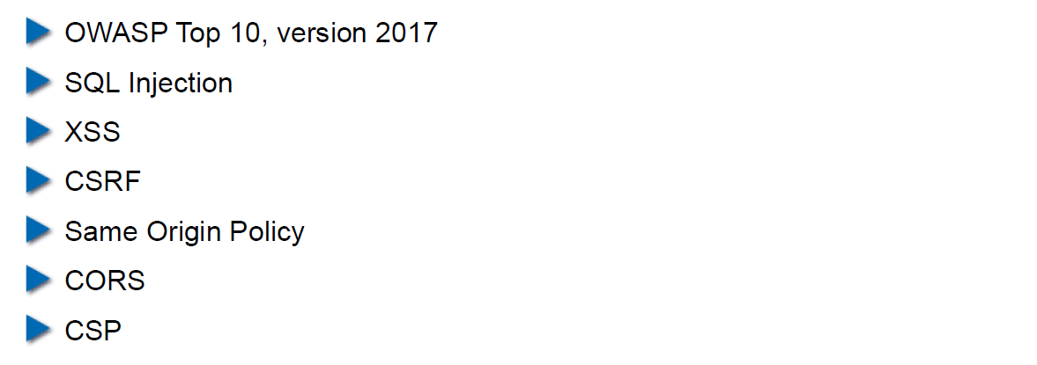

## OWASP – Open Web Application Security Project

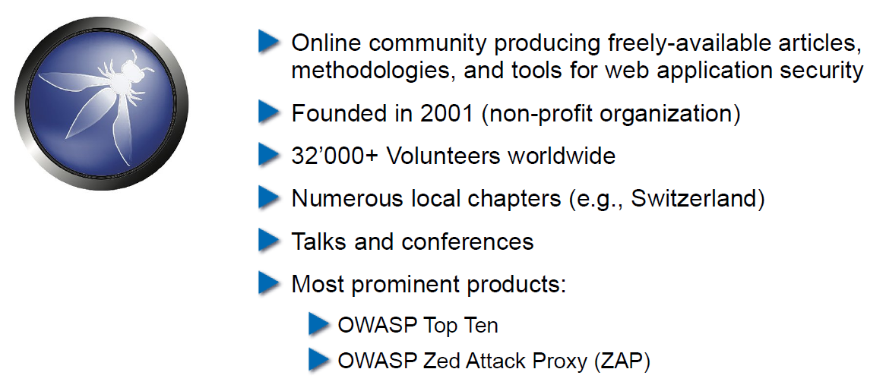

## OWASP Top Ten

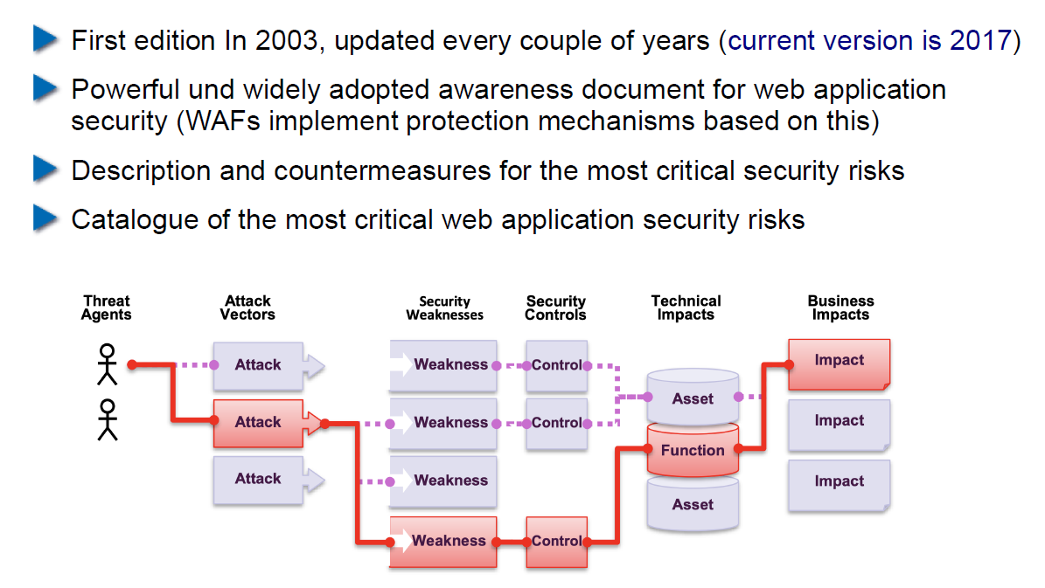

## OWASP Top Ten

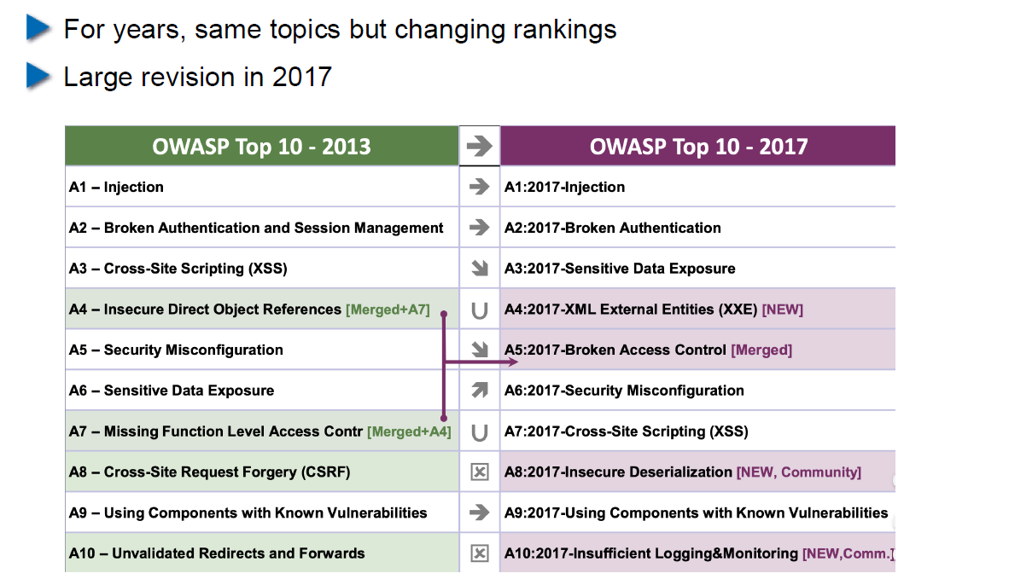

## Cross-Site Scripting (XSS): Cookie Theft

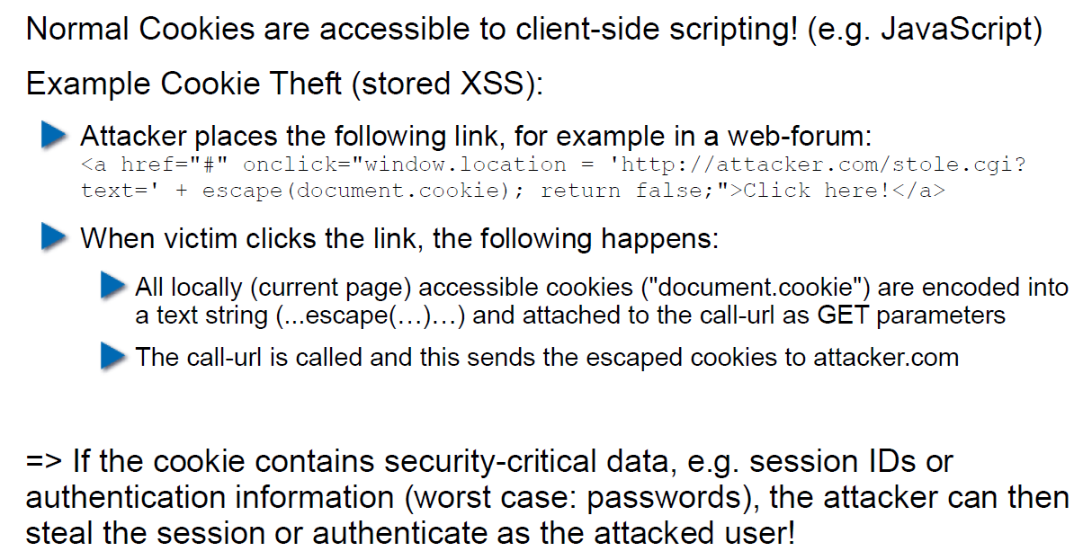

## Stored XSS Countermeasures

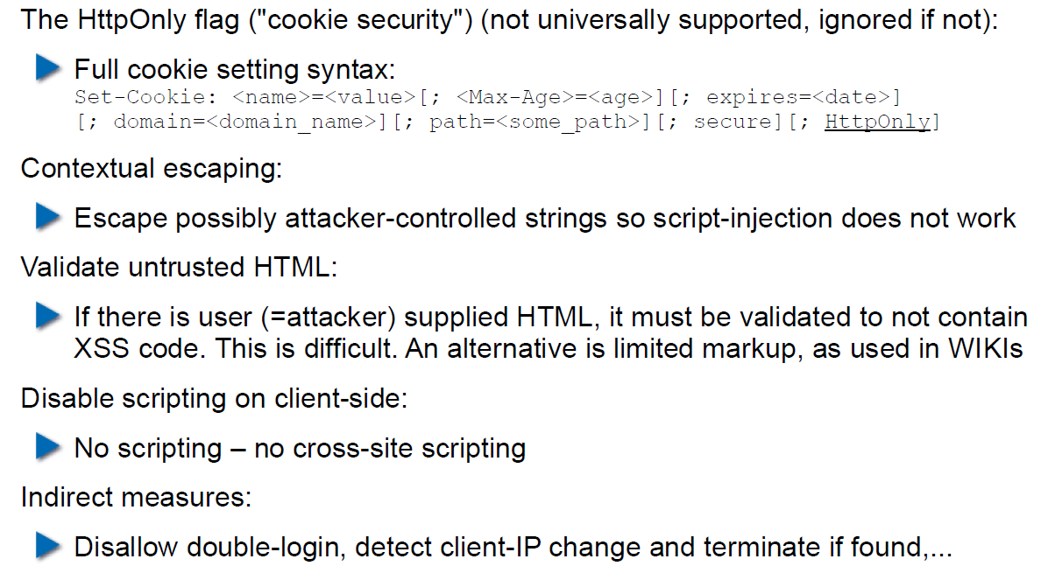

## Reflected XSS

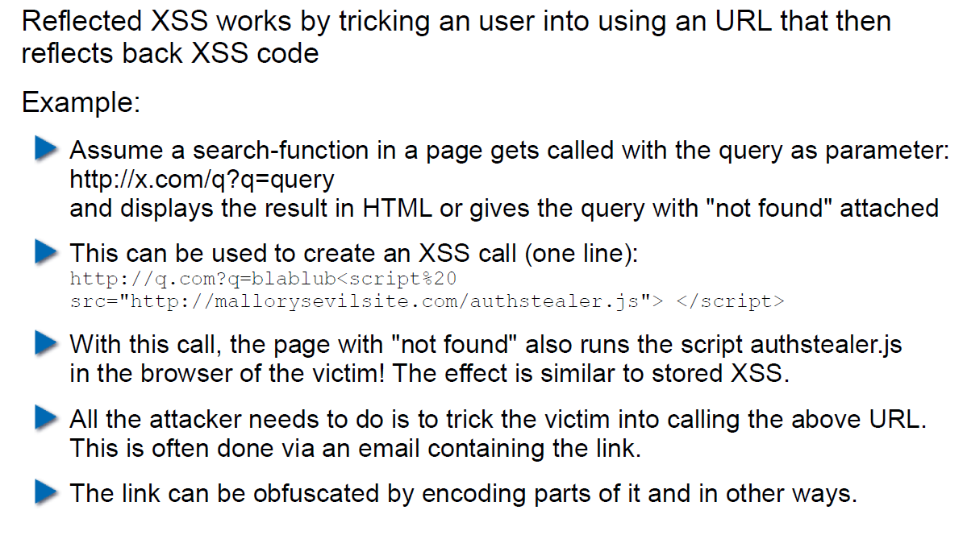

## Defense Against Reflected XSS

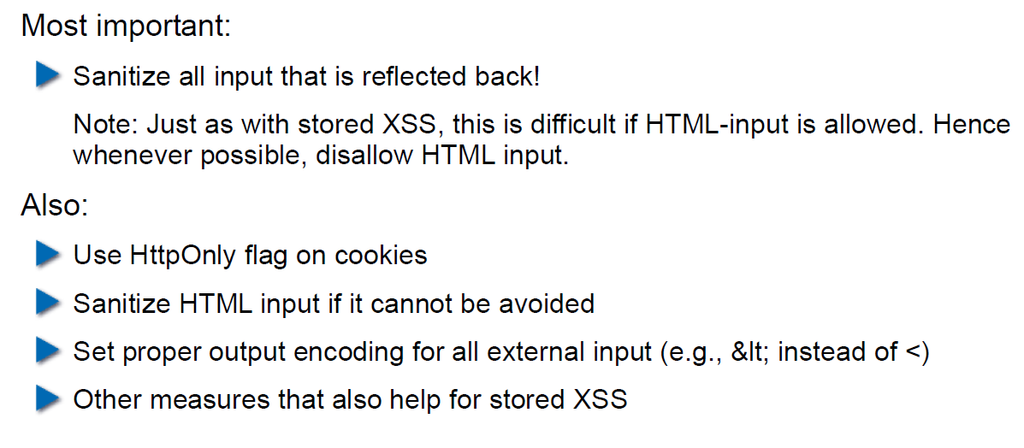

## Cross Site Request Forgery (CRSF)

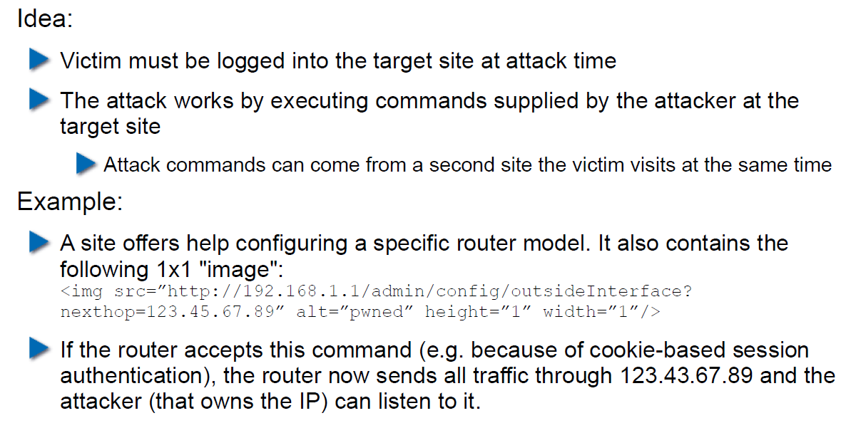

## CRSF Example 2

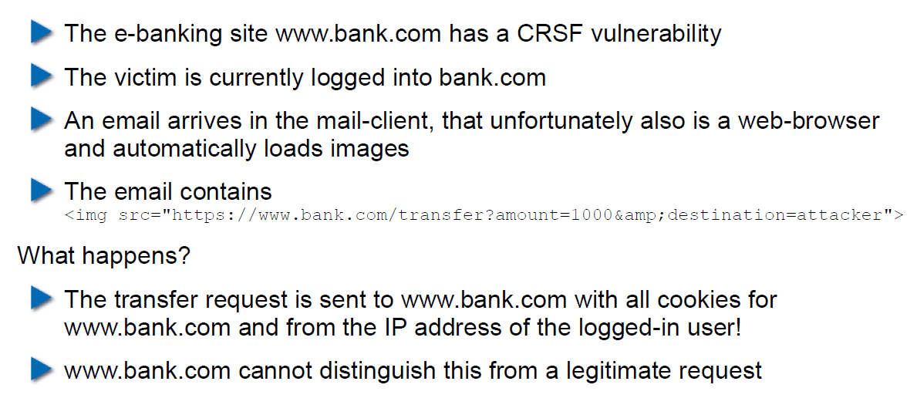

## CRSF Countermeasures

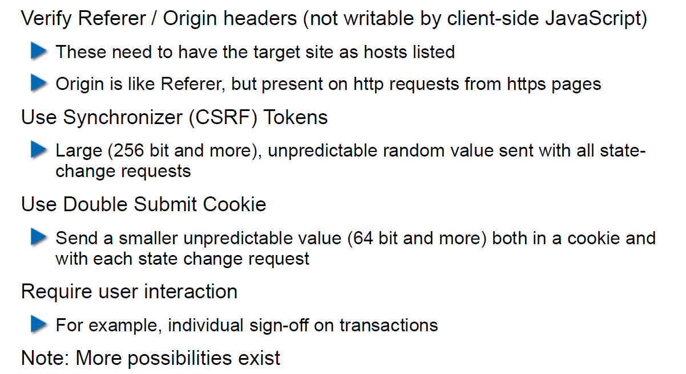

## Same-Origin Policy

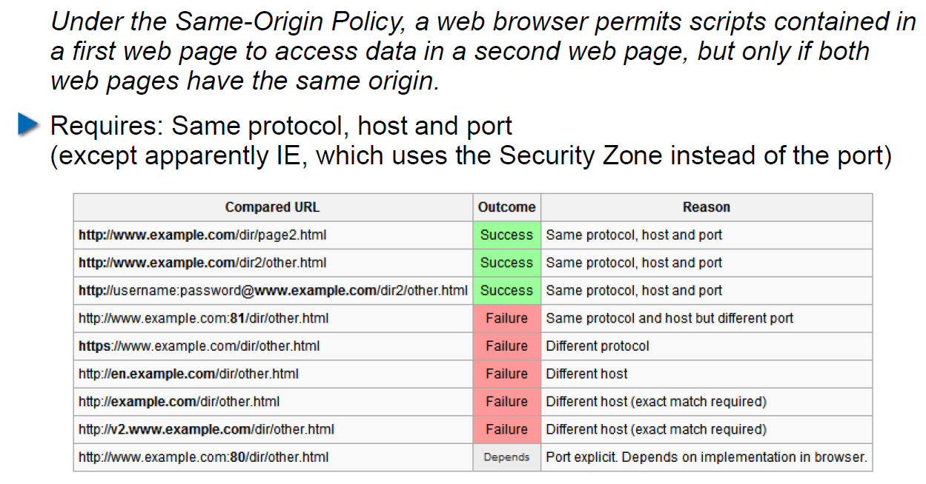

## Cookies and Same Origin

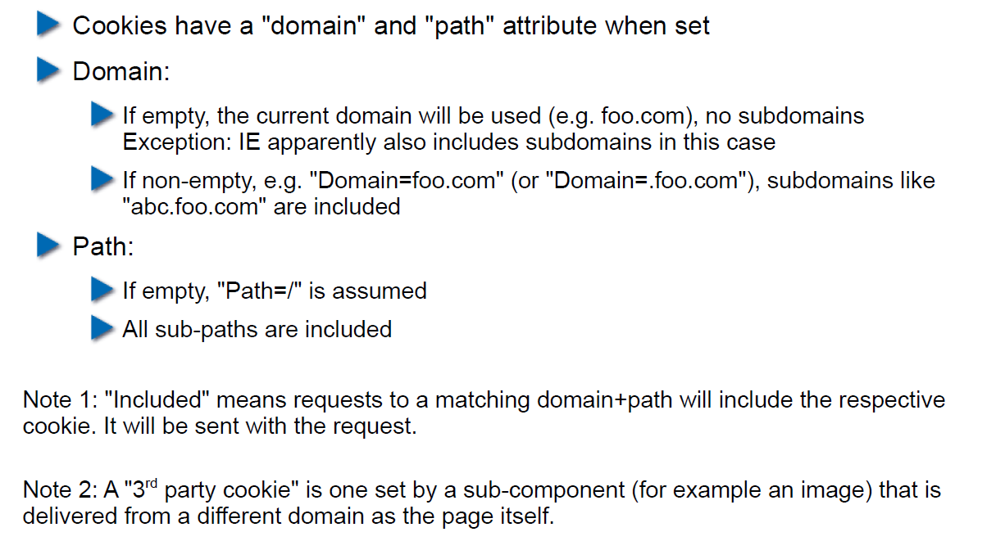

## Same Origin Policy (SOP) and its Limits

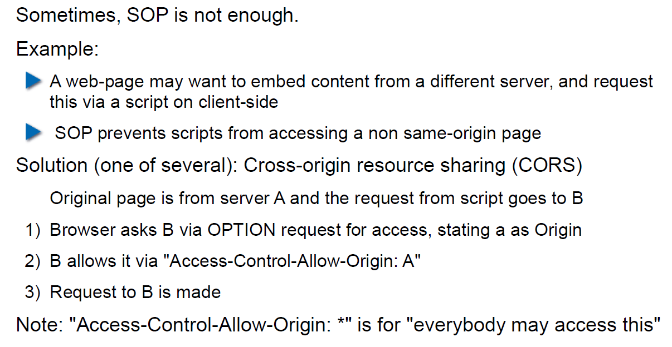

## CORS Overview

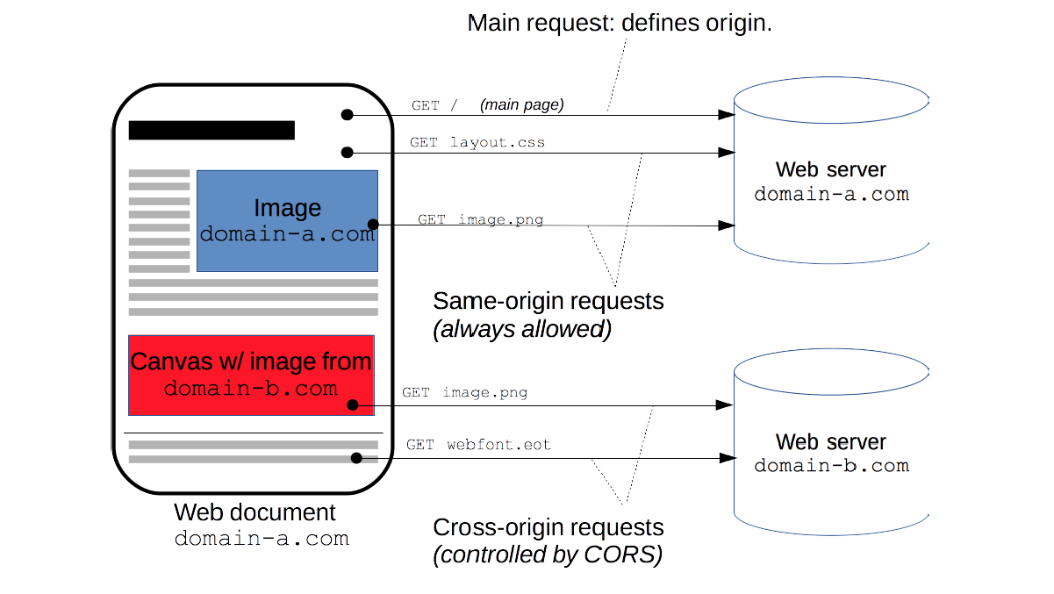

## CORS Preflight Requests

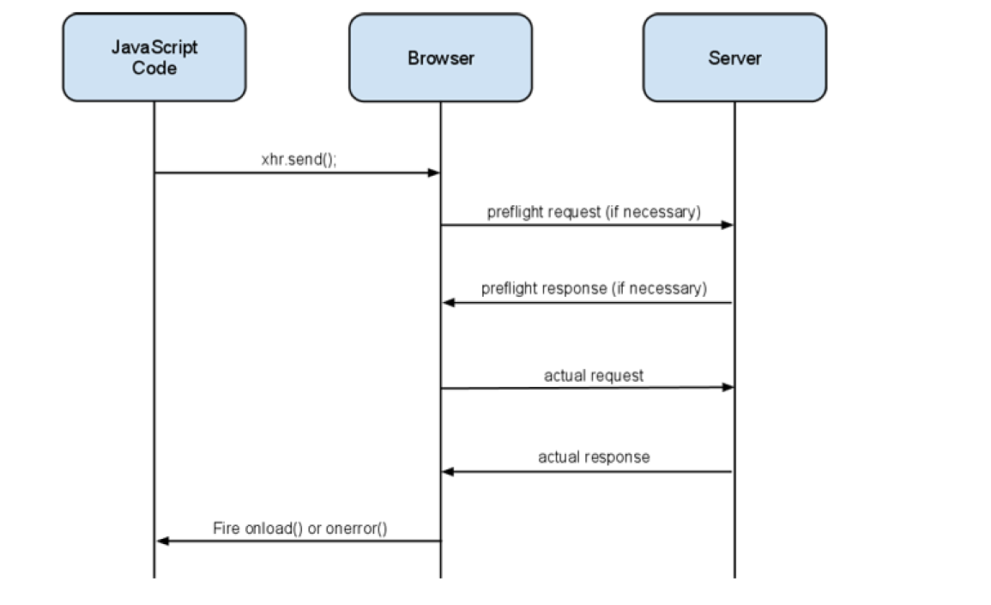

## CORS Example (slightly abbreviated)

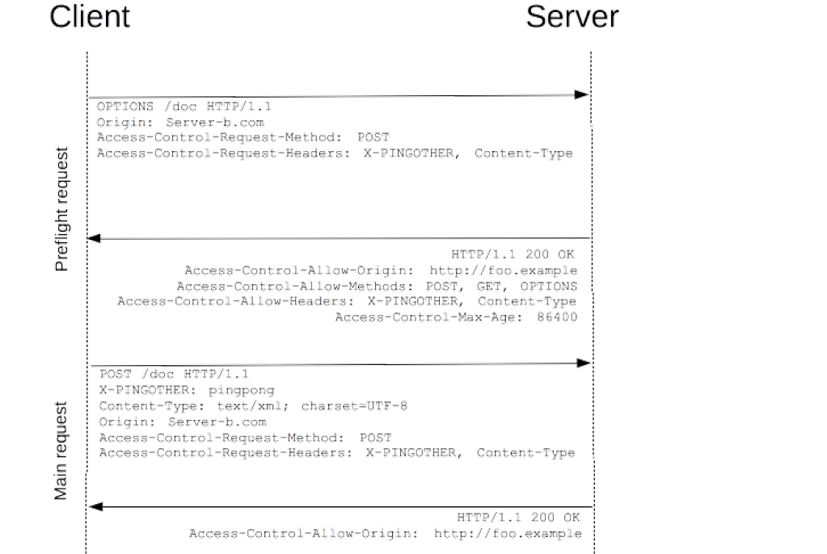

## CORS for Multiple Domains

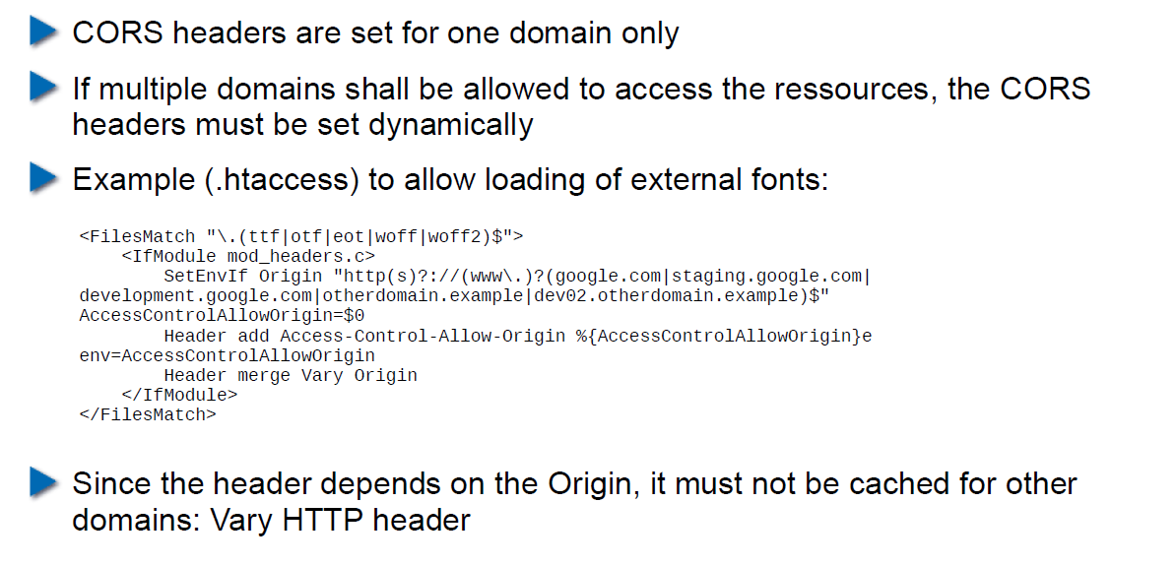

## Content Security Policy (CSP) Headers

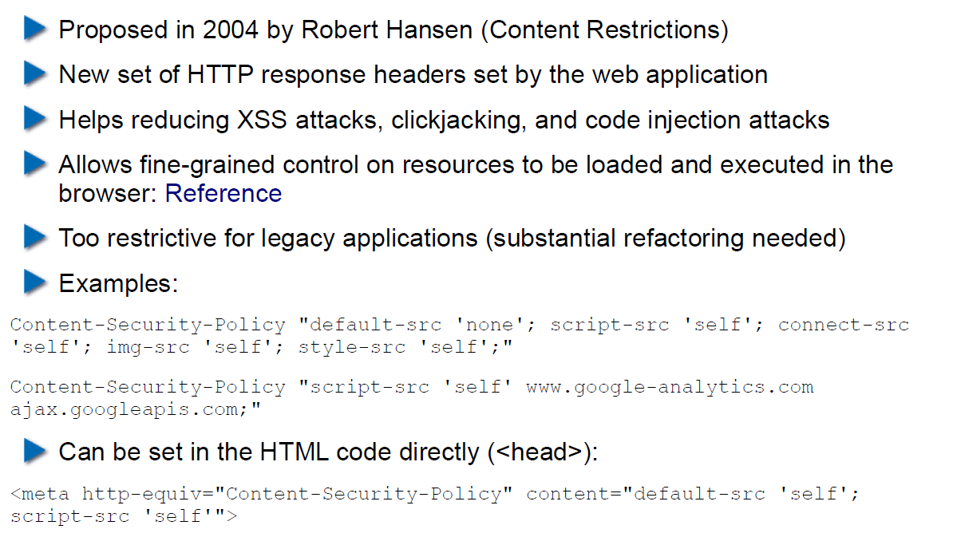

## Overview of Common CSP Options

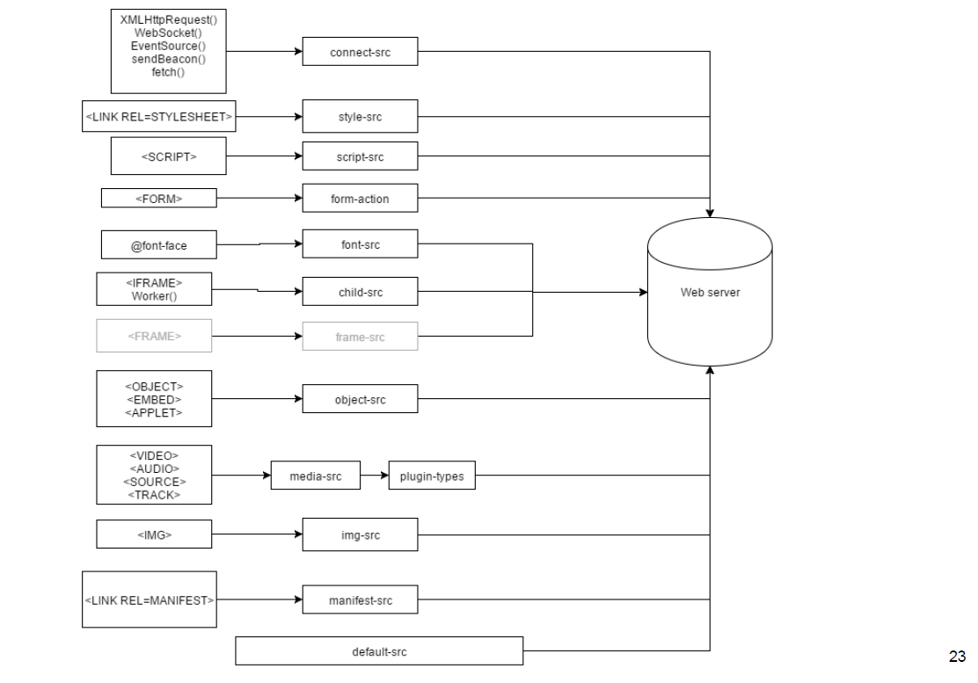

## Exercise: U08

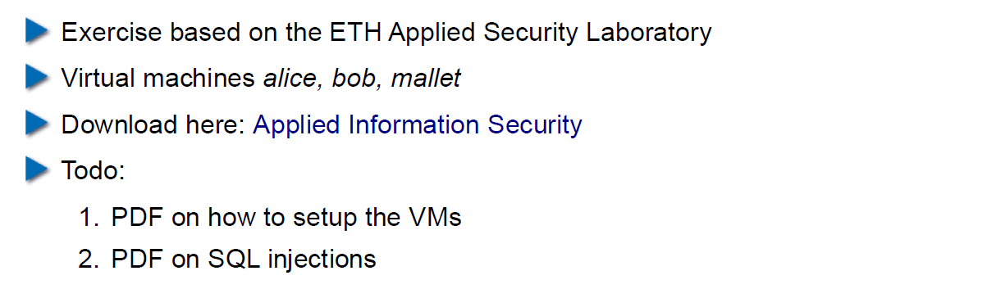

# Woche 9

## Agenda

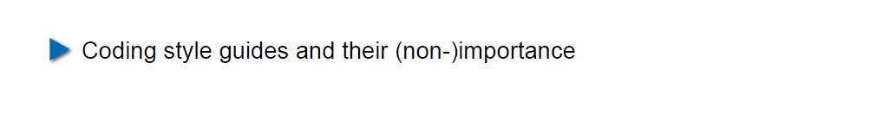

## Coding Style Guides / Coding Standards

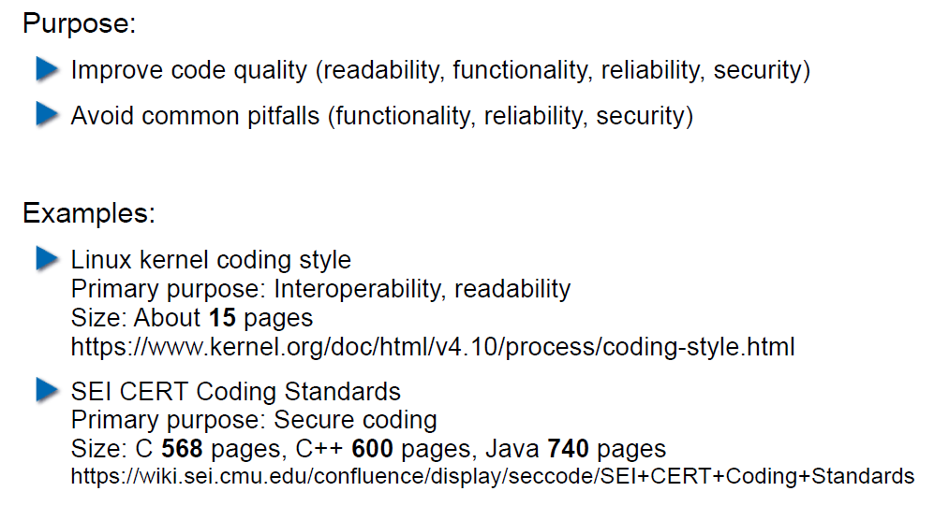

## Linux Kernel Coding Style: Introduction

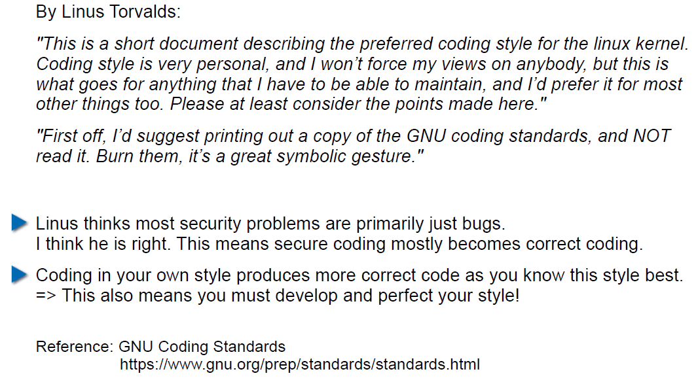

## Linux Kernel Coding Style: Examples (1)

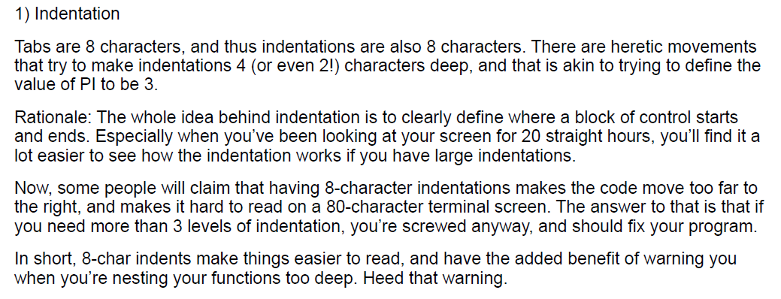

## Linux Kernel Coding Style: Examples (2)

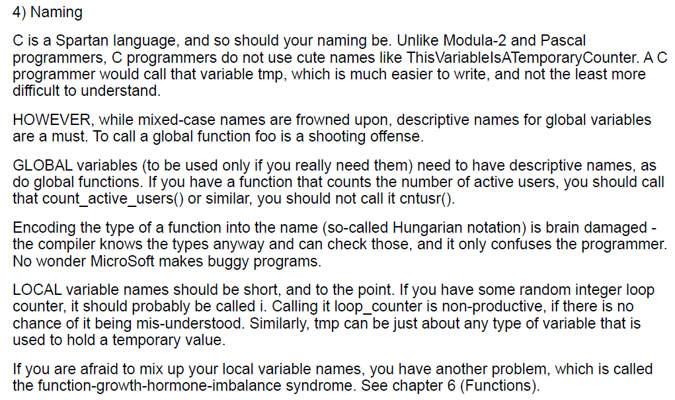

## Linux Kernel Coding Style: Examples (3)

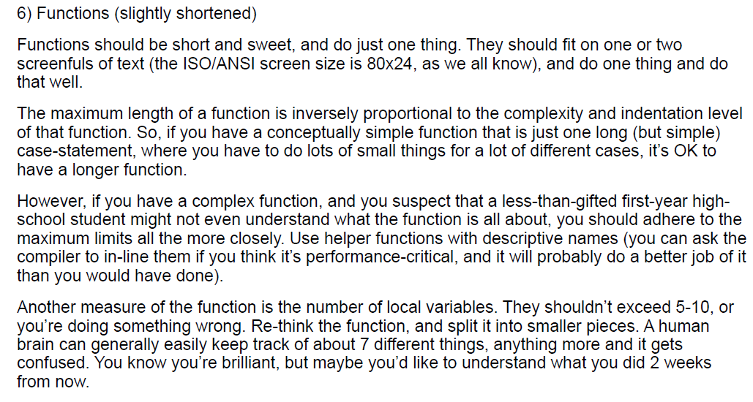

## Linux Kernel Coding Style: Examples (4)

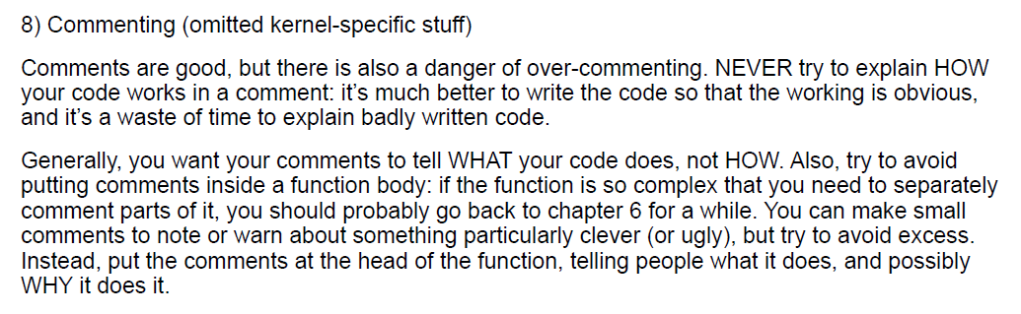

## CERT/SEI Rules and Recommendations

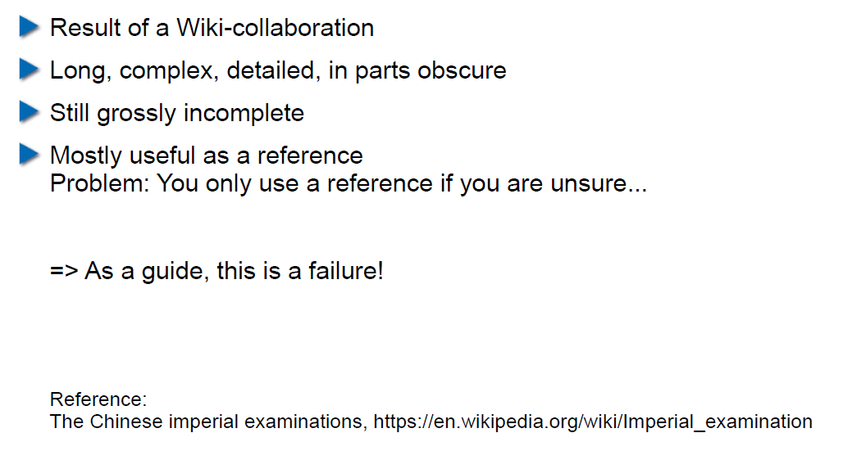

## What do Coding Style Guides Accomplish in Reality?

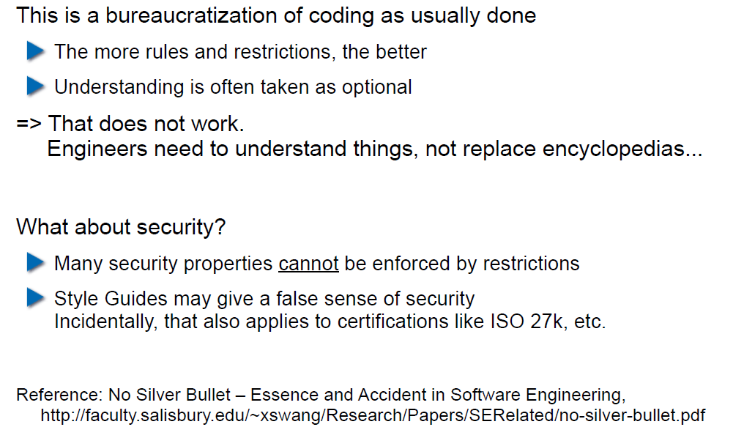

## Problems with Restrictive Coding Environments

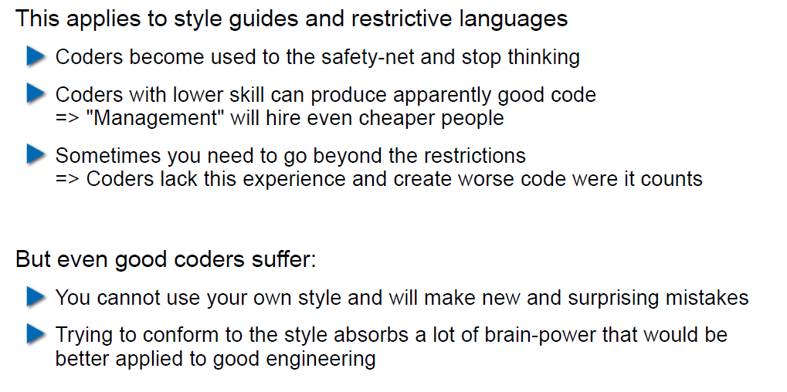

## What About Interfaces and Naming in Them?

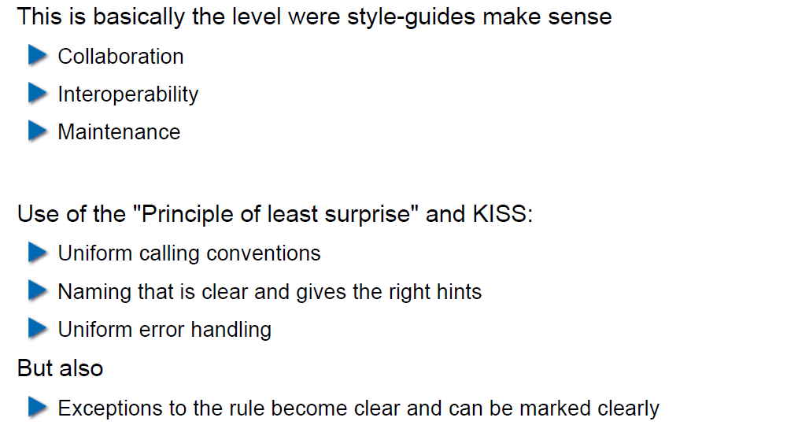

## So use a Style Guide or not?

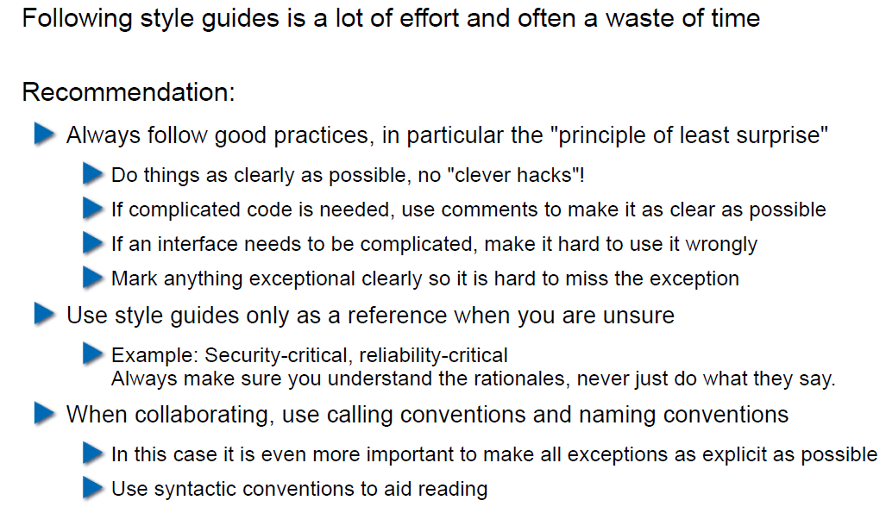

# Woche 10

## Agenda

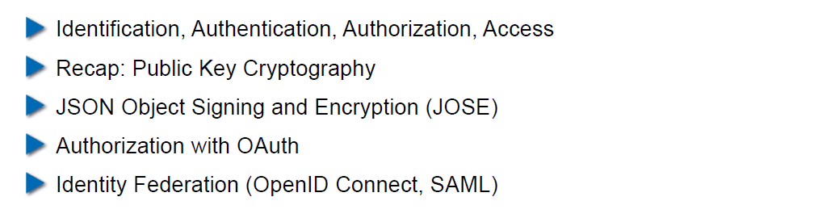

## Authentication

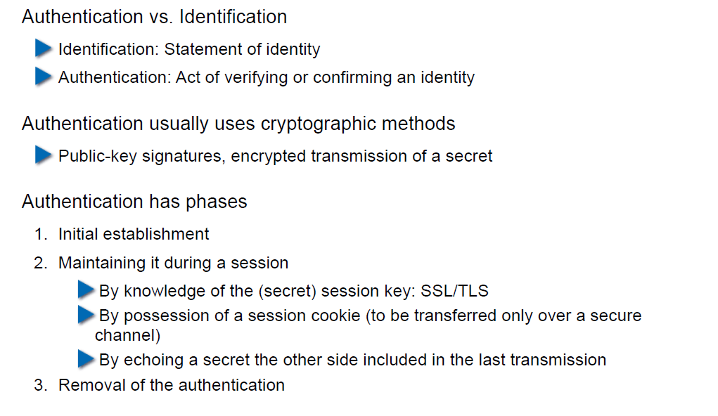

## Authorization

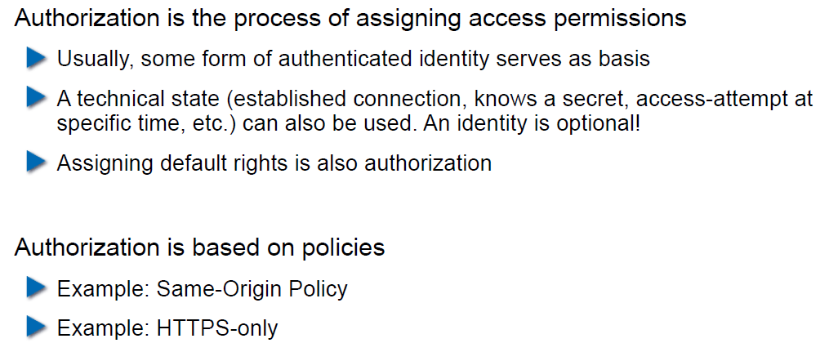

## Access to a Resource

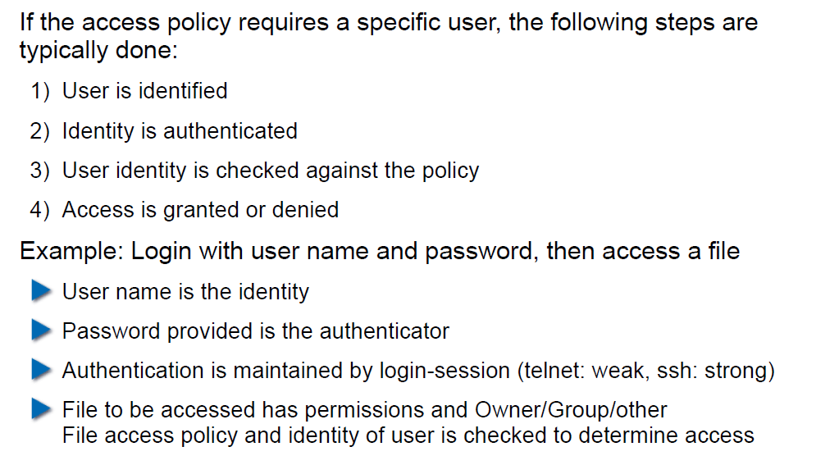

## Recap: Public Key Cryptography

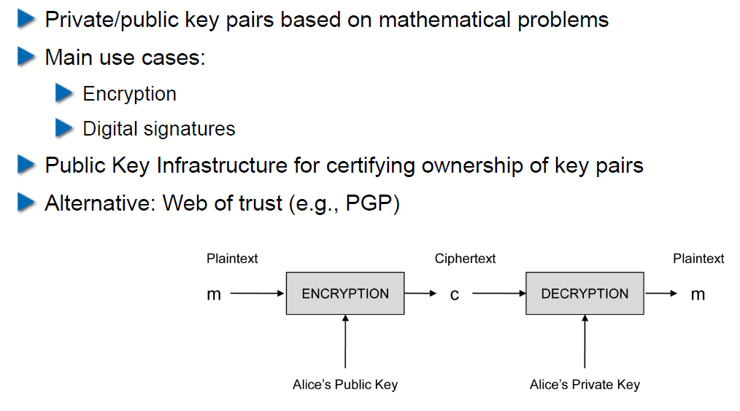

## JSON Object Signing and Encryption (JOSE)

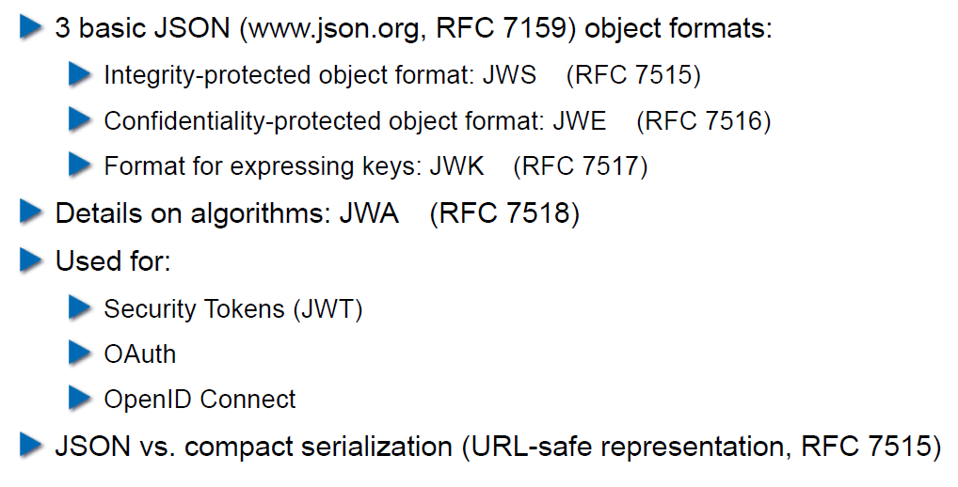

## JSON Web Signatures (JWS)

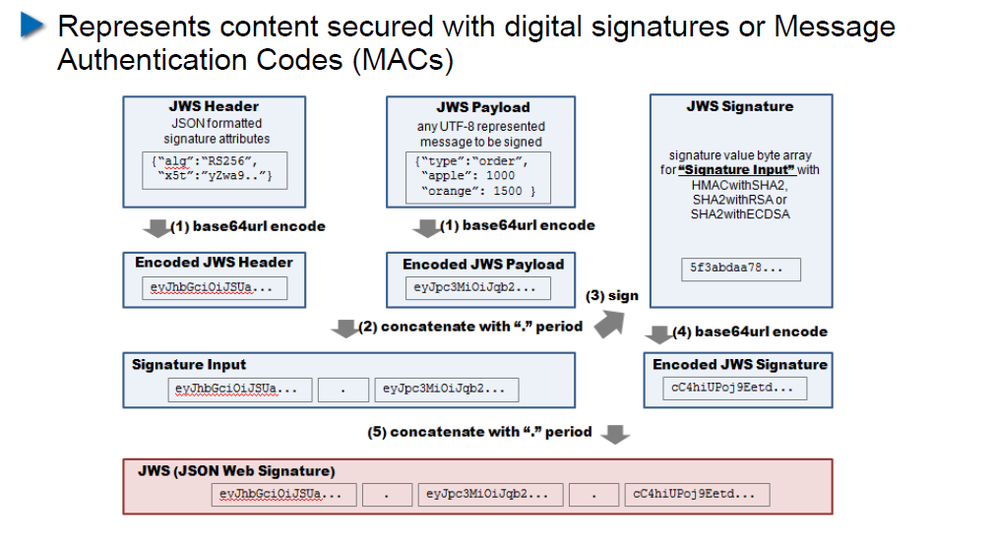

## JSON Web Encryption (JWE)

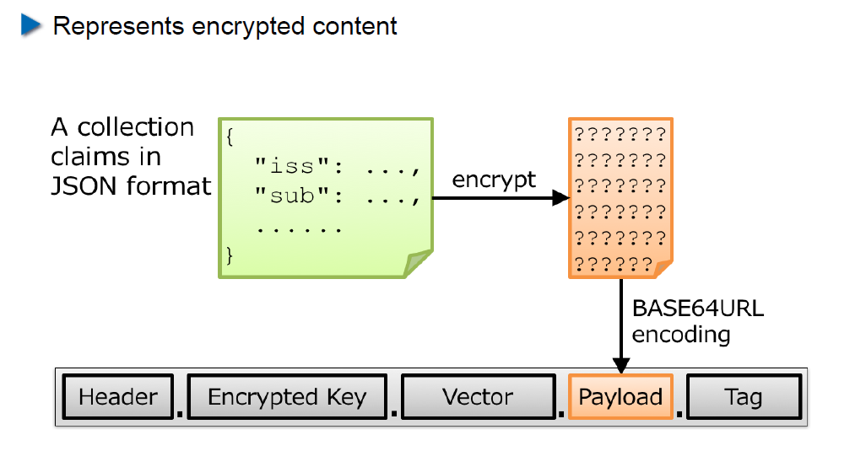

## JSON Web Token (JWT)

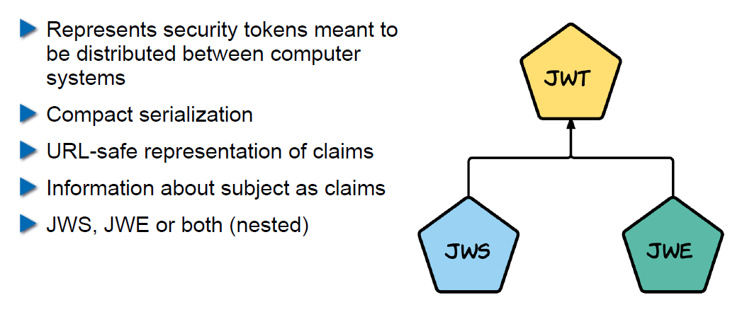

## Nested JWT

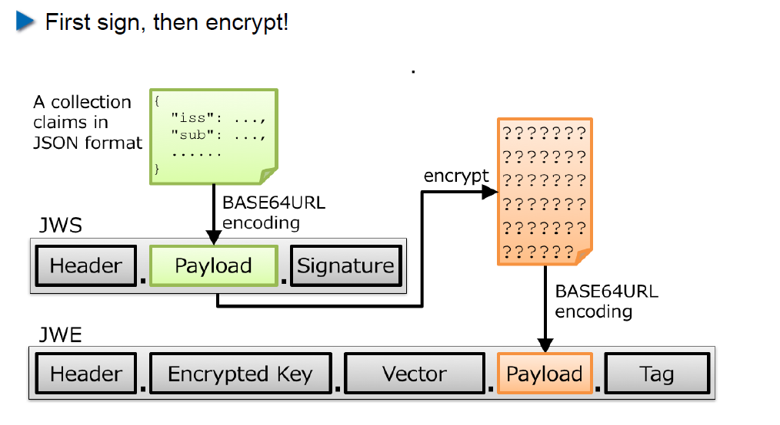

## JOSE Implementation Details

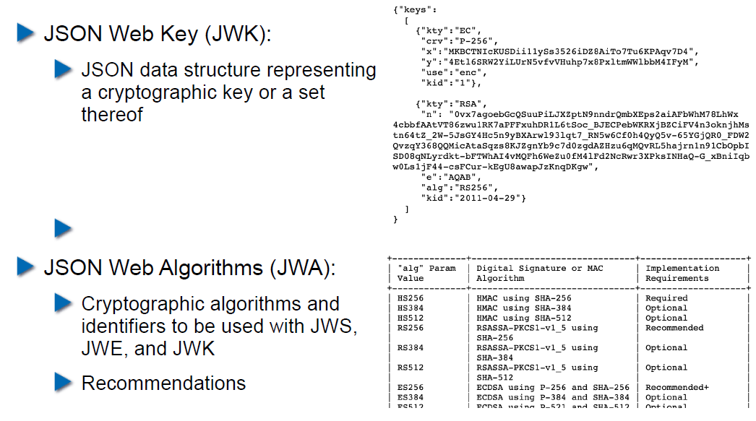

## OAuth 2.0

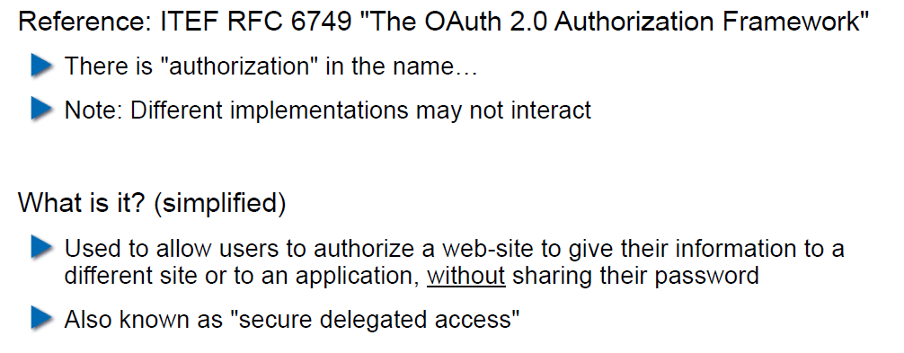

## OAuth Access Flow

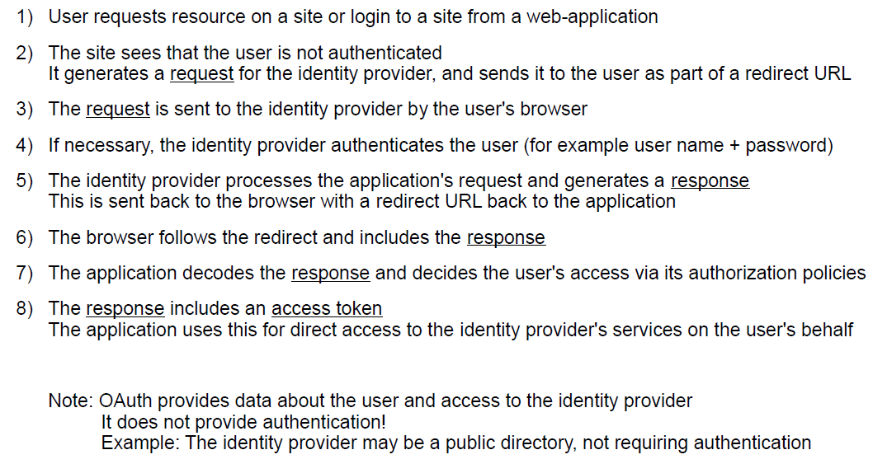

## Identity Federation

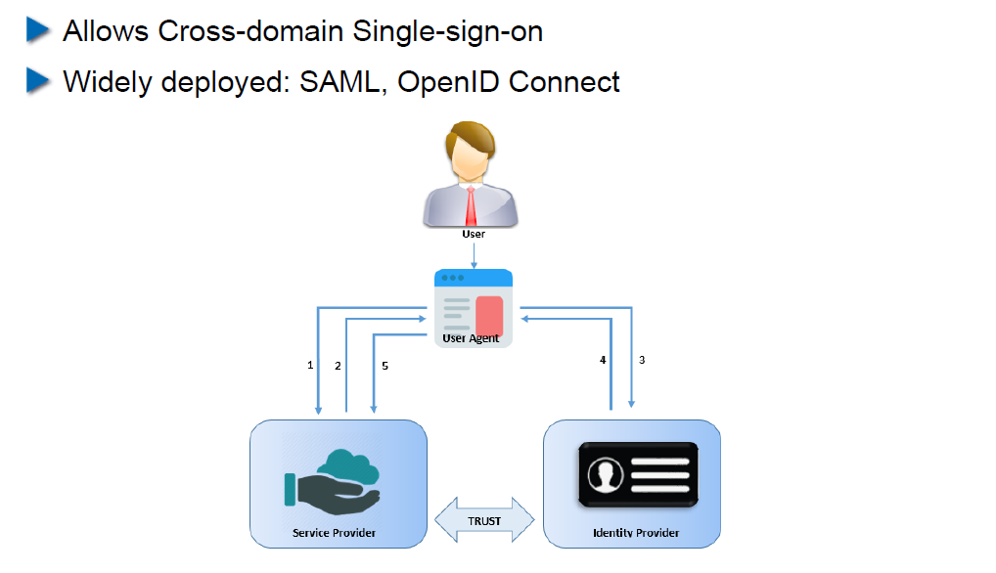

## OpenID Connect

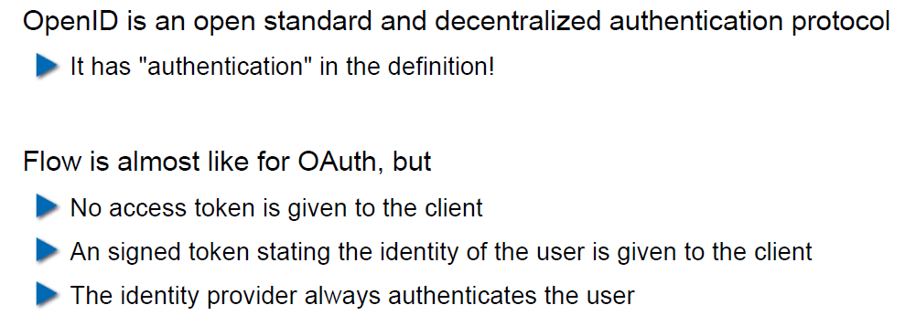

## OAuth vs. OpenID

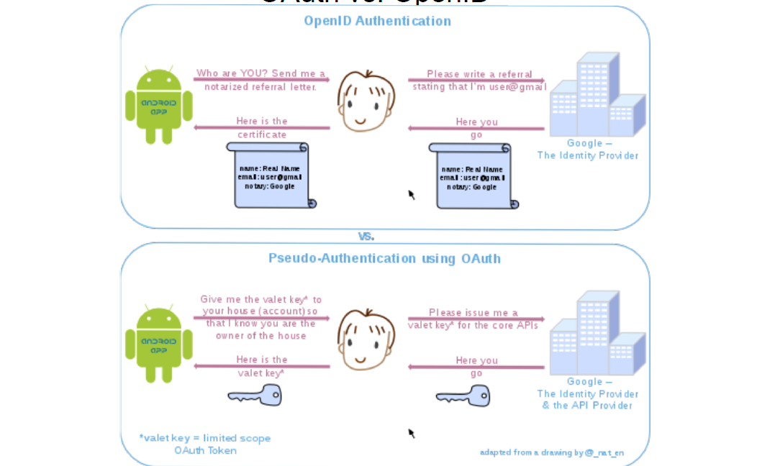

## OpenID Connect

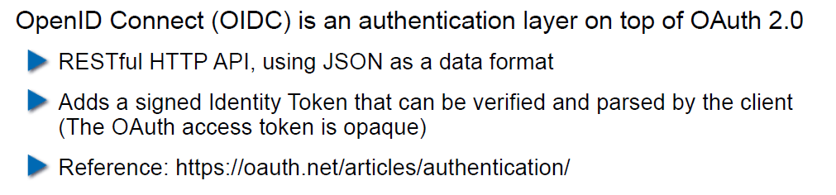

## Recent OAuth 2.0 Flaws

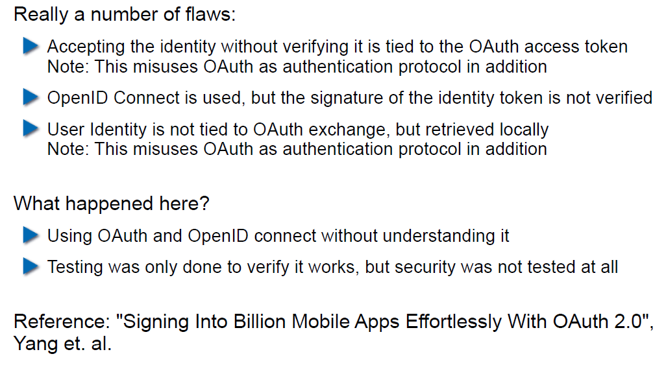

## SAML 2.0

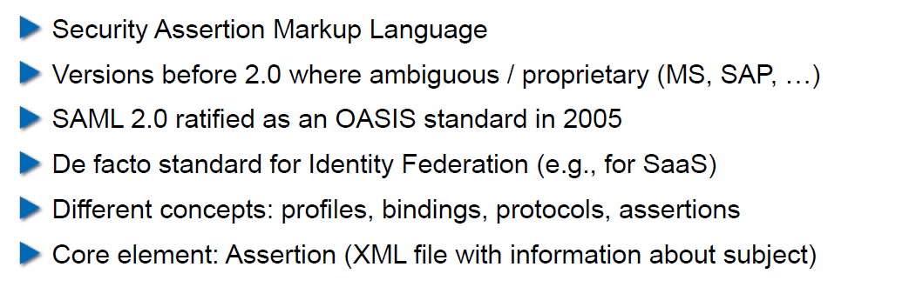

## SAML 2.0

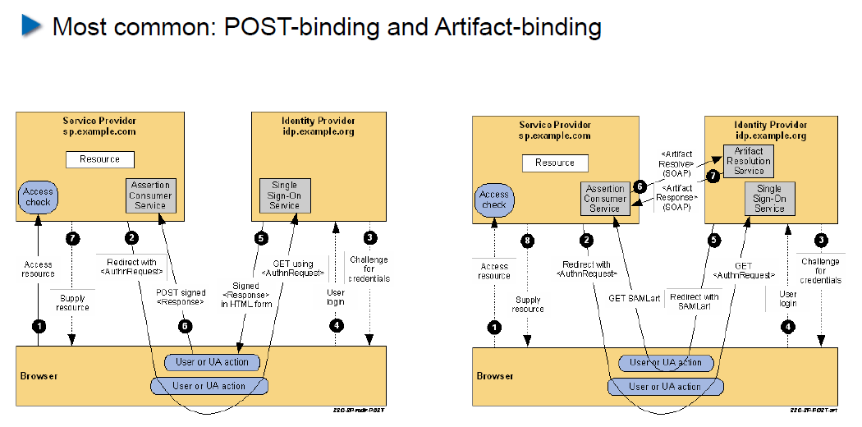

# Woche 11

In Woche 11 fand die Projektwoche statt.

# Woche 12

## Agenda

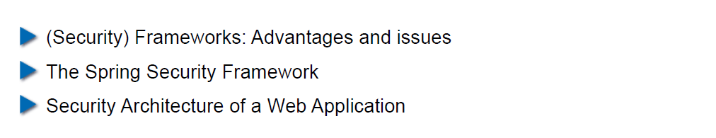

## Why use a Security Framework?

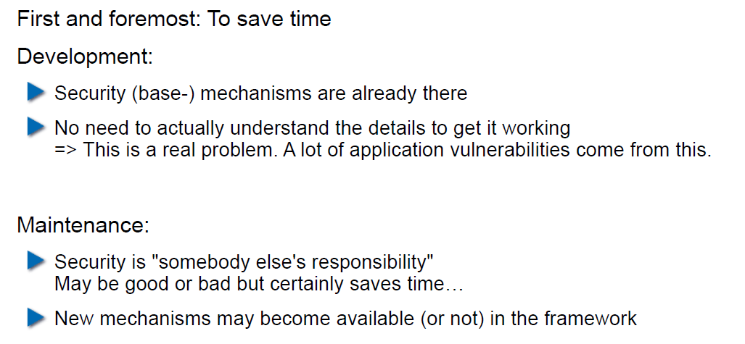

## Bad Reasons to use a (Security-) Framework

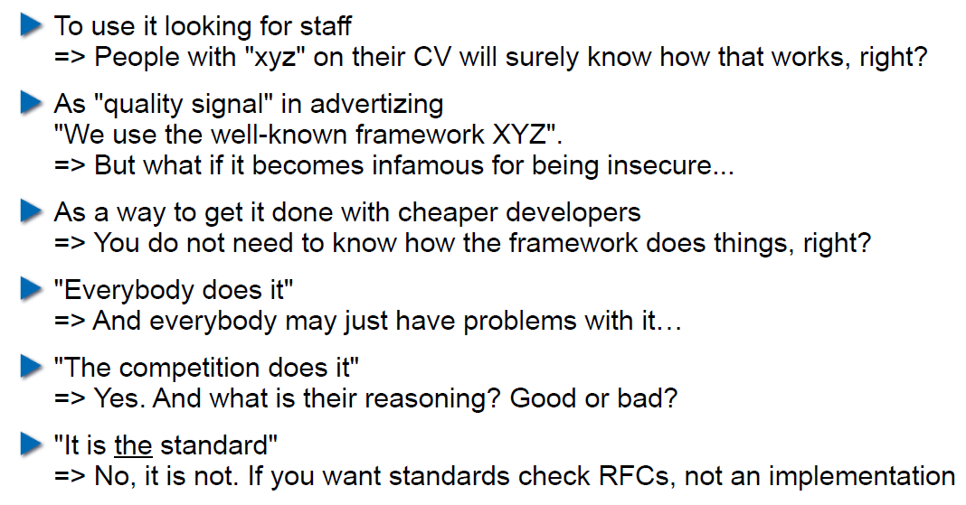

## Problems of Using a Security Framework

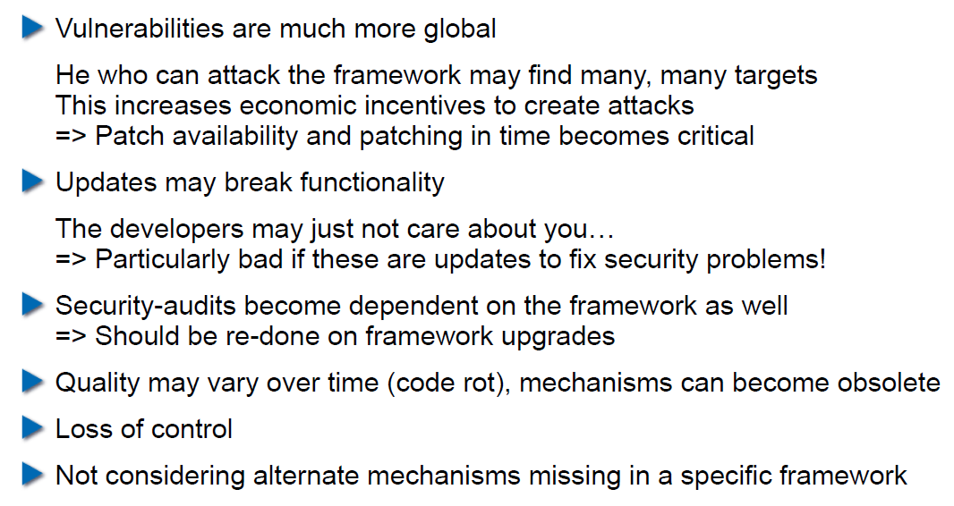

## What if the Framework will not let you go?

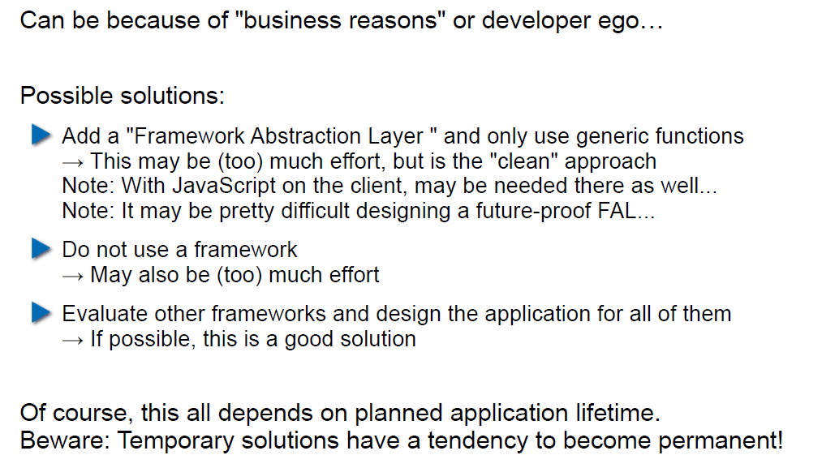

## The Spring Security Framework

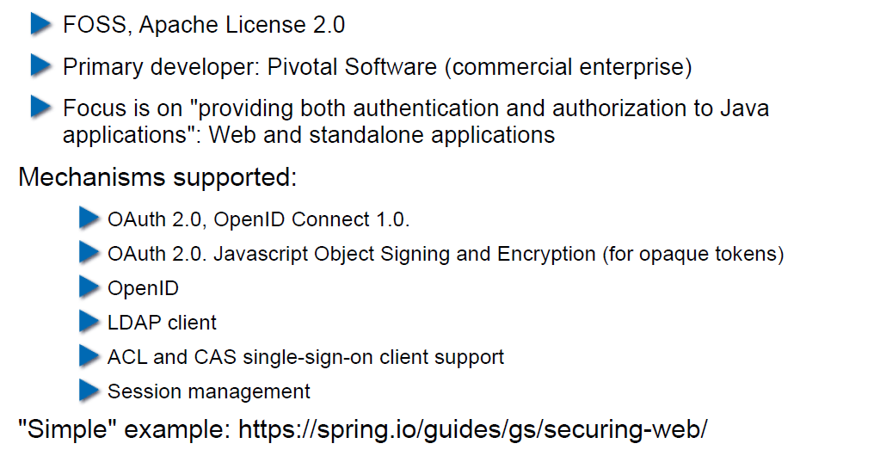

## Project Integration: Maven

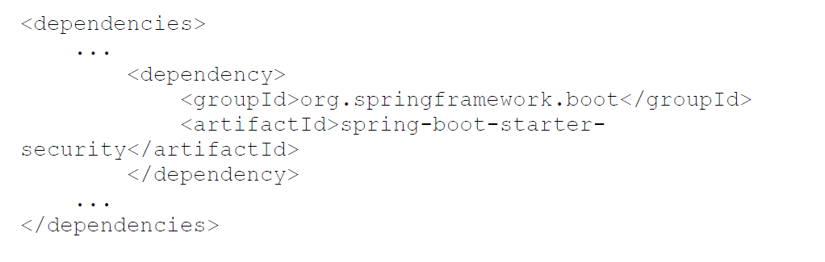

## Project Integration: Gradle

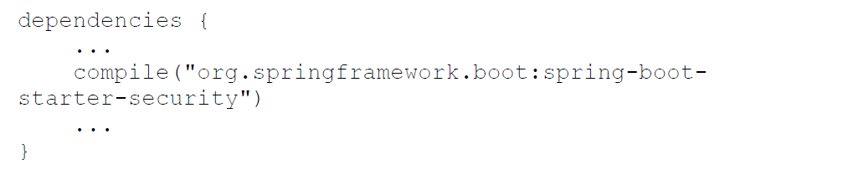

## Characteristics of the External Dependency

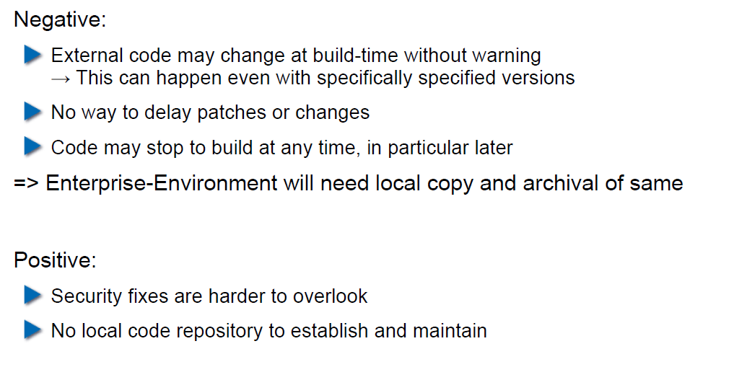

## Attacks Via External Dependency

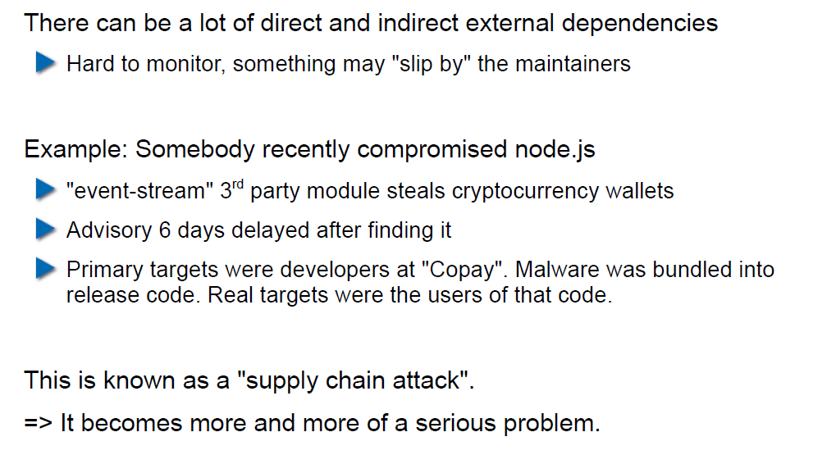

## Attacks Via External Dependency

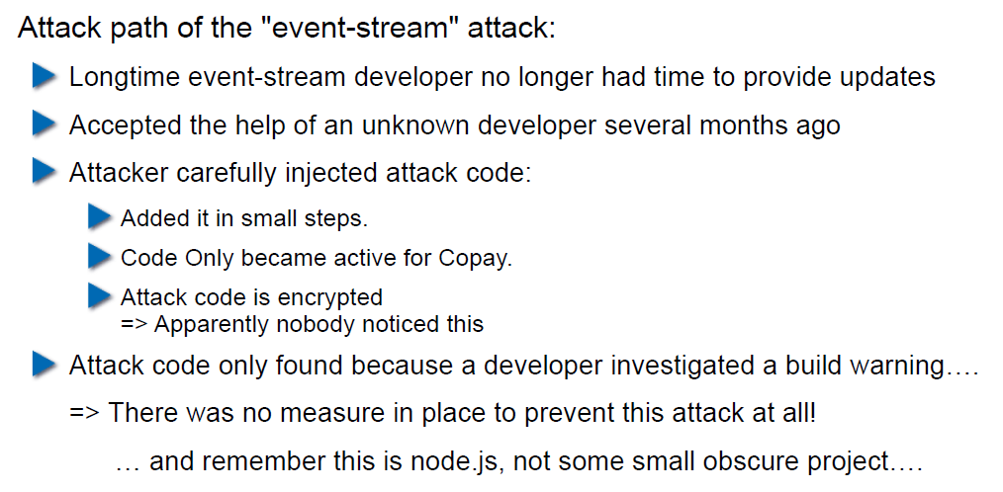

## Security Track-Record of Spring Security

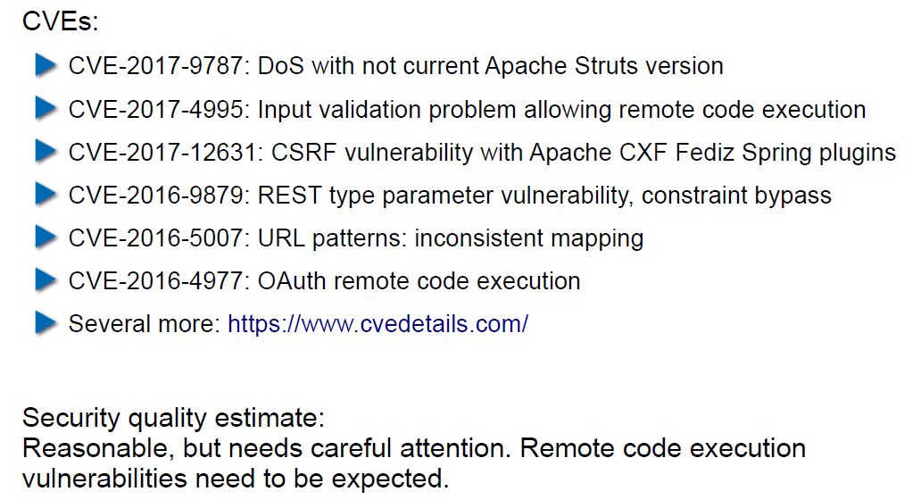

## Security Architecture of a Web Application

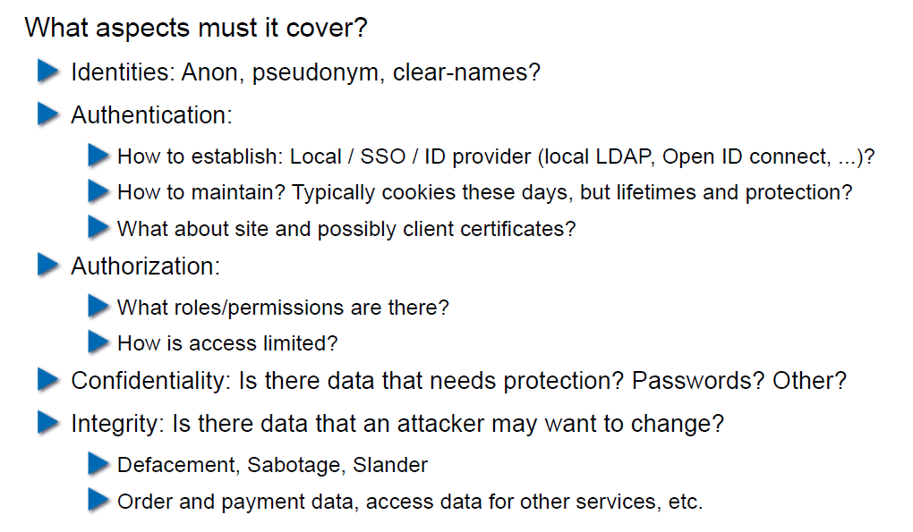

## Security Architecture of a Web Application

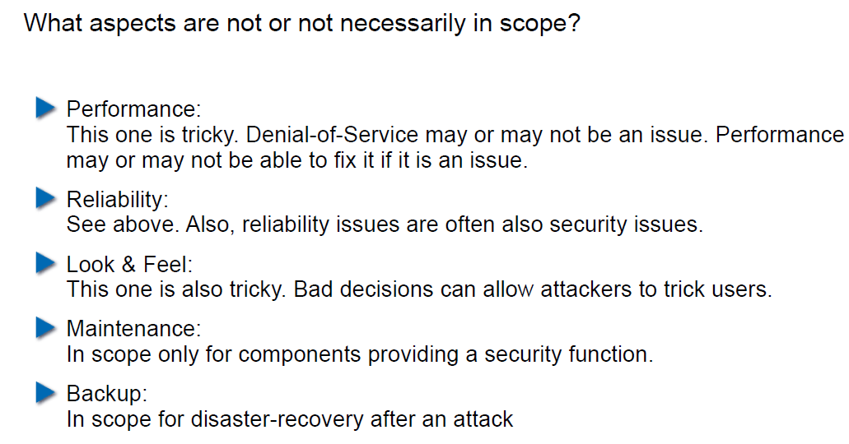

## User States

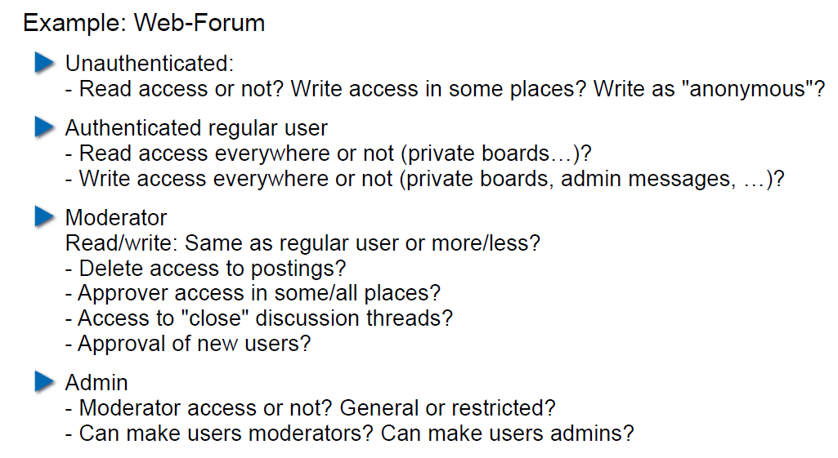

## State Transitions

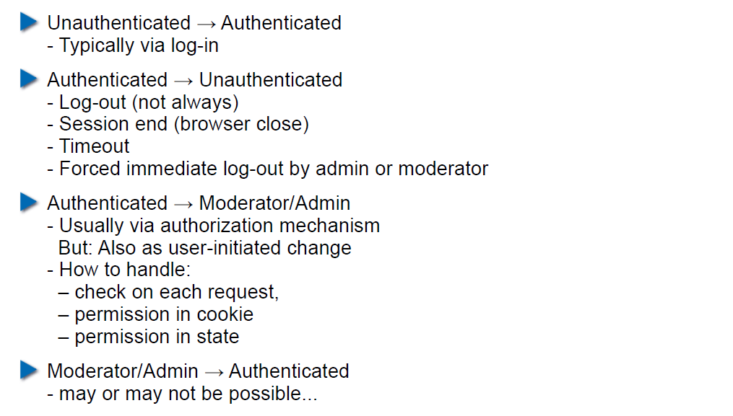

## Content-Based Attacks

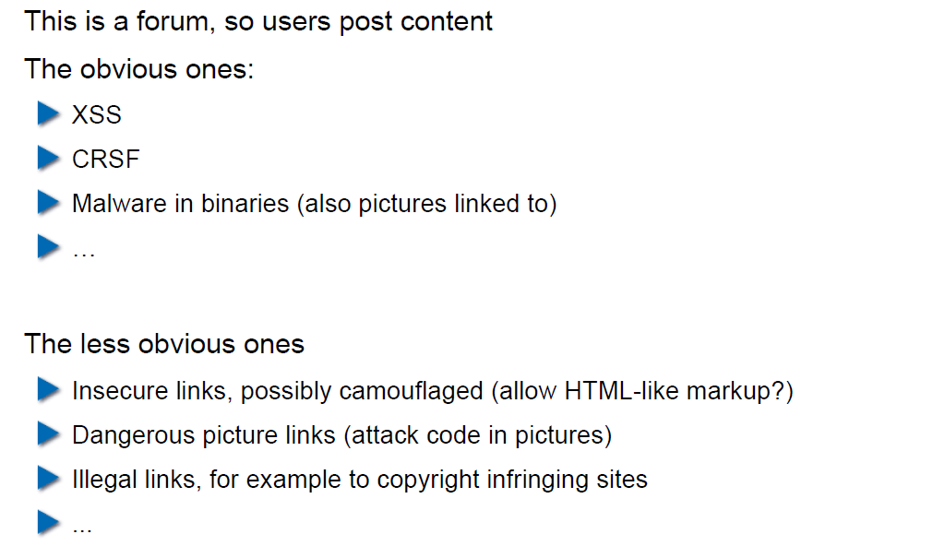

## How to Protect Against User-Generated Content?

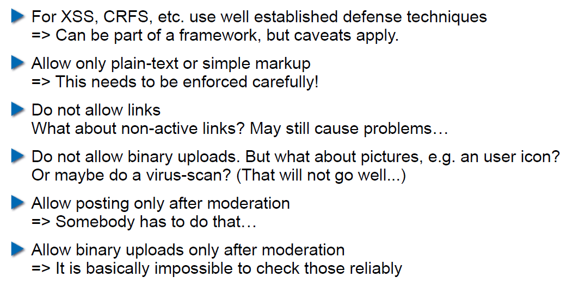

# Woche 13

## Agenda

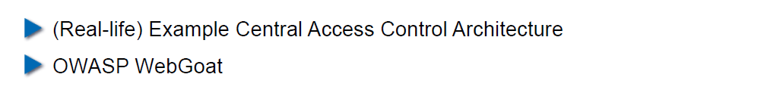

## Example Enterprise Access Control Architecture (simplified)

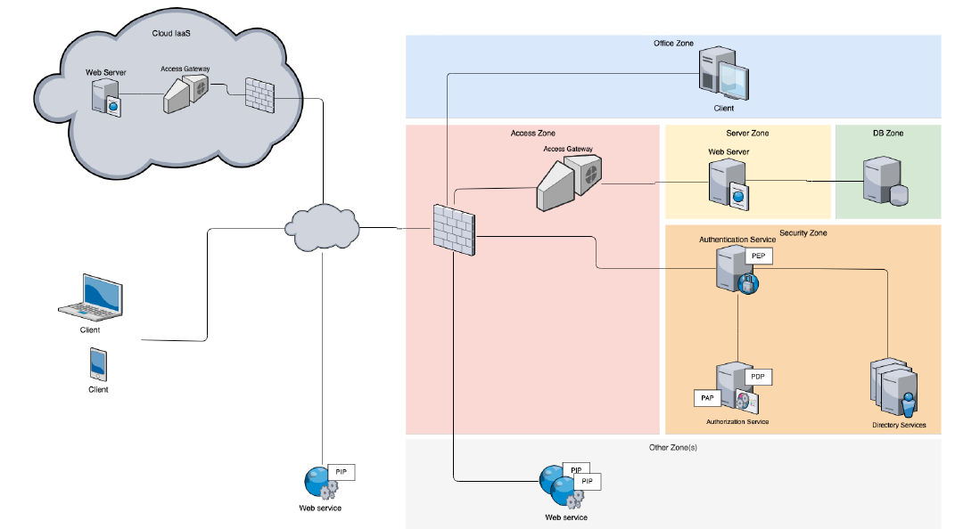

## Decentralized Access Gateways

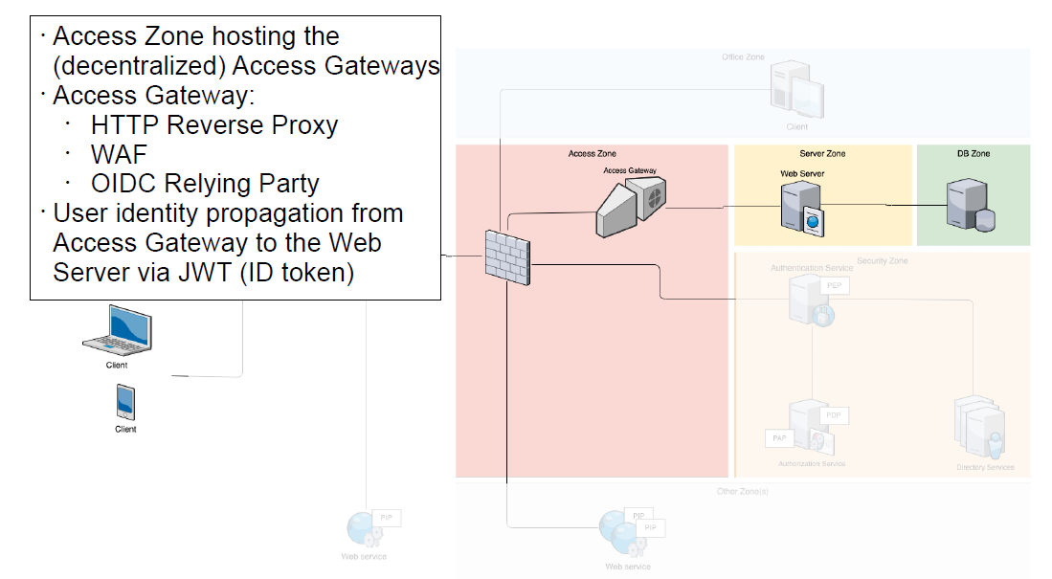

## Federated Authentication and Authorization

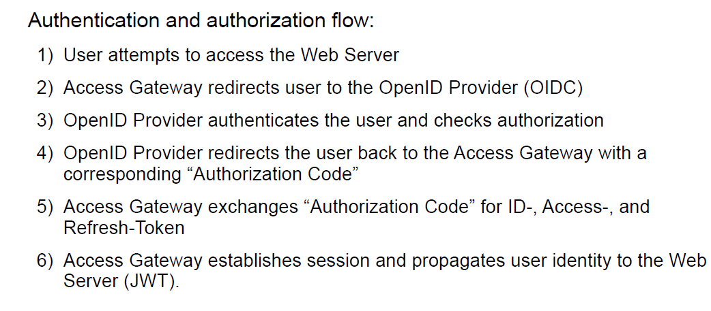

## Central Authentication and Authorization

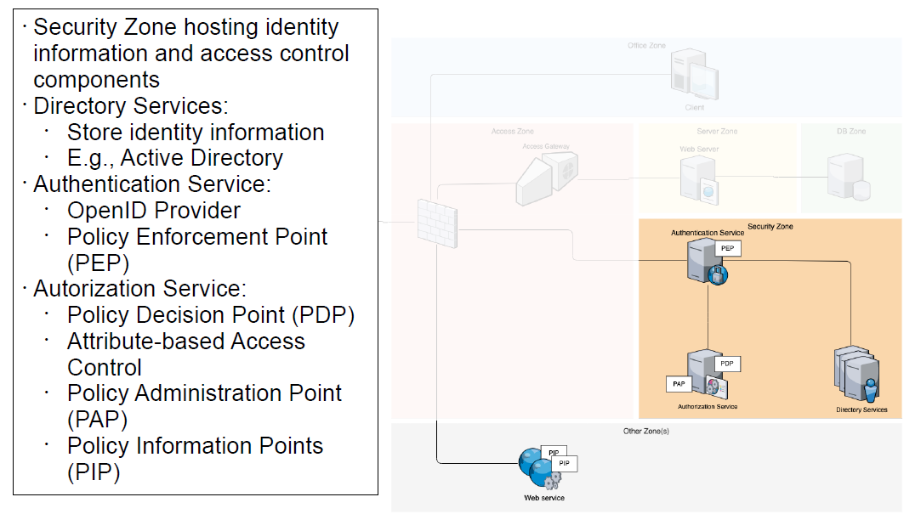

## Externalized Authorization Management

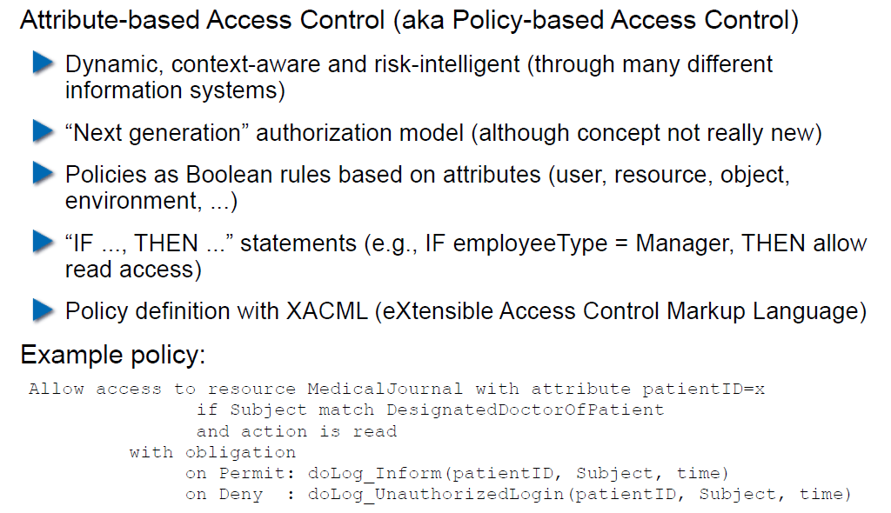

## XACML Architecture and Sample Authorization Flow

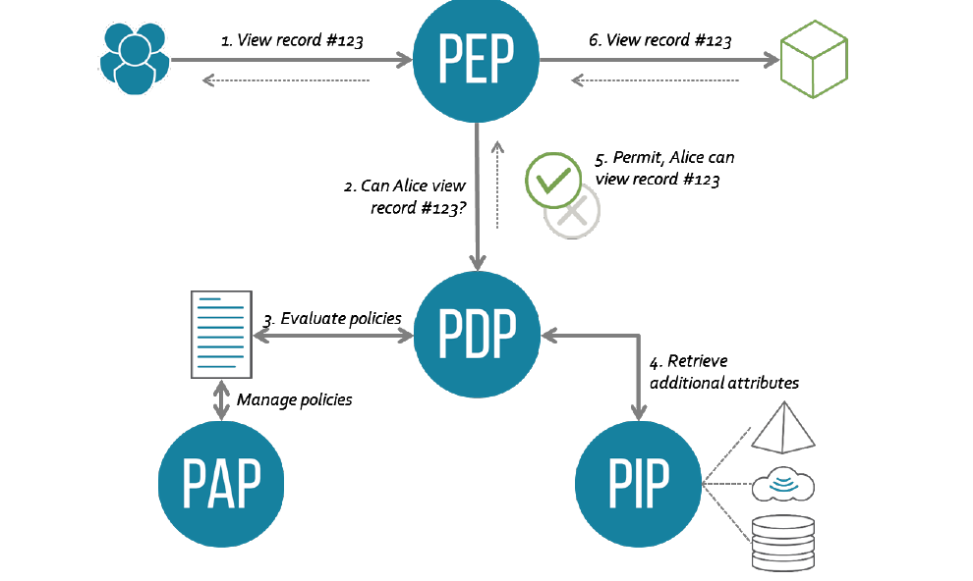

## Unified Hybrid Multi-Cloud Application Deployment

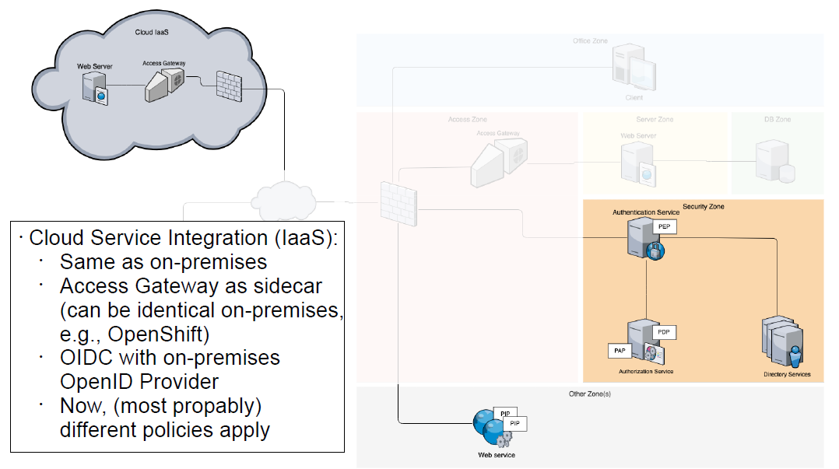

## Access Gateway based on the Sidecar Pattern

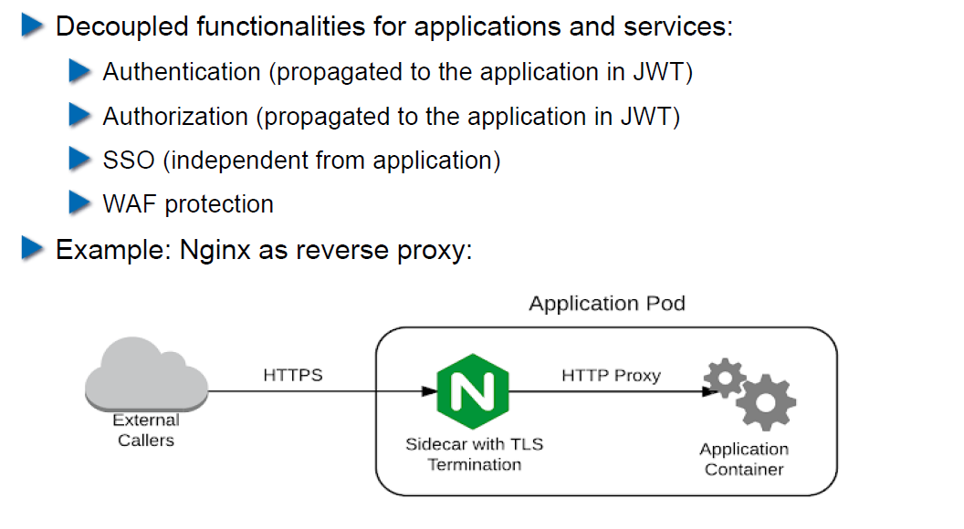

## Central Access Control Summary

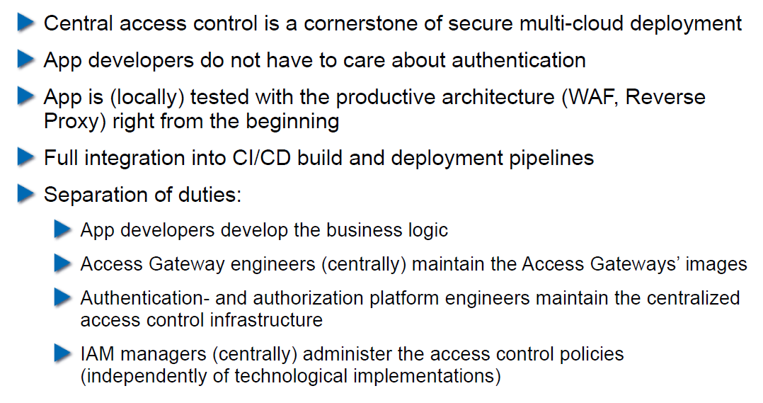

## OWASP WebGoat

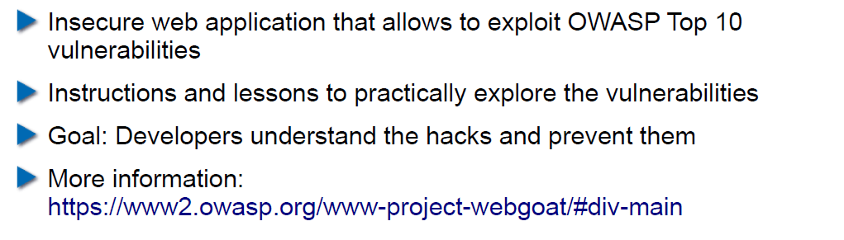

## Setup WebGoat the Simple Way

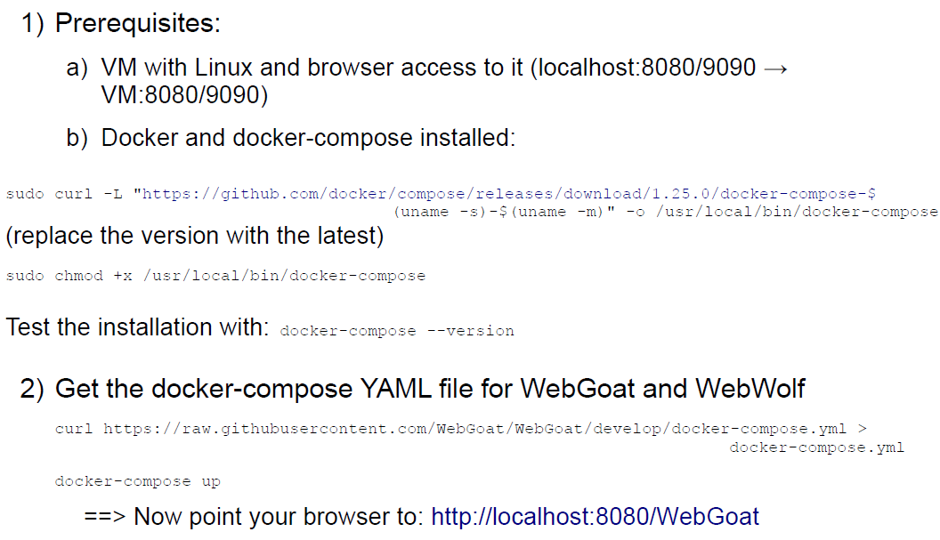

## Setup OWASP Zed Attack Proxy (ZAP)

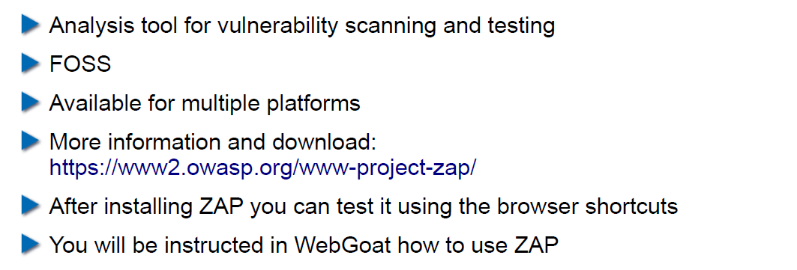

## Using OWASP WebGoat

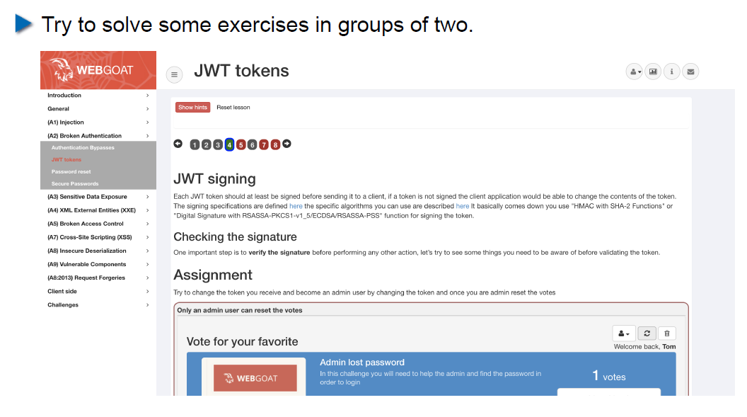

## Homework

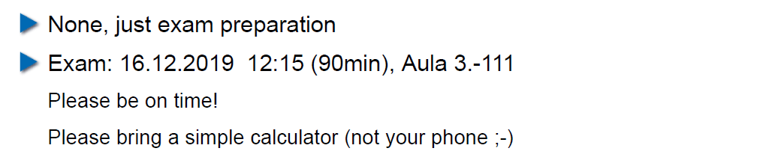

# Woche 14

In Woche 14 fand die Prüfung statt.

# Woche 15

## Agenda

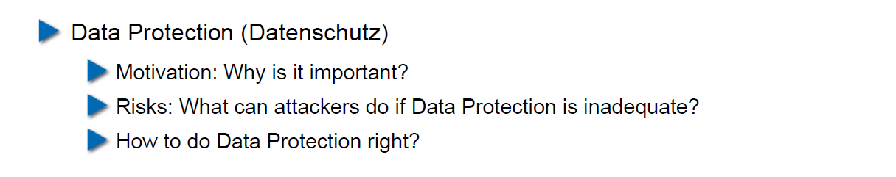

## Some Definitions (mostly from Wikipedia...)

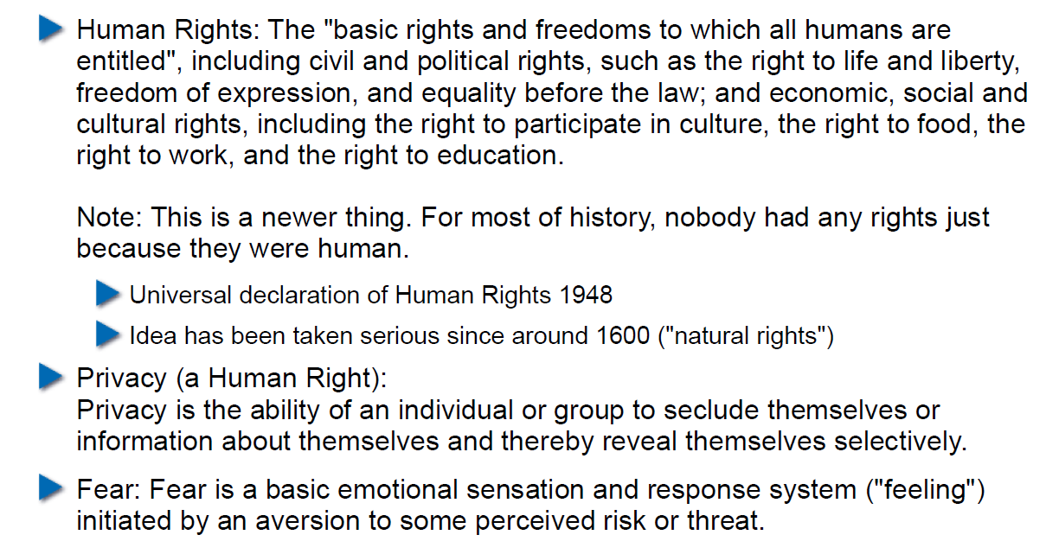

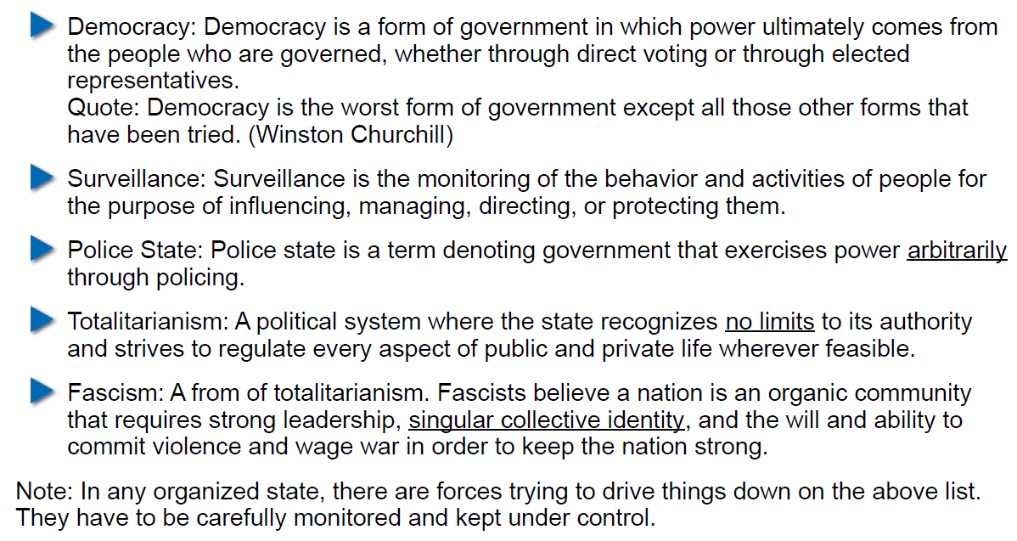

## Reasons for Privacy

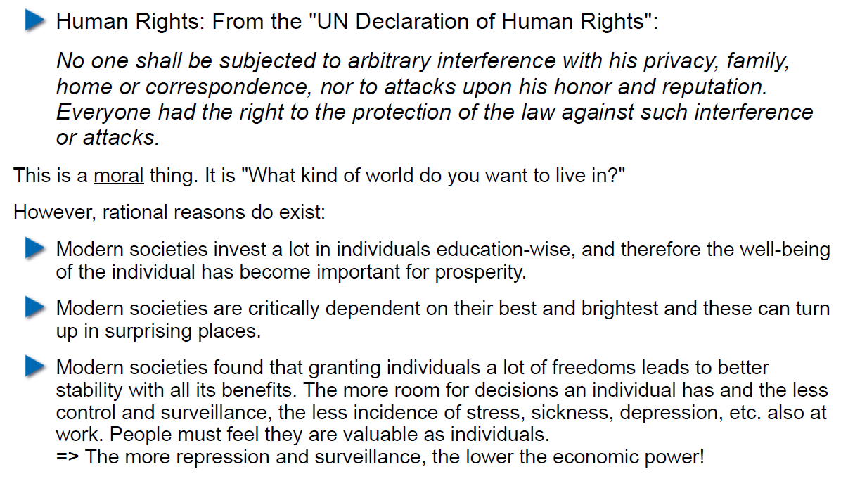

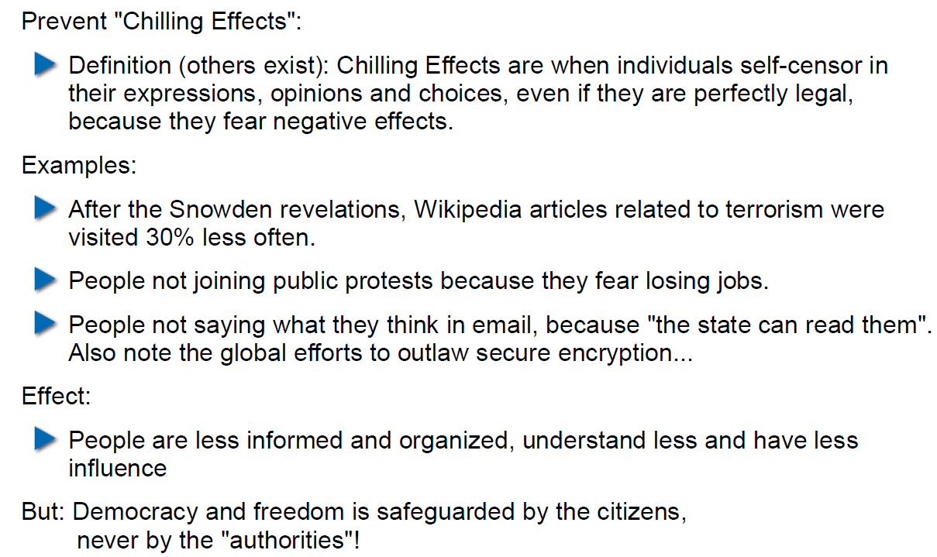

## "Authorities" have a long history of fighting privacy

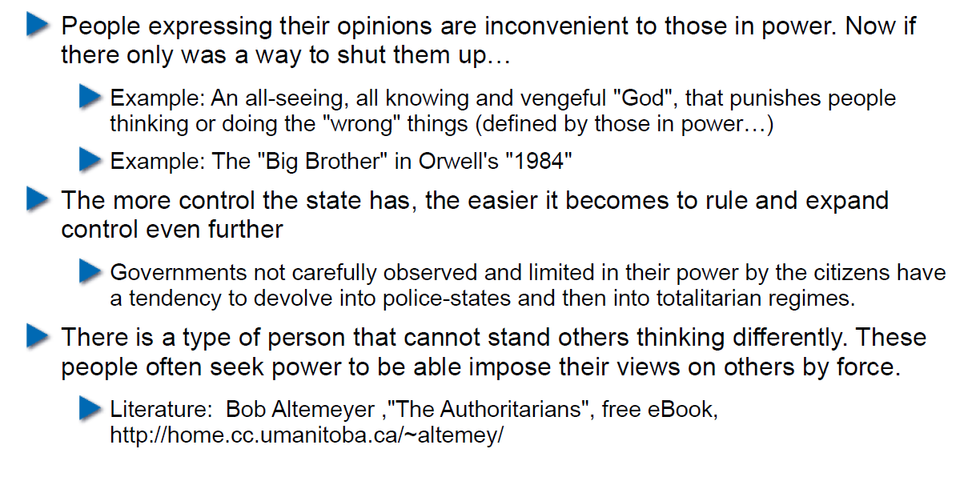

## The Role of Fear

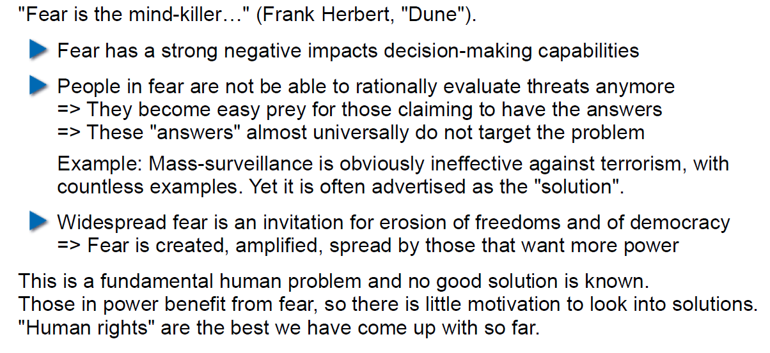

## Democracy and Freedoms need to be fought for

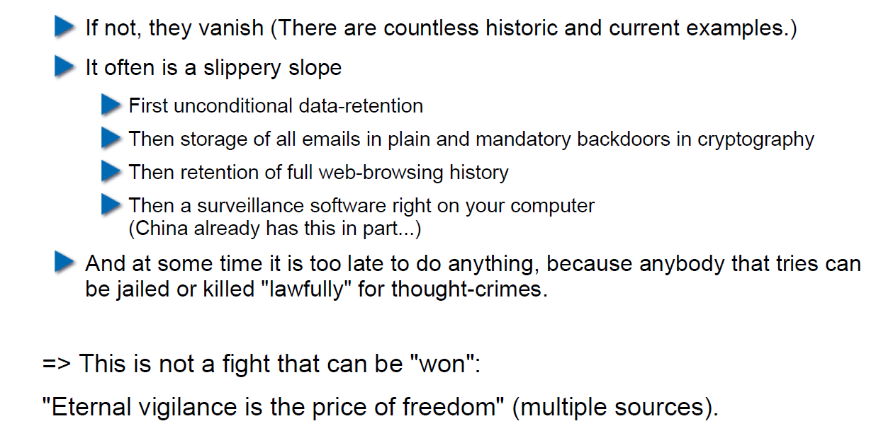

## Why is this relevant to APSI?

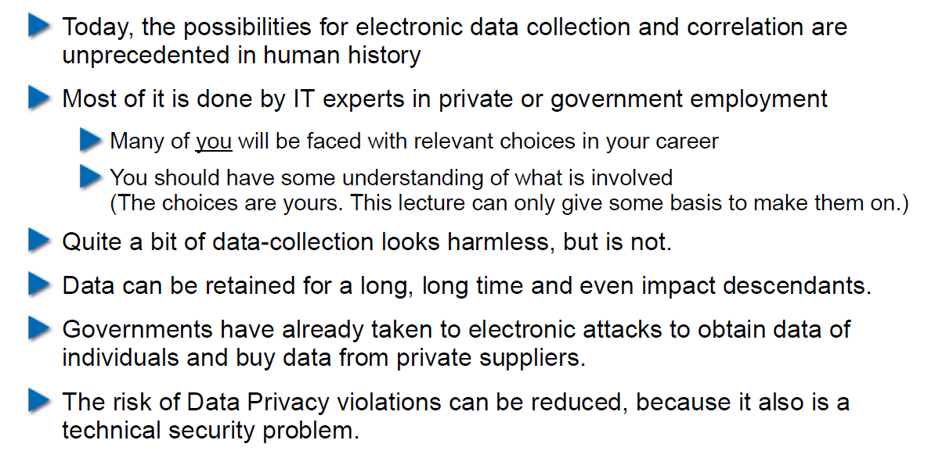

## What Can be Done with Data?

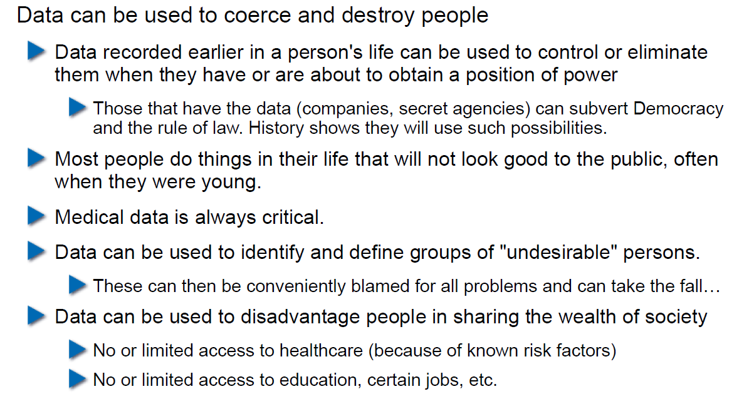

## How Critical Can (Seemingly Harmless) Data Be?

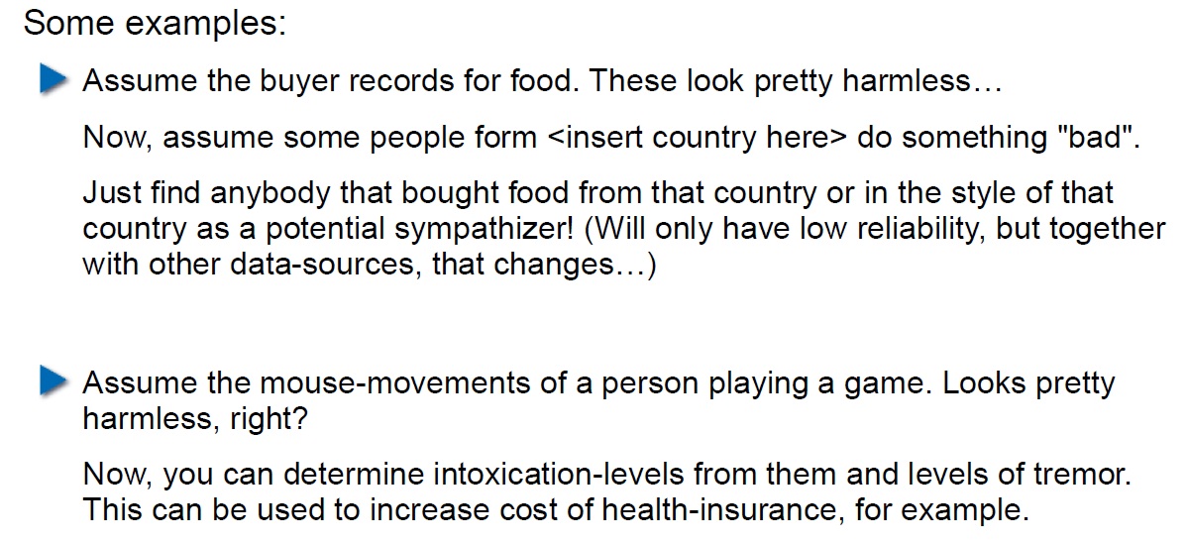

## Privacy-Relevant Data

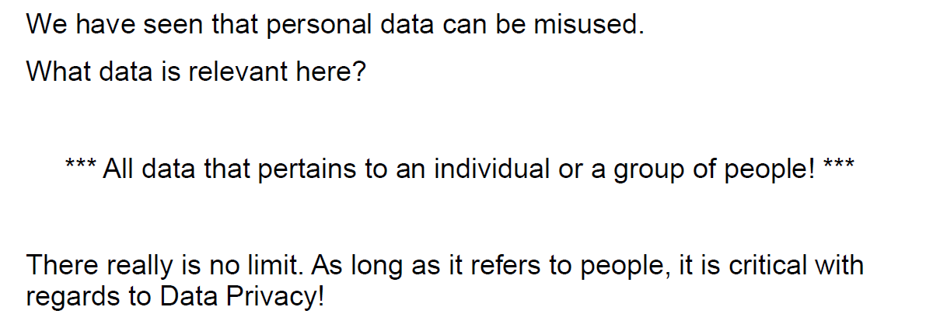

## Principles of IT Data Privacy

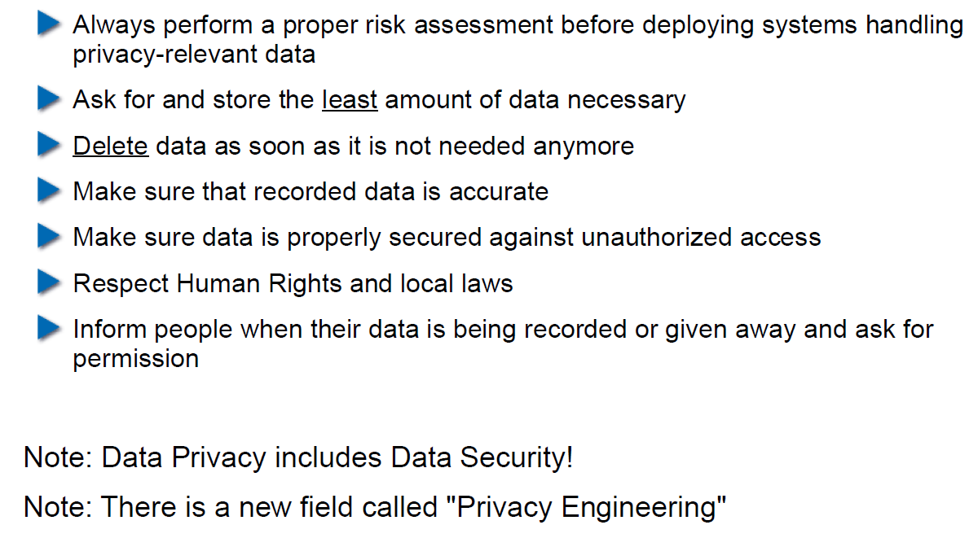

## Privacy by Design (from Systems Engineering)

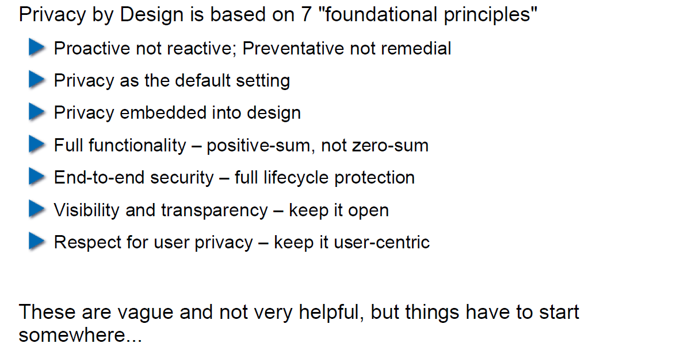

## Role of Encryption

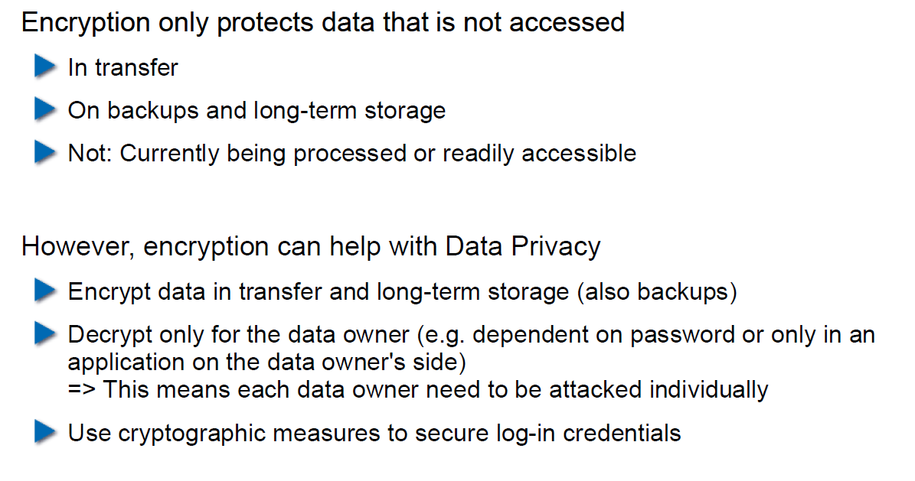

## Data Anonymization

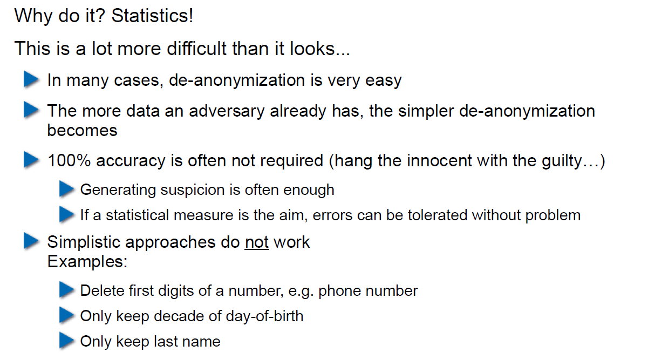

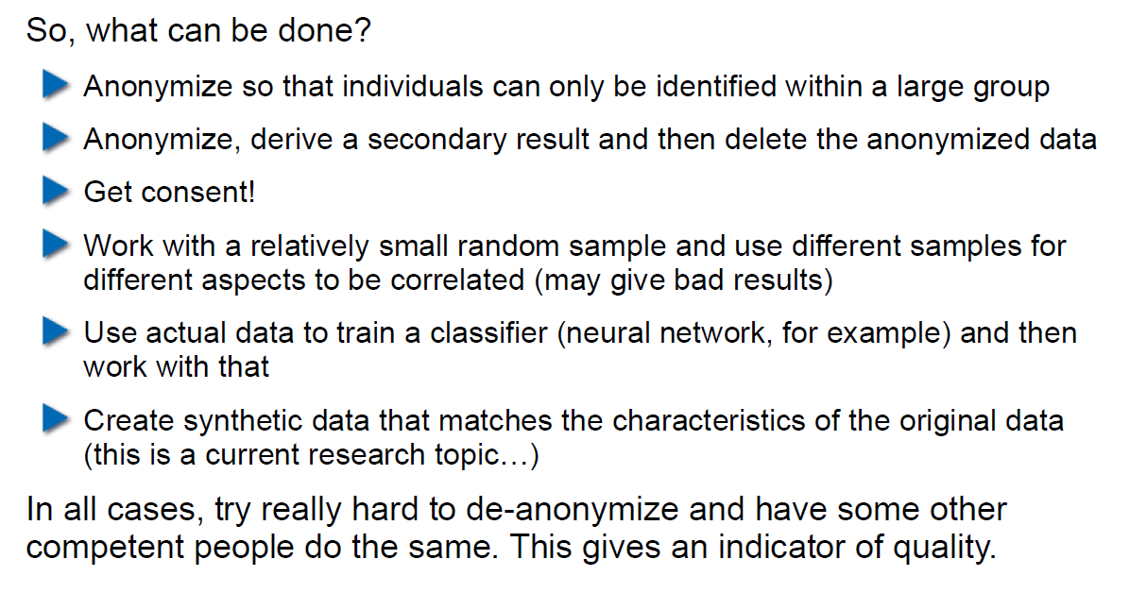

## What about the Cloud?

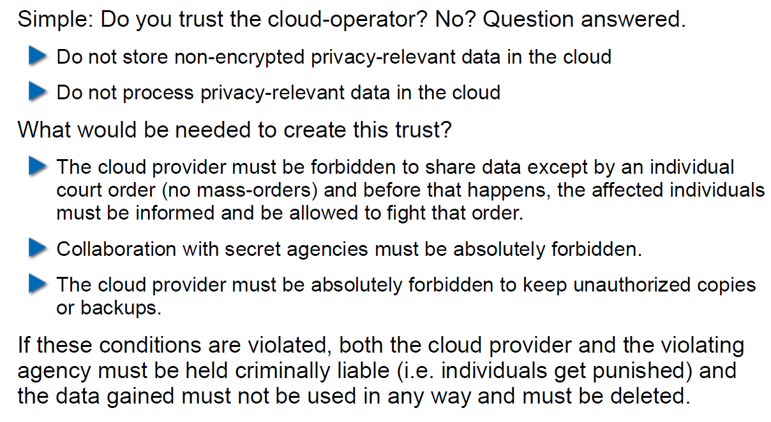

## Homework

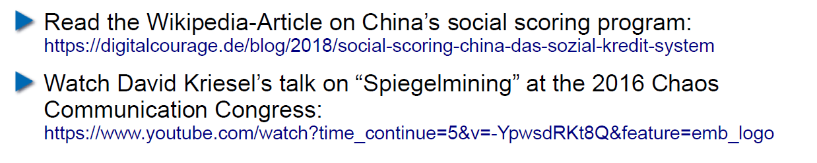

# Woche 16